Contents

1. TCABEL0001 2

2. TCABEL0002 4

3. TCABEL0003 6

4. TCATCH0001 8

5. TCATCH0002 10

6. TCATCH0003 12

7. TCATCH0004 14

8. TCATCH0005 16

9. TCATCH0006 18

10. TCATCH0007 20

11. TCATCH0008 22

12. TCATCH0009 24

13. TCATCH0010 26

14. TCATCH0011 28

15. TCATCH0012 30

16. TCATNM0001 32

17. TCATNM0002 34

18. TCATNM0003 36

19. TCATNM0004 38

20. TCATNM0005 40

21. TCATNM0006 42

# TCABEL0001

| Min. | 1st Qu. | Median | Mean | 3rd Qu. | Max. |
| --- | --- | --- | --- | --- | --- |
| 31.51004 | 44.99244 | 50.6176 | 54.10413 | 60.12415 | 105.0064 |

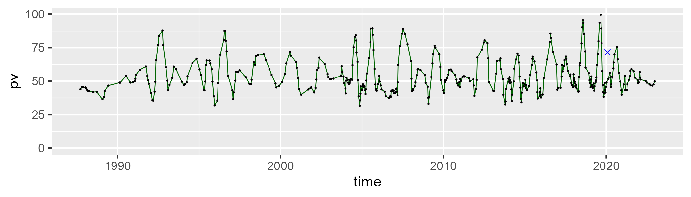

| Min. | 1st Qu. | Median | Mean | 3rd Qu. | Max. |
| --- | --- | --- | --- | --- | --- |
| 0.7851488 | 32.44844 | 40.66484 | 38.06293 | 45.29915 | 57.63047 |

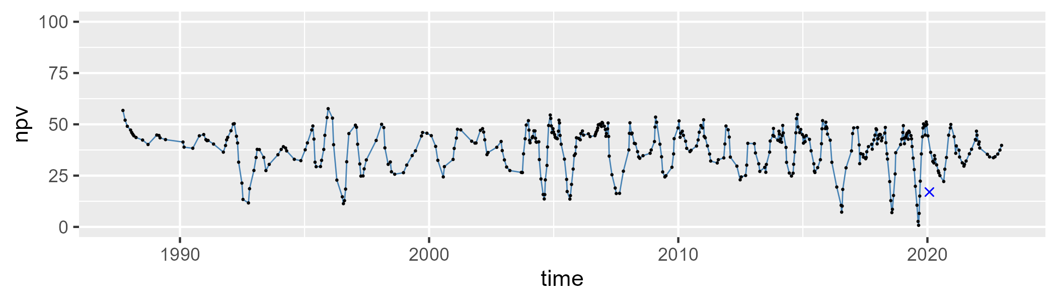

| Min. | 1st Qu. | Median | Mean | 3rd Qu. | Max. |
| --- | --- | --- | --- | --- | --- |
| 0 | 4.241625 | 7.002654 | 7.69689 | 10.31948 | 21.59224 |

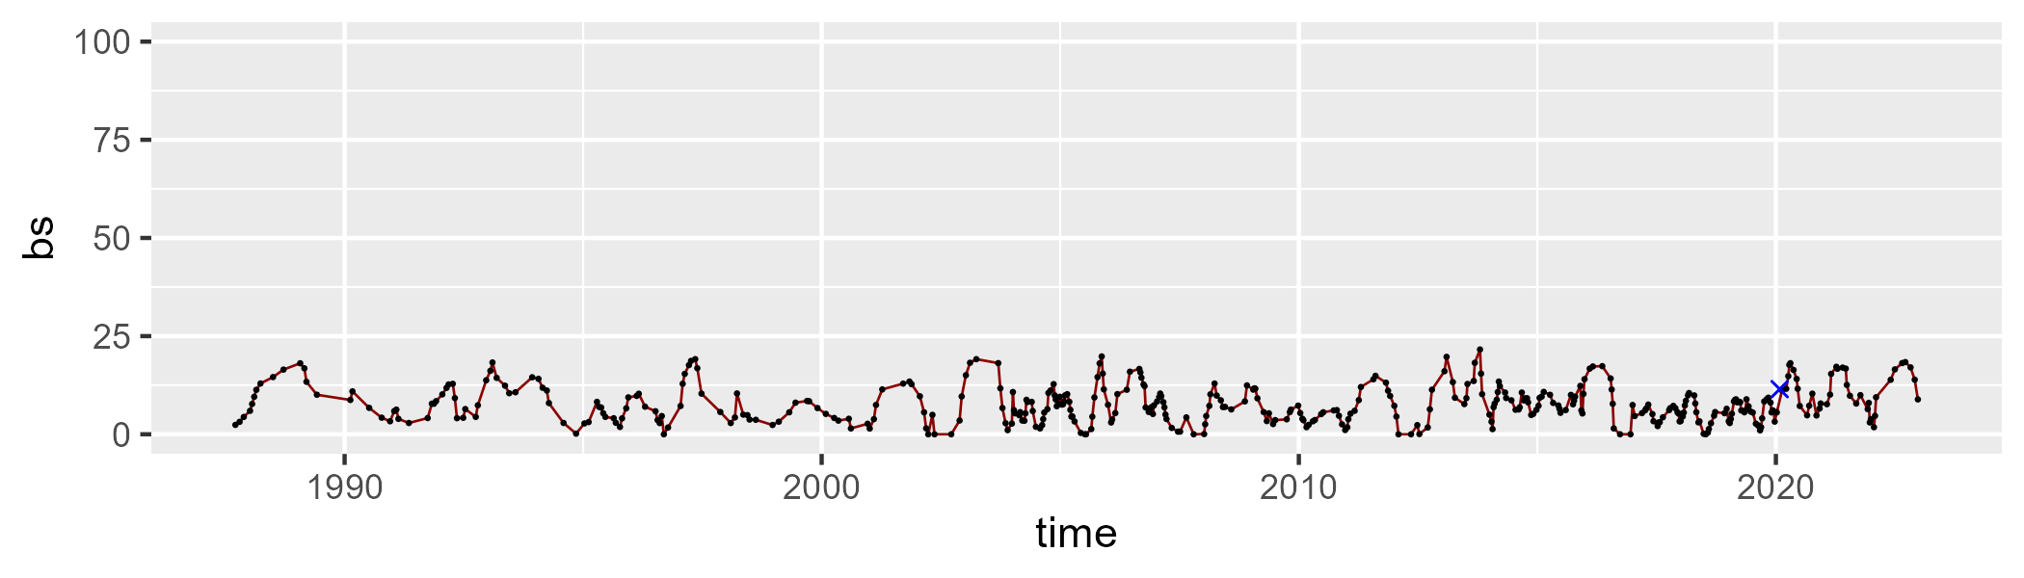

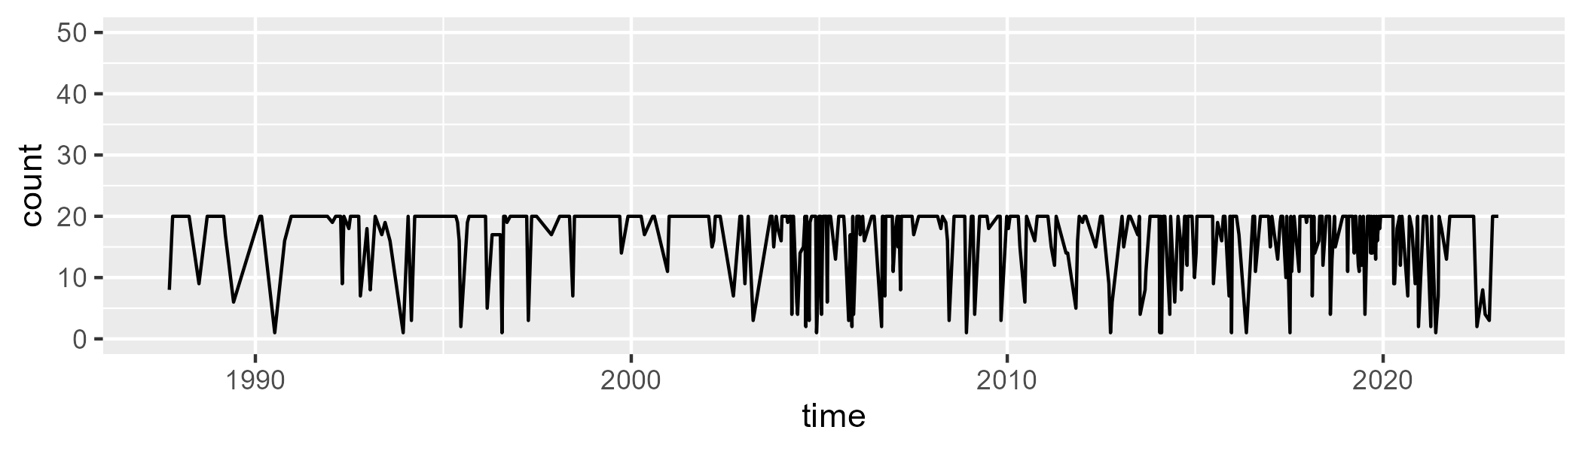

Min. : 1.00 1st Qu.:15.00 Median :20.00 Mean :16.68 3rd Qu.:20.00 Max. :20.00

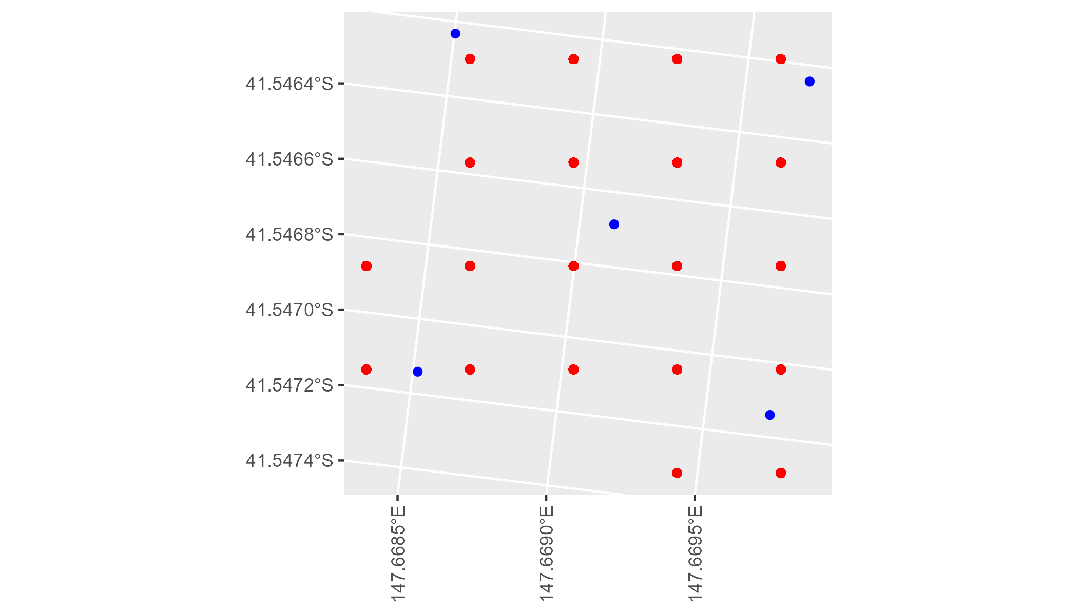

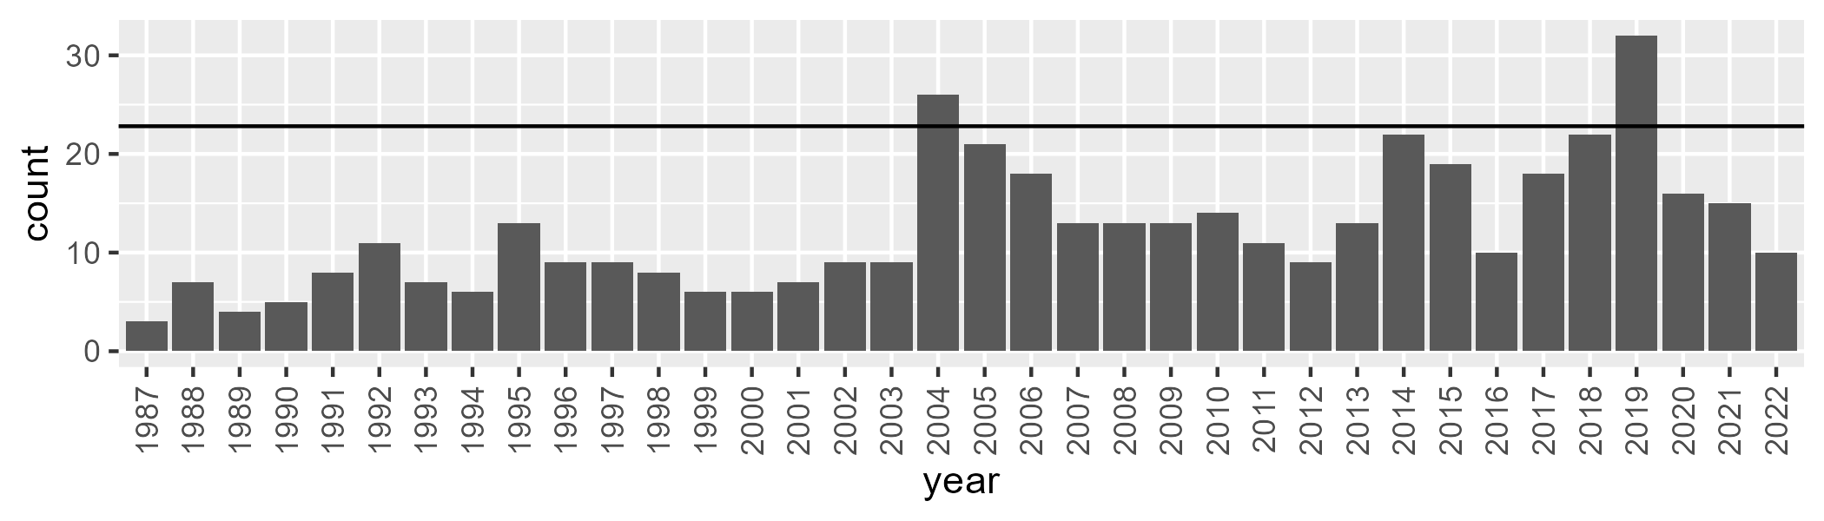

Number of samples: 442

# TCABEL0002

| Min. | 1st Qu. | Median | Mean | 3rd Qu. | Max. |
| --- | --- | --- | --- | --- | --- |
| 26.1431 | 39.37732 | 46.53097 | 49.12802 | 56.01318 | 98.23284 |

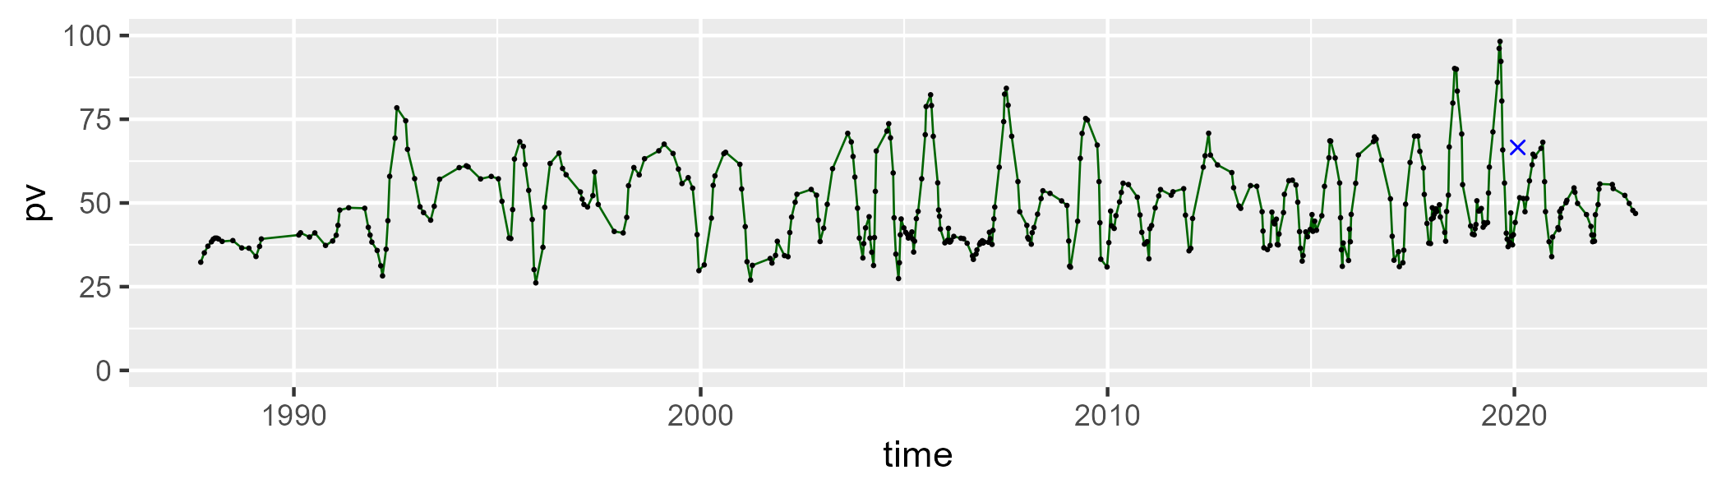

| Min. | 1st Qu. | Median | Mean | 3rd Qu. | Max. |
| --- | --- | --- | --- | --- | --- |
| 9.745225 | 36.29272 | 43.9407 | 41.96106 | 49.15287 | 67.54522 |

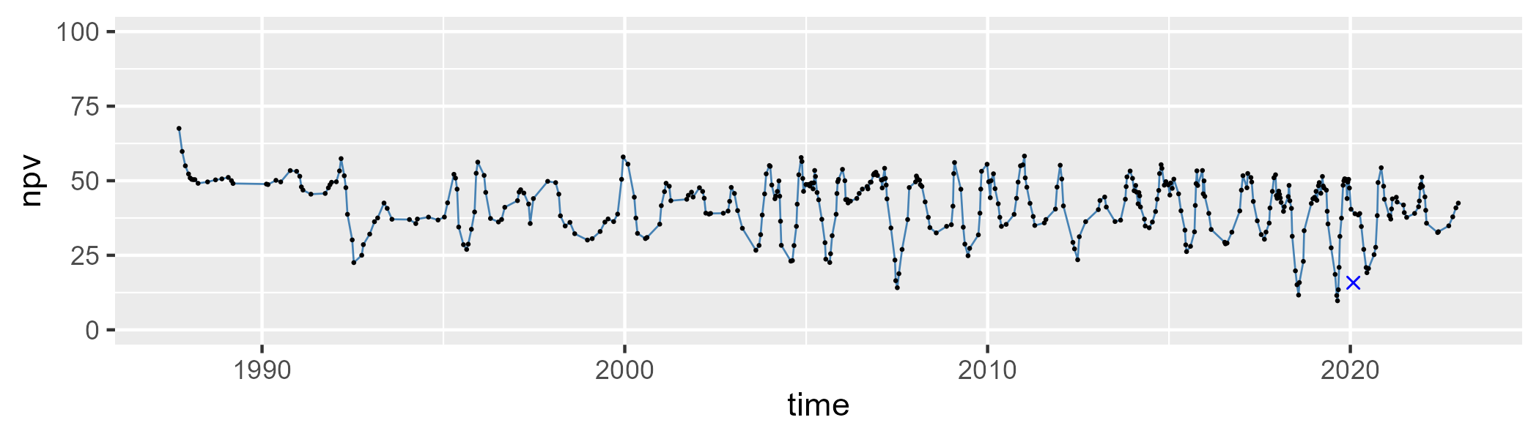

| Min. | 1st Qu. | Median | Mean | 3rd Qu. | Max. |
| --- | --- | --- | --- | --- | --- |
| 0 | 5.526352 | 8.418435 | 8.634291 | 11.1698 | 23.78105 |

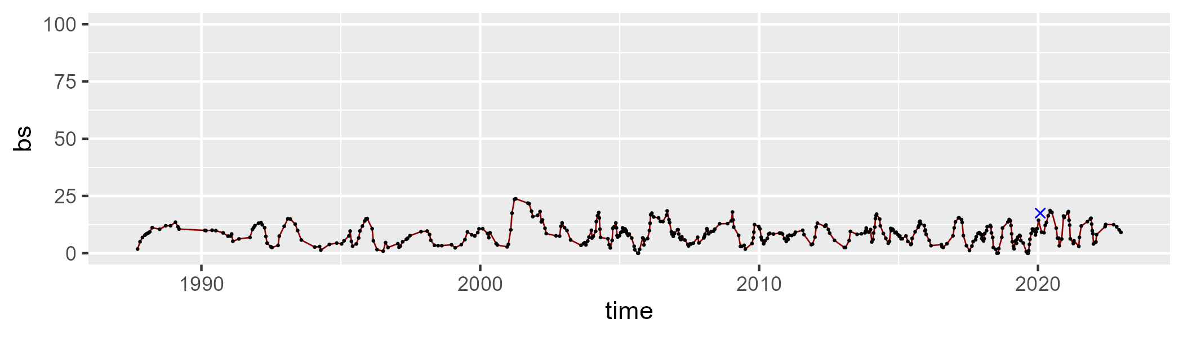

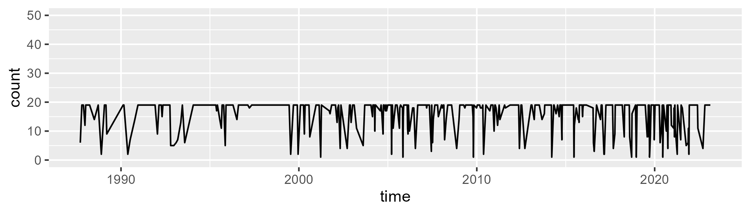

Min. : 1.00 1st Qu.:16.00 Median :19.00 Mean :16.22 3rd Qu.:19.00 Max. :19.00

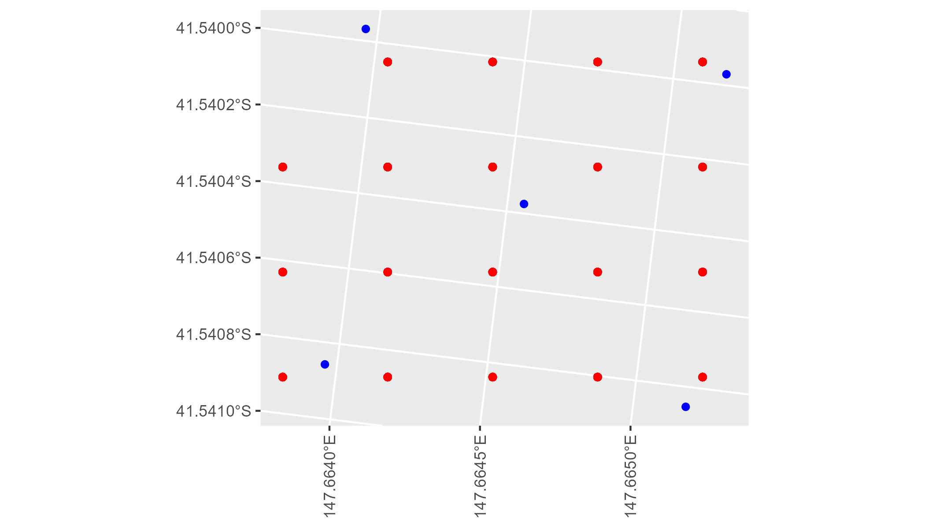

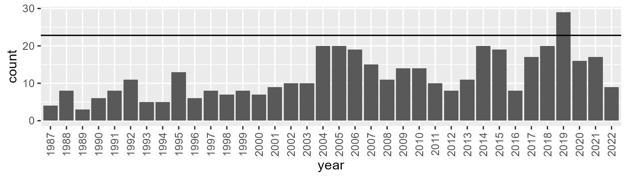

Number of samples: 425

# TCABEL0003

| Min. | 1st Qu. | Median | Mean | 3rd Qu. | Max. |
| --- | --- | --- | --- | --- | --- |
| 34.7852 | 49.54523 | 54.56428 | 55.37244 | 60.32436 | 88.51279 |

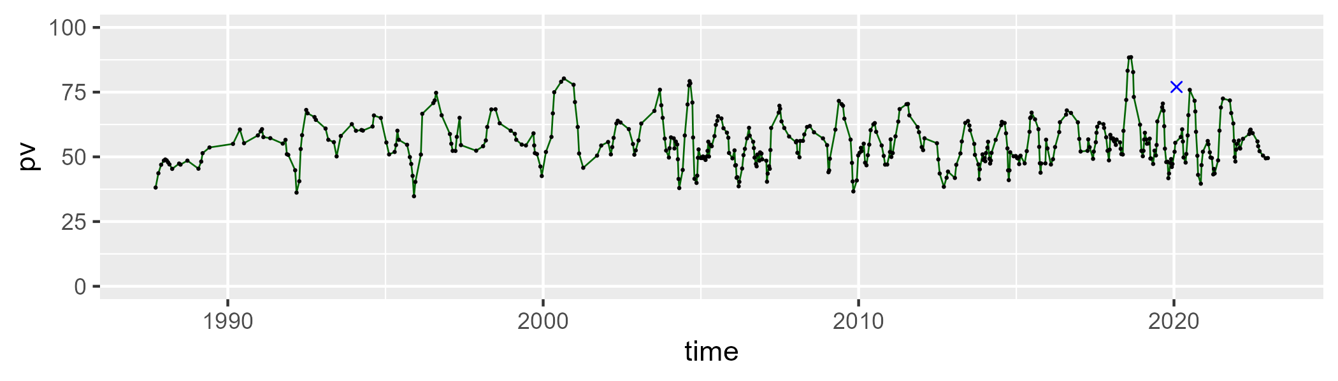

| Min. | 1st Qu. | Median | Mean | 3rd Qu. | Max. |
| --- | --- | --- | --- | --- | --- |
| 13.60799 | 31.17313 | 37.94791 | 36.55109 | 42.3253 | 54.57874 |

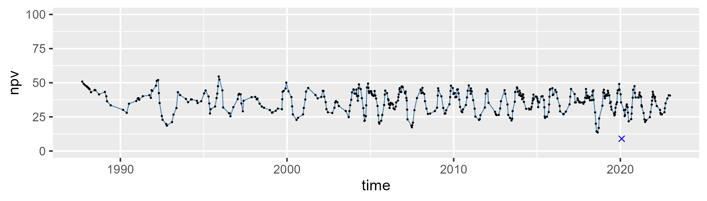

| Min. | 1st Qu. | Median | Mean | 3rd Qu. | Max. |
| --- | --- | --- | --- | --- | --- |
| 0 | 4.012044 | 6.824435 | 7.760824 | 10.85147 | 34.03756 |

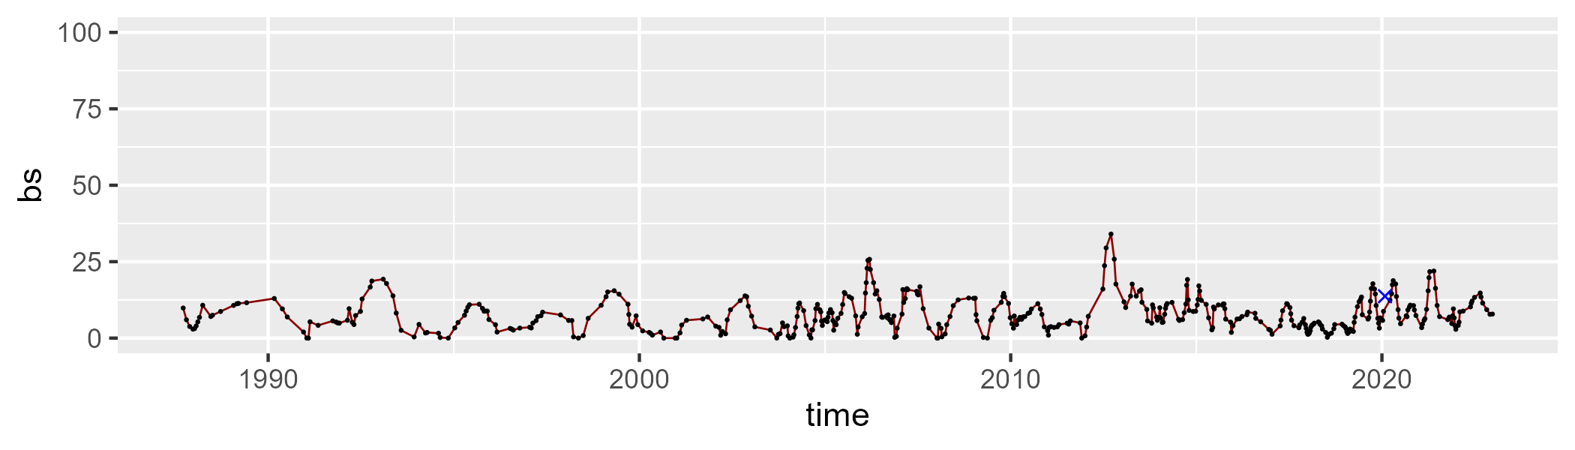

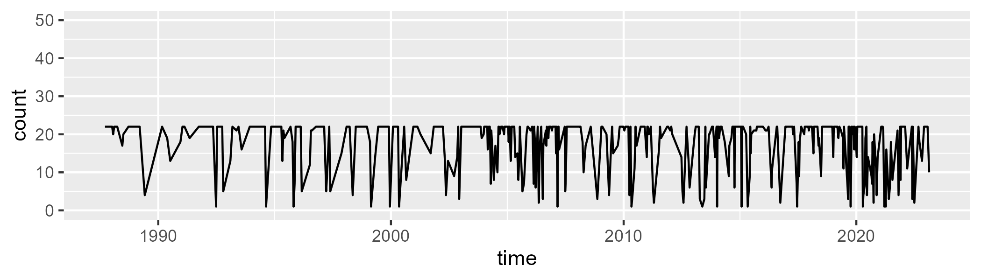

Min. : 1.00 1st Qu.:15.50 Median :22.00 Mean :17.75 3rd Qu.:22.00 Max. :22.00

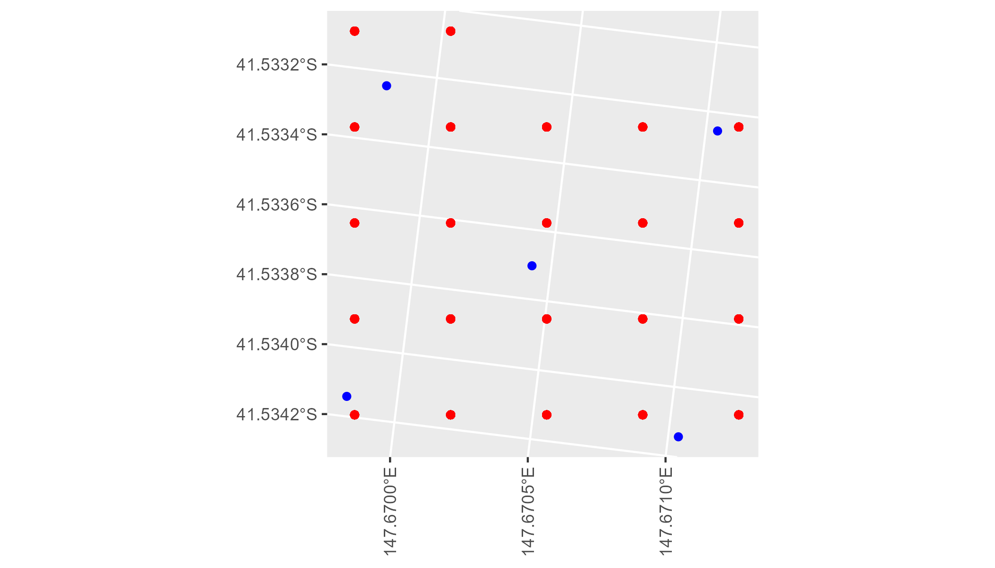

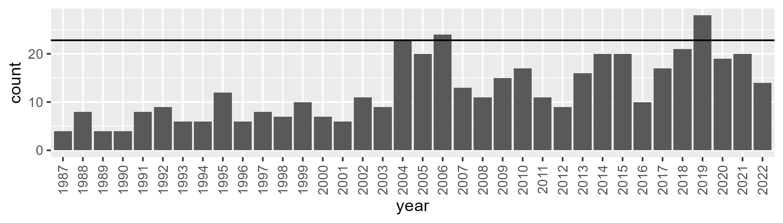

Number of samples: 453

# TCATCH0001

| Min. | 1st Qu. | Median | Mean | 3rd Qu. | Max. |
| --- | --- | --- | --- | --- | --- |
| 32.49757 | 43.82043 | 47.09867 | 47.27257 | 50.09299 | 80.06731 |

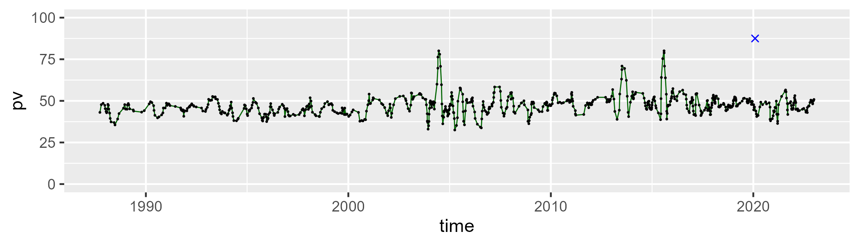

| Min. | 1st Qu. | Median | Mean | 3rd Qu. | Max. |
| --- | --- | --- | --- | --- | --- |
| 6.408781 | 30.42268 | 37.31469 | 35.10242 | 40.69897 | 53.48444 |

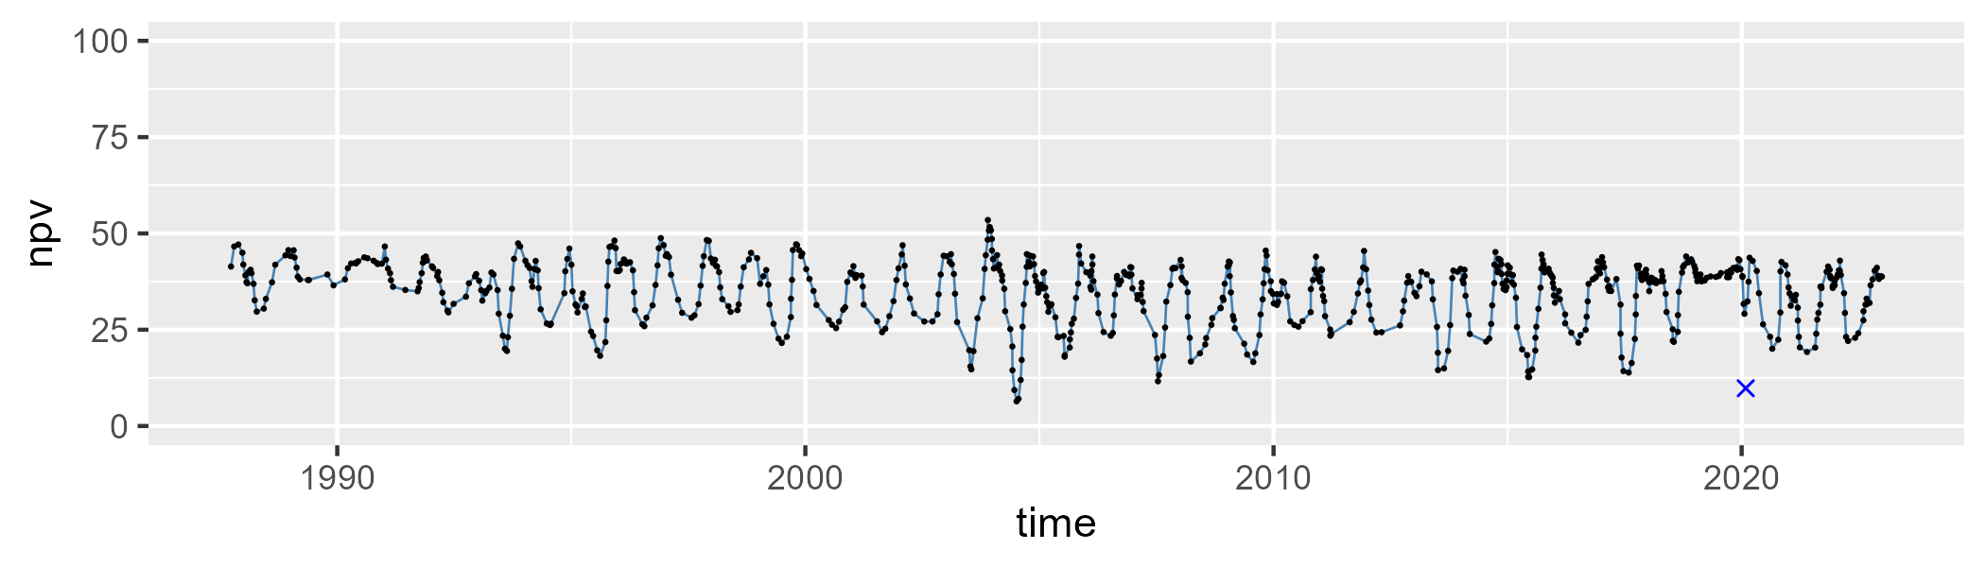

| Min. | 1st Qu. | Median | Mean | 3rd Qu. | Max. |
| --- | --- | --- | --- | --- | --- |
| 0 | 9.979199 | 14.58653 | 16.46587 | 21.07785 | 41.72833 |

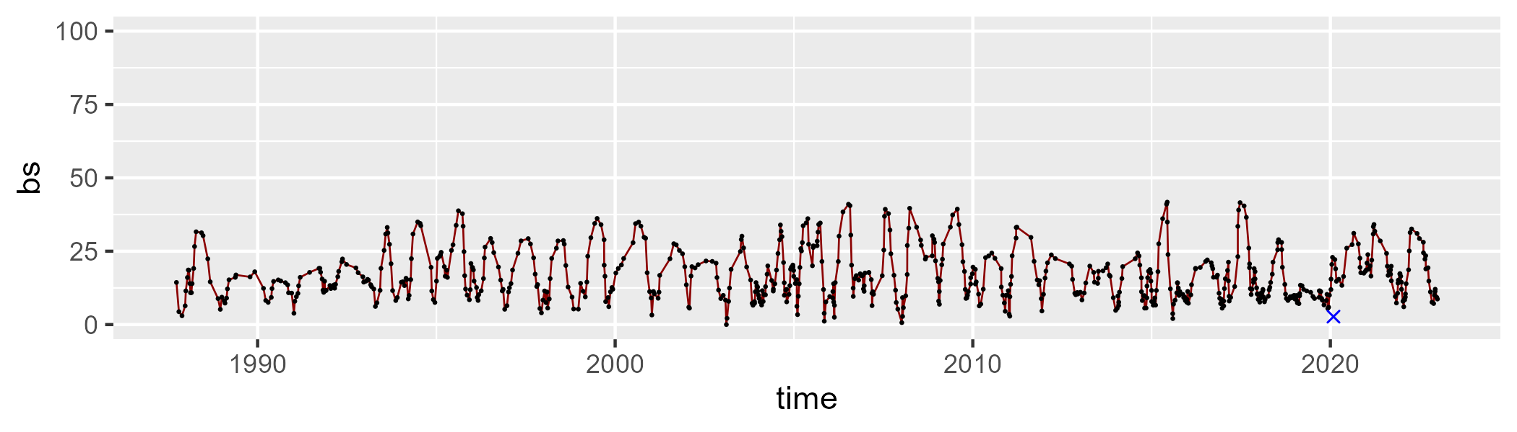

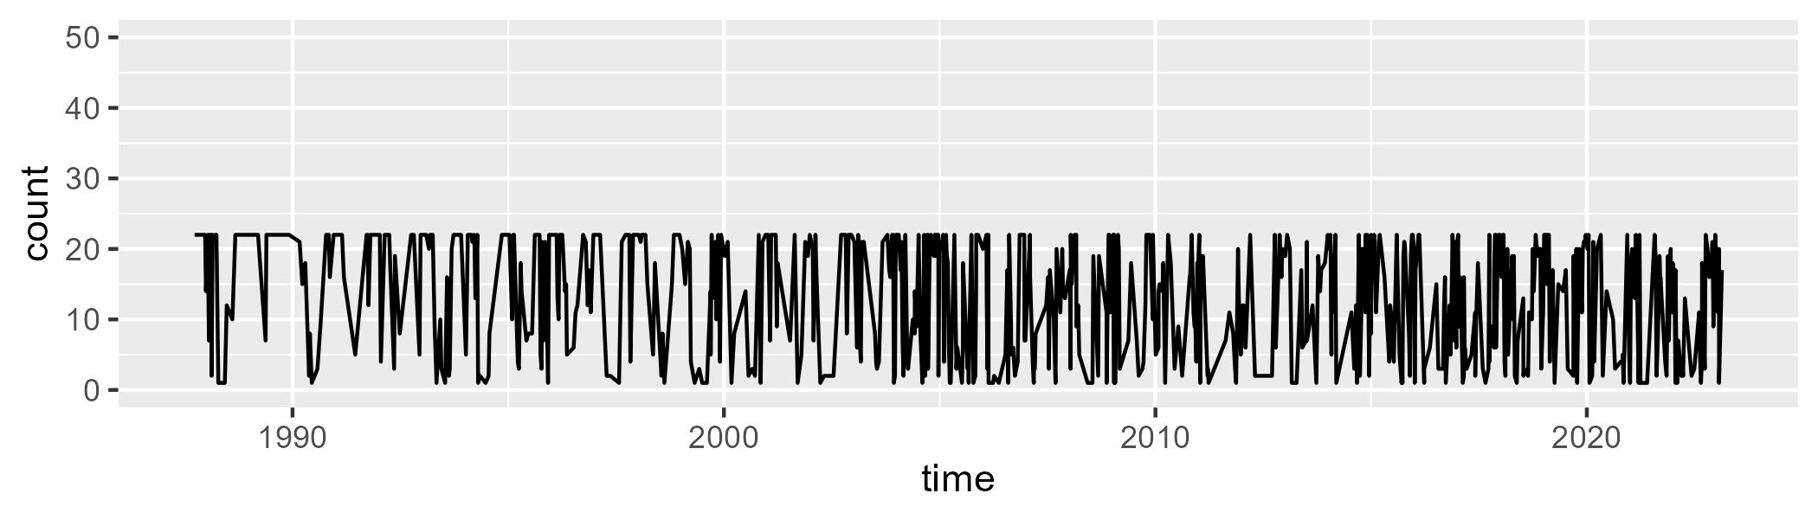

Min. : 1.00 1st Qu.: 5.00 Median :16.00 Mean :13.43 3rd Qu.:22.00 Max. :22.00

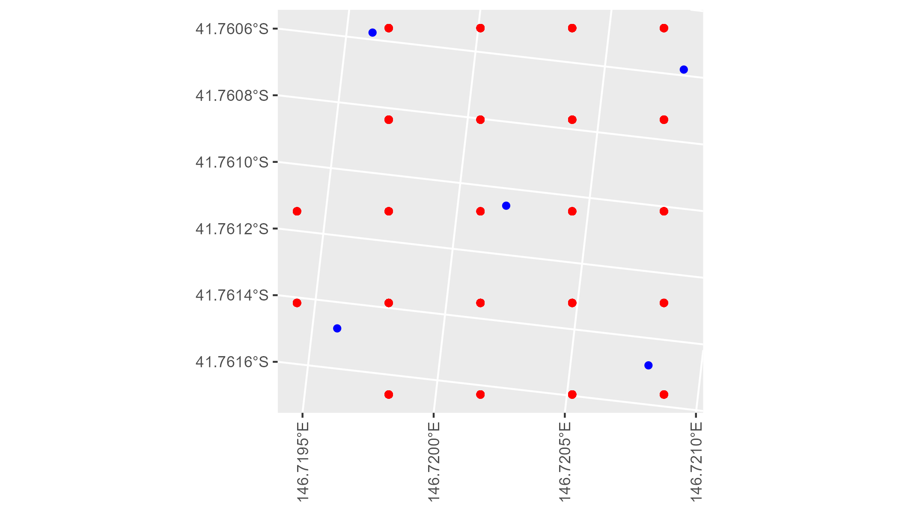

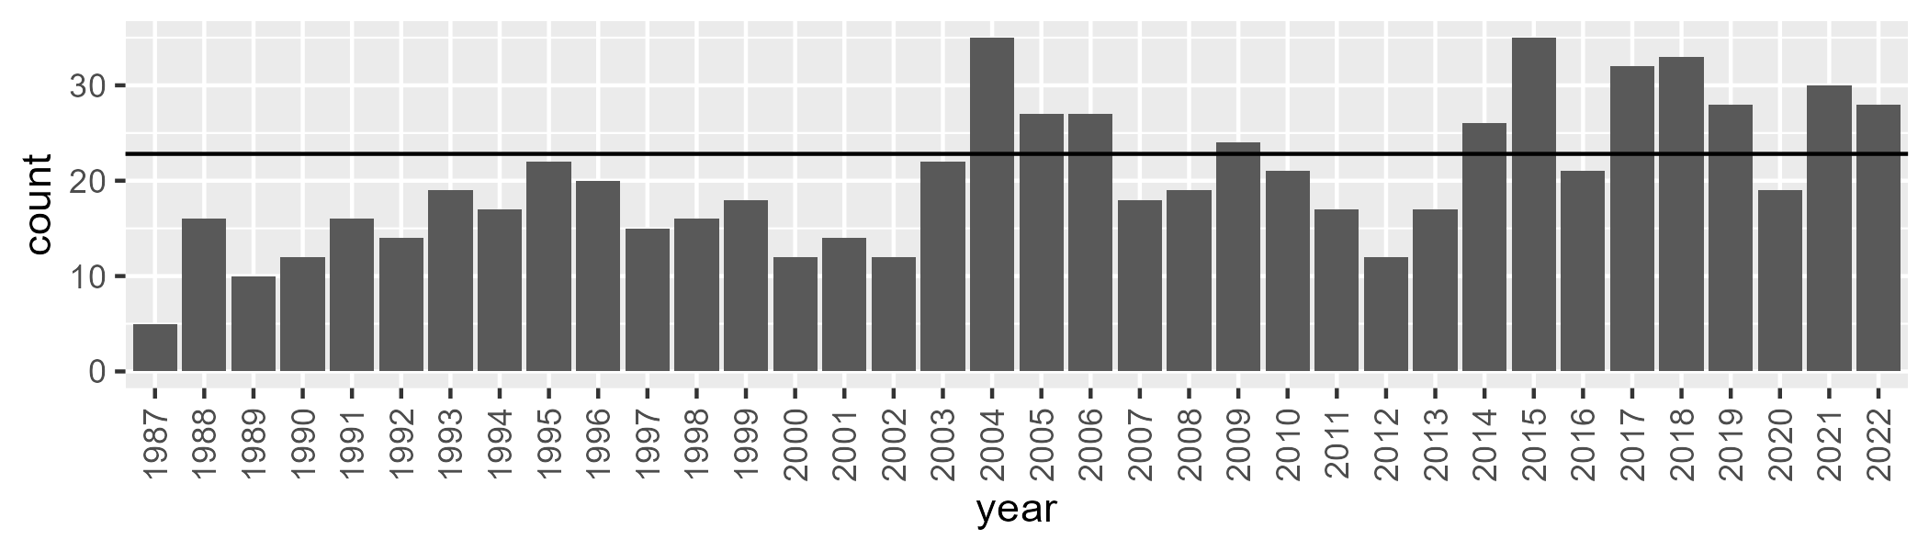

Number of samples: 729

# TCATCH0002

| Min. | 1st Qu. | Median | Mean | 3rd Qu. | Max. |
| --- | --- | --- | --- | --- | --- |
| 16.66313 | 33.94145 | 38.68608 | 39.2145 | 43.43777 | 94.48951 |

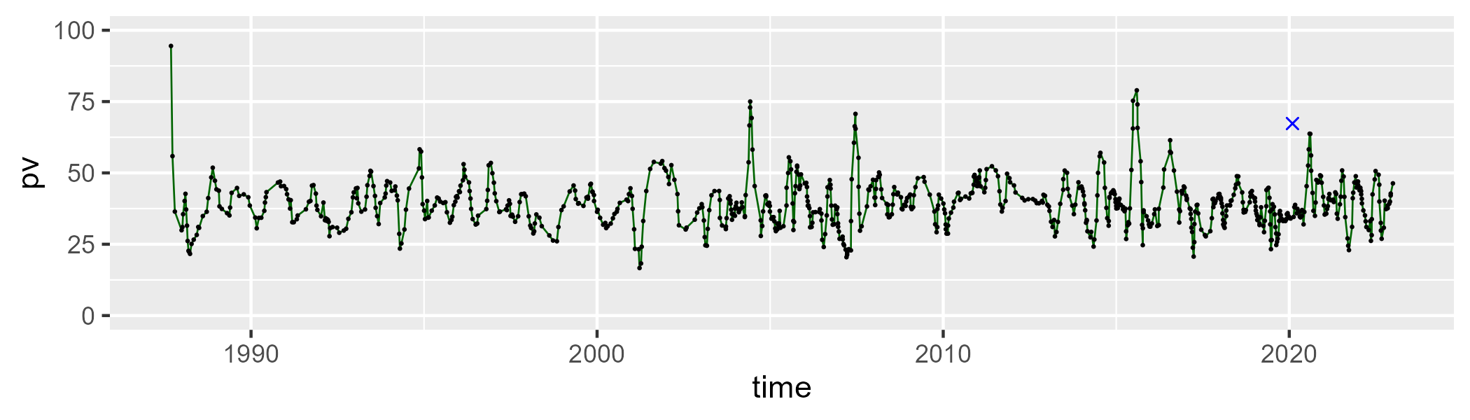

| Min. | 1st Qu. | Median | Mean | 3rd Qu. | Max. |
| --- | --- | --- | --- | --- | --- |
| 13.24782 | 46.79167 | 51.00444 | 50.28112 | 54.67523 | 68.45682 |

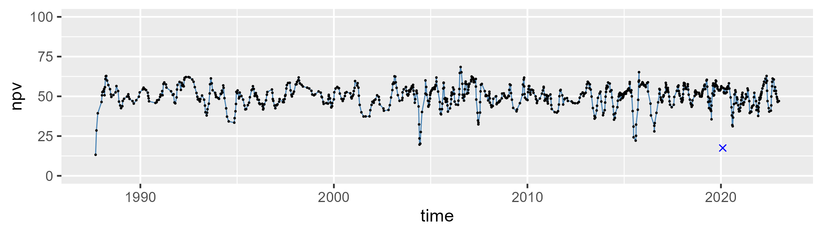

| Min. | 1st Qu. | Median | Mean | 3rd Qu. | Max. |
| --- | --- | --- | --- | --- | --- |
| 0 | 6.375216 | 8.831588 | 9.608636 | 11.94412 | 34.30236 |

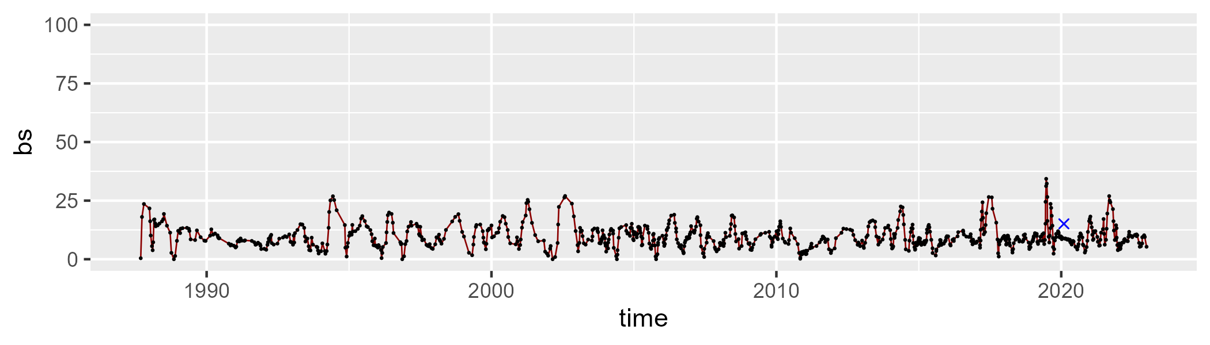

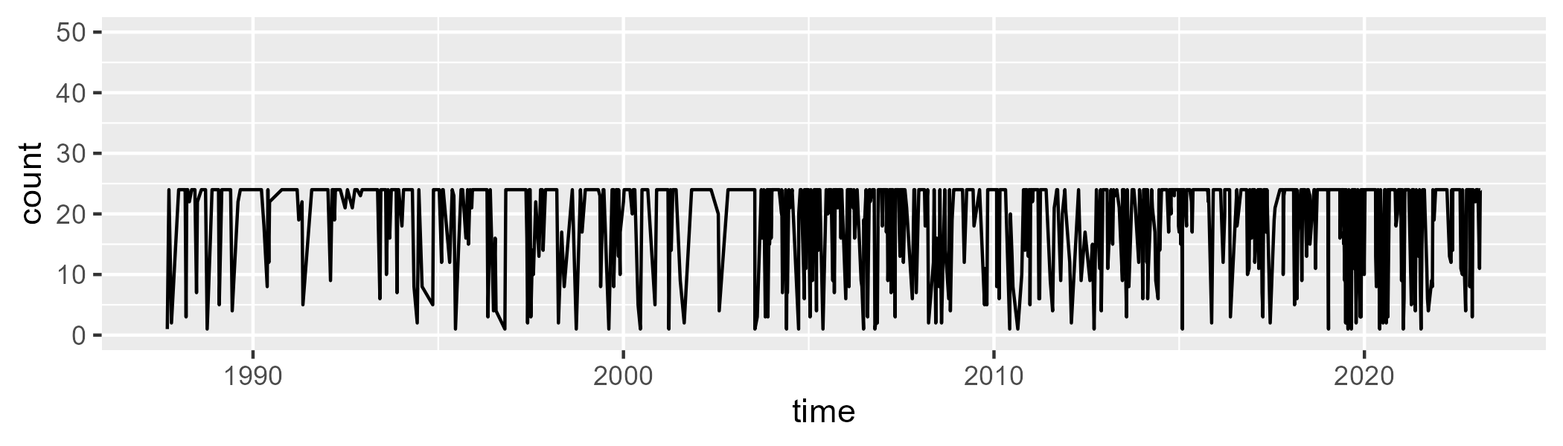

Min. : 1.00 1st Qu.:17.00 Median :24.00 Mean :19.58 3rd Qu.:24.00 Max. :24.00

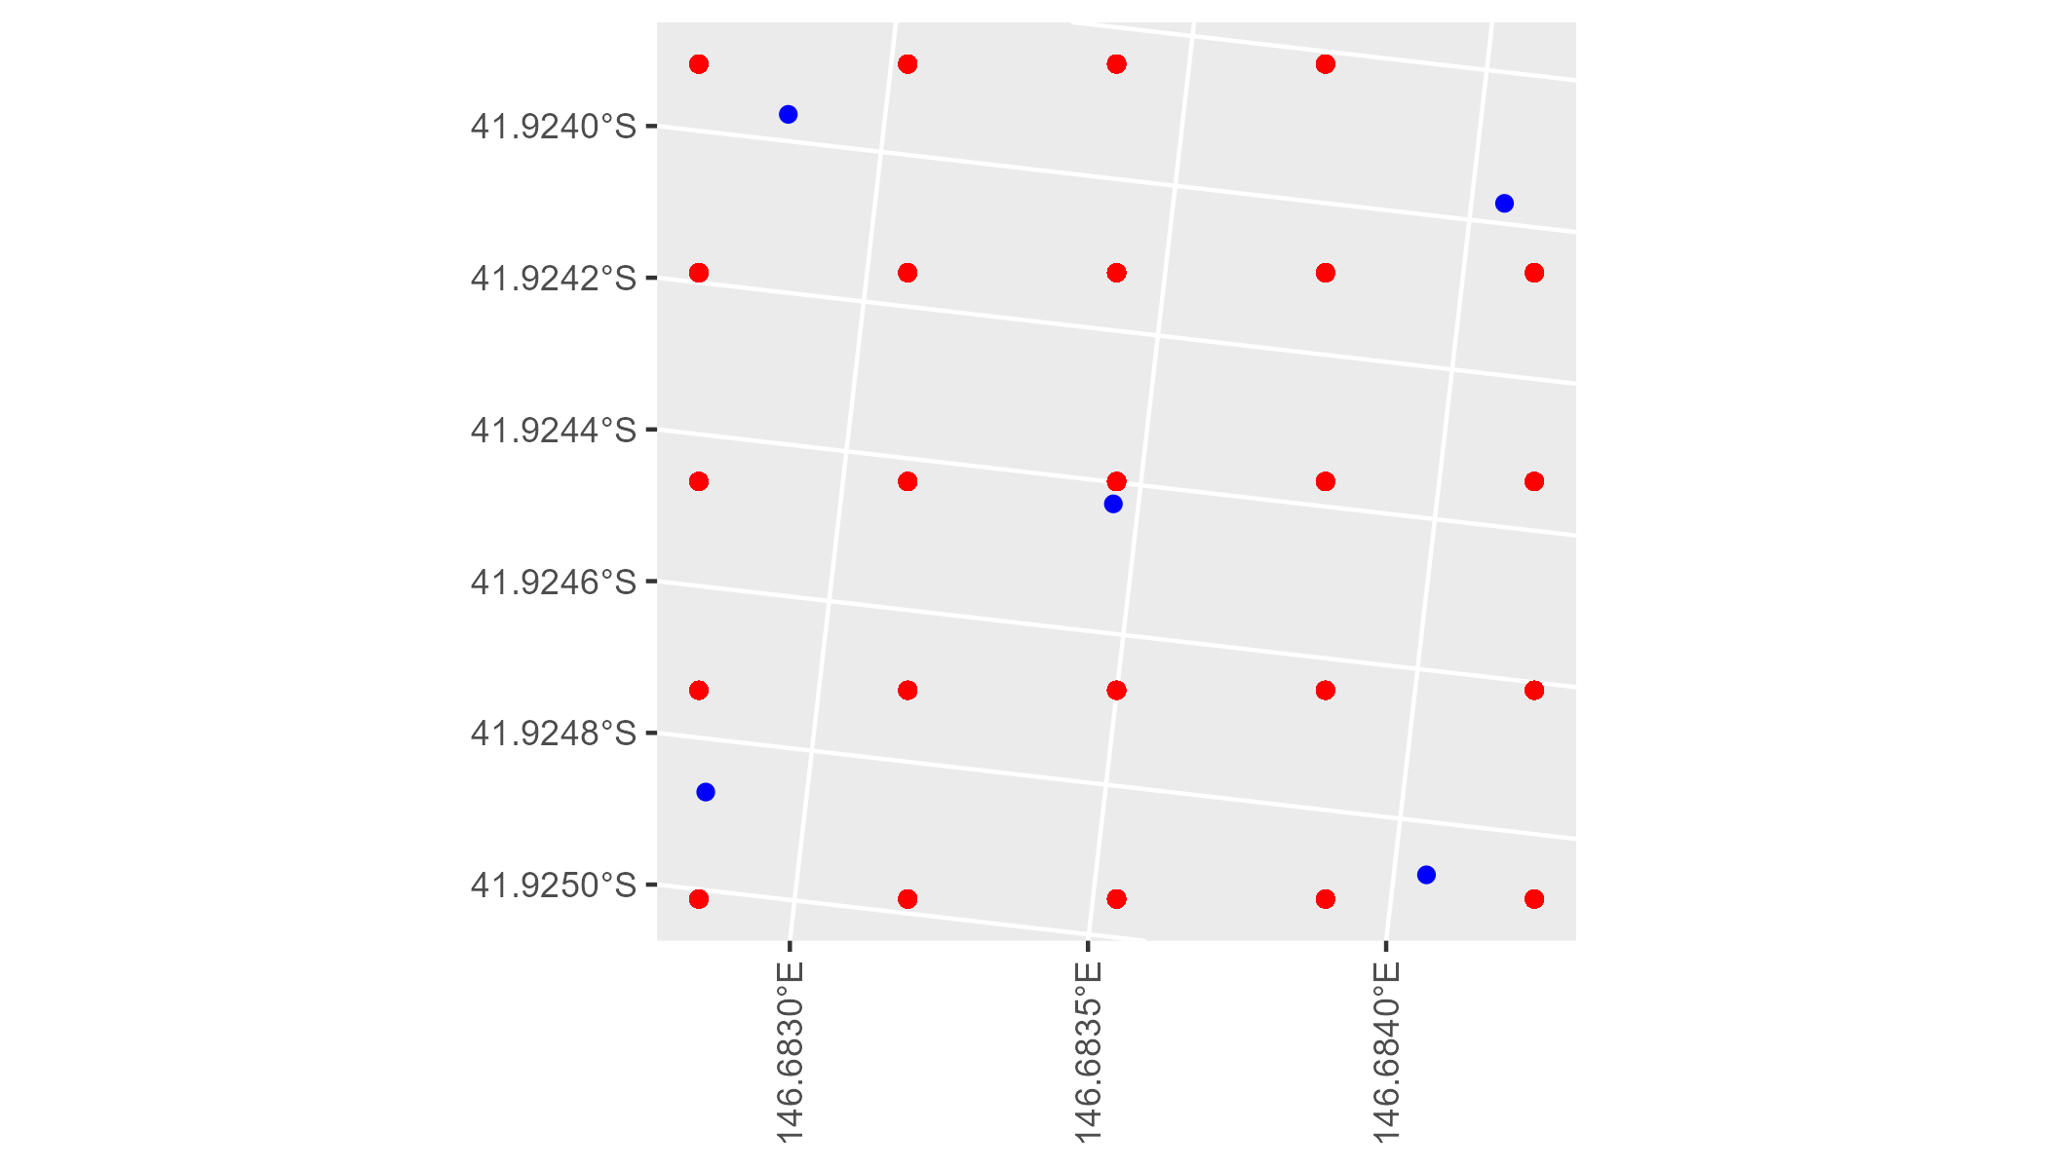

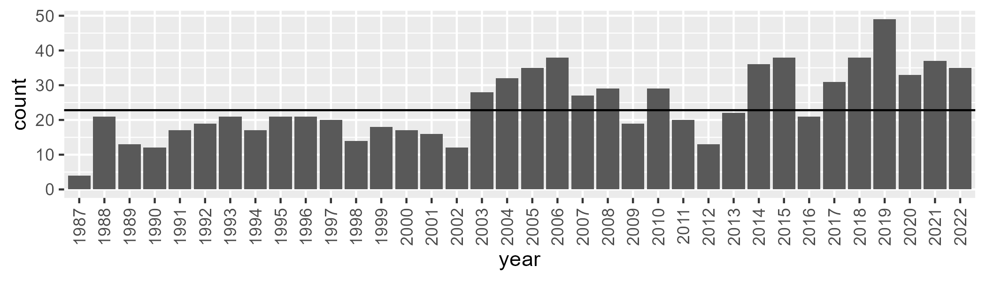

Number of samples: 873

# TCATCH0003

| Min. | 1st Qu. | Median | Mean | 3rd Qu. | Max. |
| --- | --- | --- | --- | --- | --- |
| 21.13225 | 37.83701 | 42.56405 | 42.49878 | 47.11241 | 64.66738 |

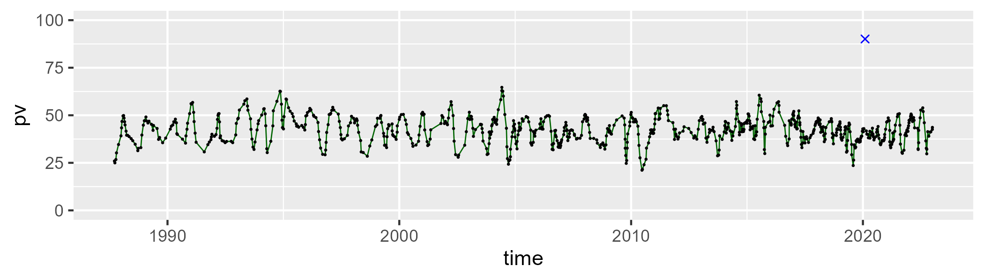

| Min. | 1st Qu. | Median | Mean | 3rd Qu. | Max. |
| --- | --- | --- | --- | --- | --- |
| 13.47194 | 40.78737 | 45.62902 | 44.37624 | 48.90321 | 63.34958 |

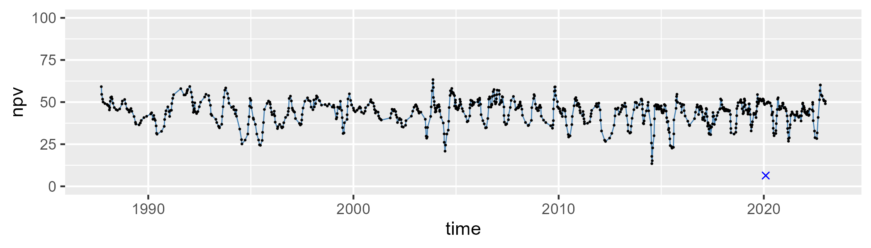

| Min. | 1st Qu. | Median | Mean | 3rd Qu. | Max. |
| --- | --- | --- | --- | --- | --- |
| 0 | 5.891788 | 10.49953 | 12.24387 | 17.35868 | 47.87116 |

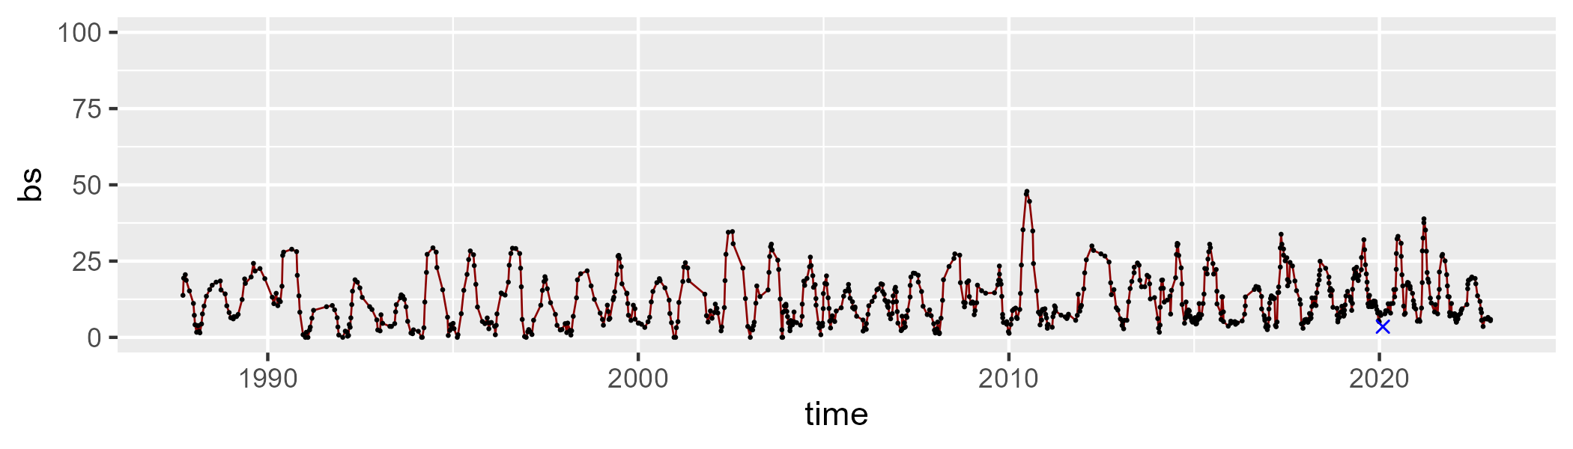

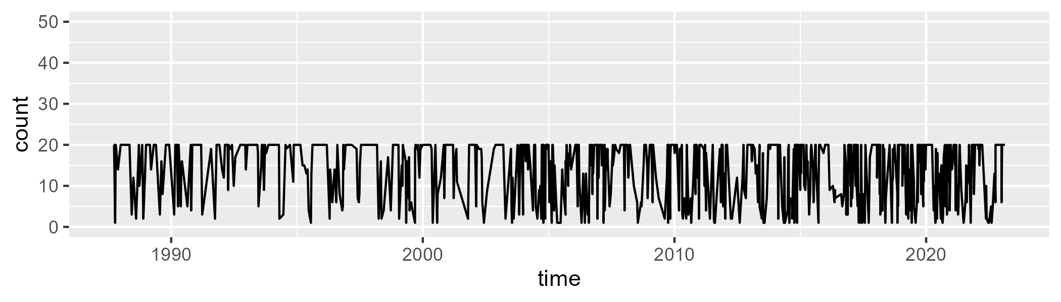

Min. : 1.00 1st Qu.: 8.00 Median :19.00 Mean :14.33 3rd Qu.:20.00 Max. :20.00

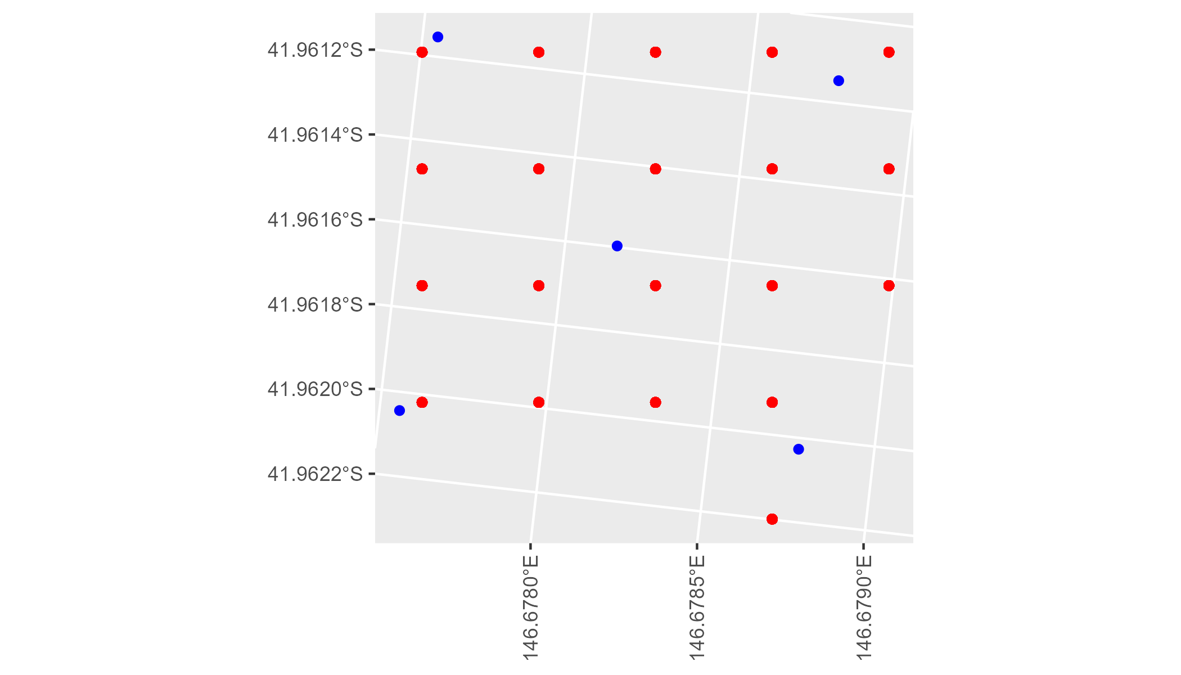

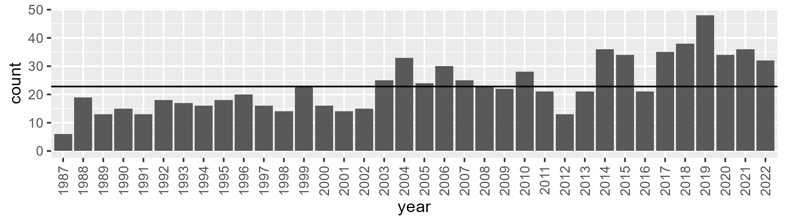

Number of samples: 832

# TCATCH0004

| Min. | 1st Qu. | Median | Mean | 3rd Qu. | Max. |
| --- | --- | --- | --- | --- | --- |
| 0 | 26.84282 | 34.20176 | 33.86226 | 39.67701 | 78.153 |

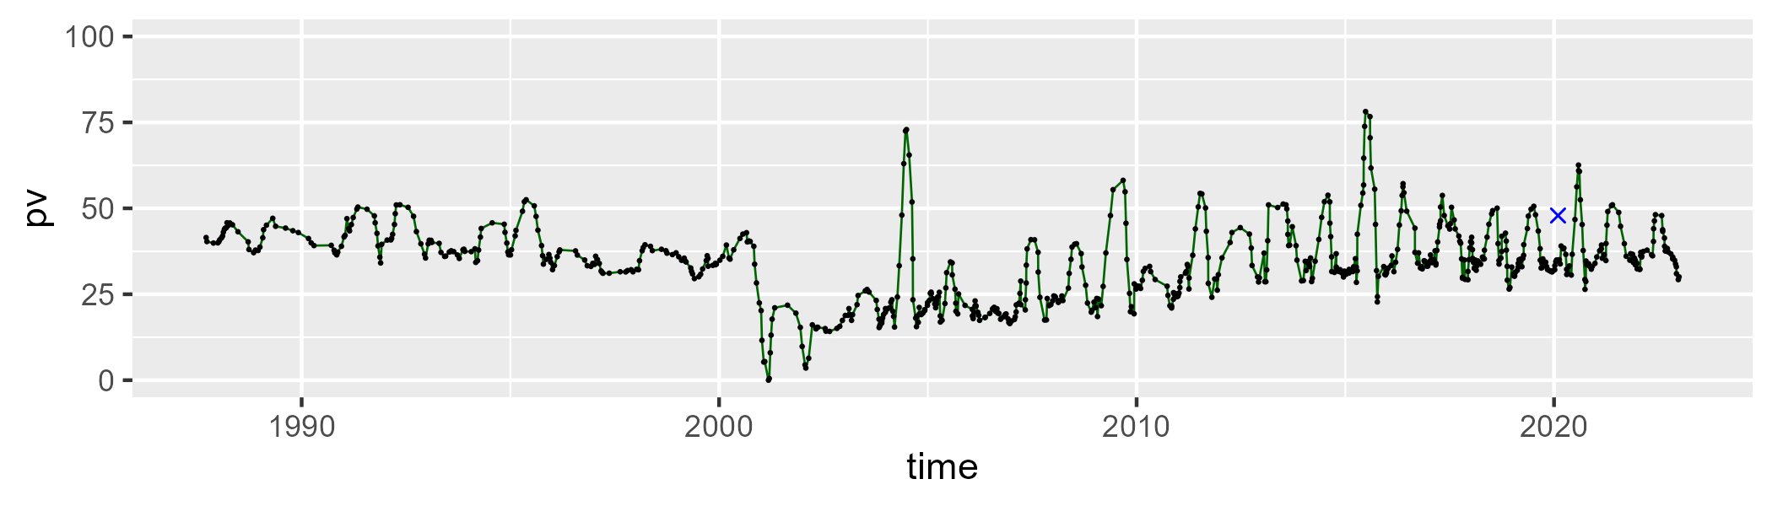

| Min. | 1st Qu. | Median | Mean | 3rd Qu. | Max. |
| --- | --- | --- | --- | --- | --- |
| 6.048281 | 40.0131 | 48.71747 | 45.93798 | 53.64615 | 64.41216 |

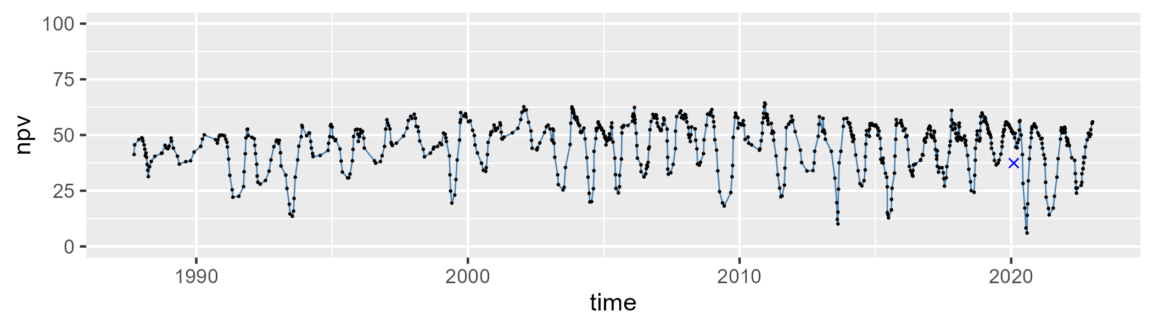

| Min. | 1st Qu. | Median | Mean | 3rd Qu. | Max. |
| --- | --- | --- | --- | --- | --- |
| 0.9971205 | 12.87522 | 16.88096 | 19.22174 | 23.75802 | 49.8357 |

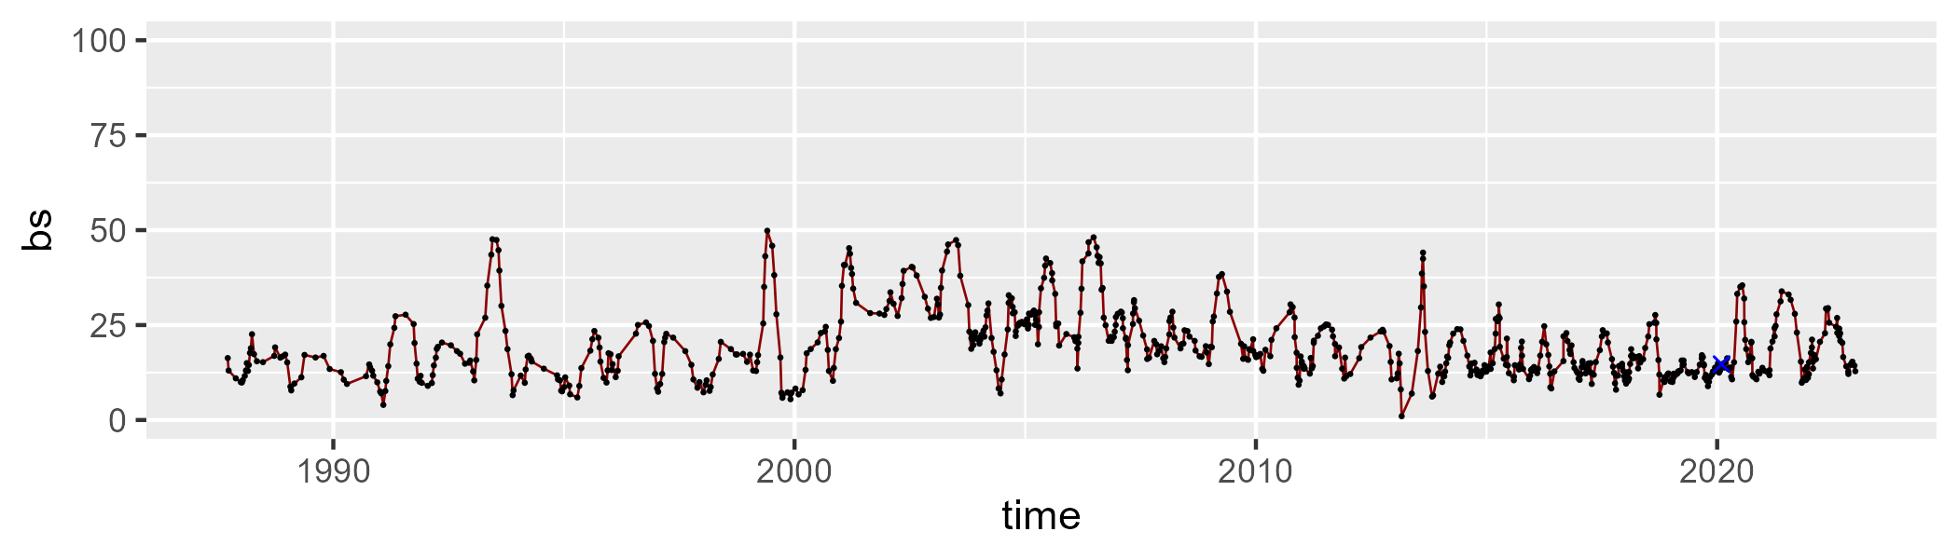

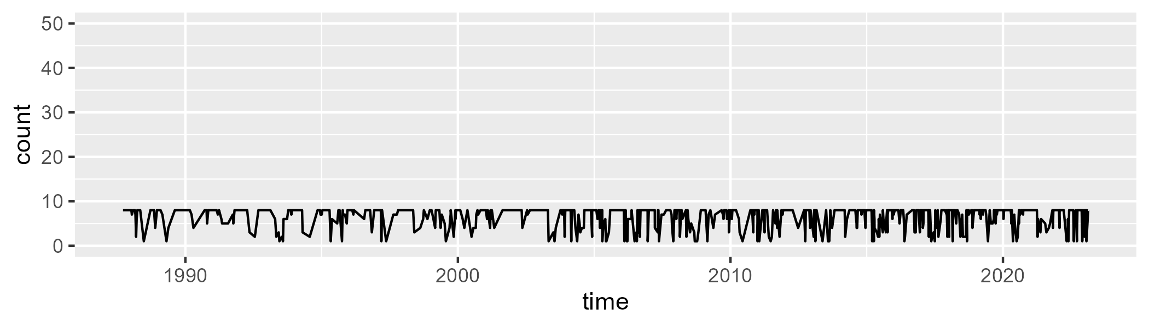

Min. :1.000 1st Qu.:6.000 Median :8.000 Mean :6.584 3rd Qu.:8.000 Max. :8.000

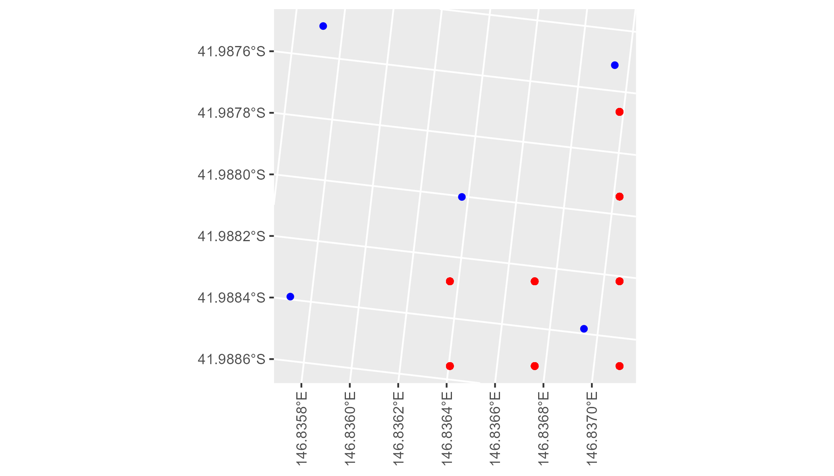

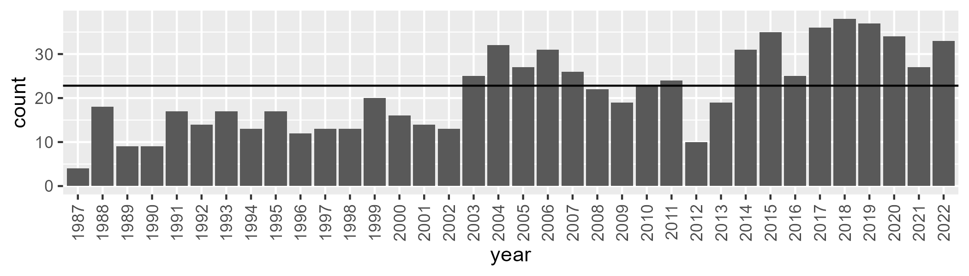

Number of samples: 773

# TCATCH0005

| Min. | 1st Qu. | Median | Mean | 3rd Qu. | Max. |
| --- | --- | --- | --- | --- | --- |
| 0 | 34.02254 | 38.63552 | 38.59231 | 43.16624 | 72.81061 |

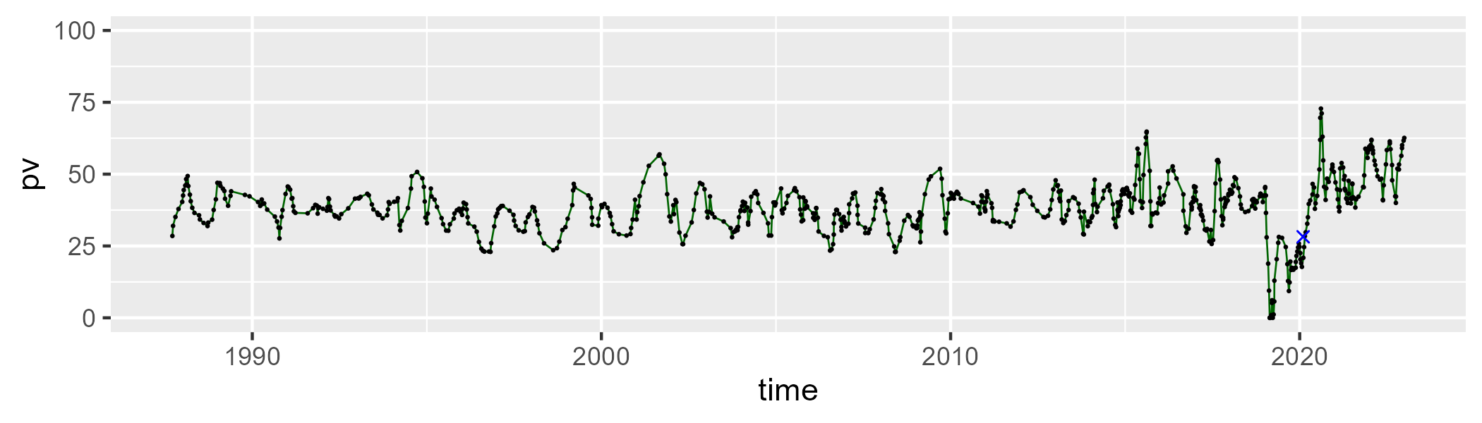

| Min. | 1st Qu. | Median | Mean | 3rd Qu. | Max. |
| --- | --- | --- | --- | --- | --- |
| 17.66029 | 39.05935 | 46.93176 | 44.39301 | 50.88886 | 65.99881 |

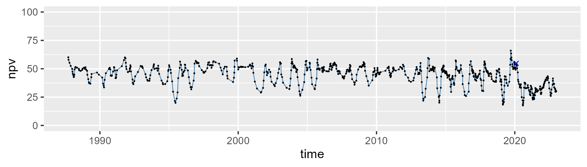

| Min. | 1st Qu. | Median | Mean | 3rd Qu. | Max. |
| --- | --- | --- | --- | --- | --- |
| 0.5588778 | 9.221901 | 13.47694 | 16.07228 | 20.03339 | 83.09173 |

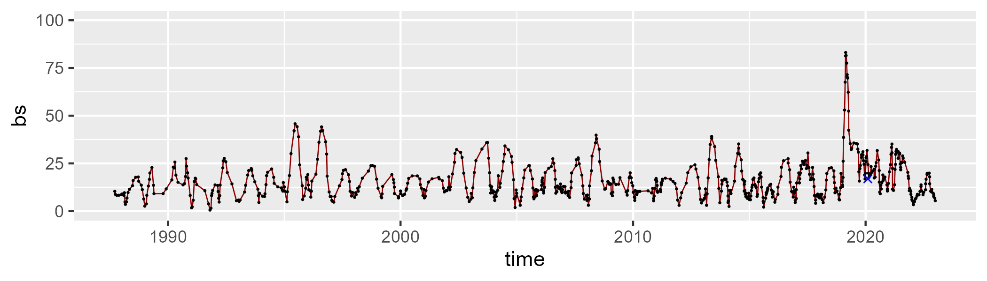

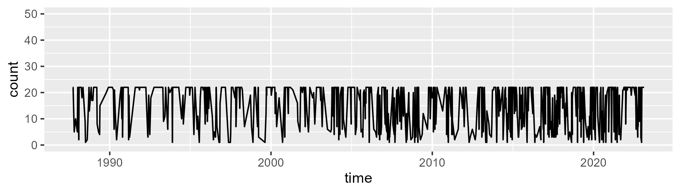

Min. : 1.00 1st Qu.: 8.00 Median :20.00 Mean :15.49 3rd Qu.:22.00 Max. :22.00

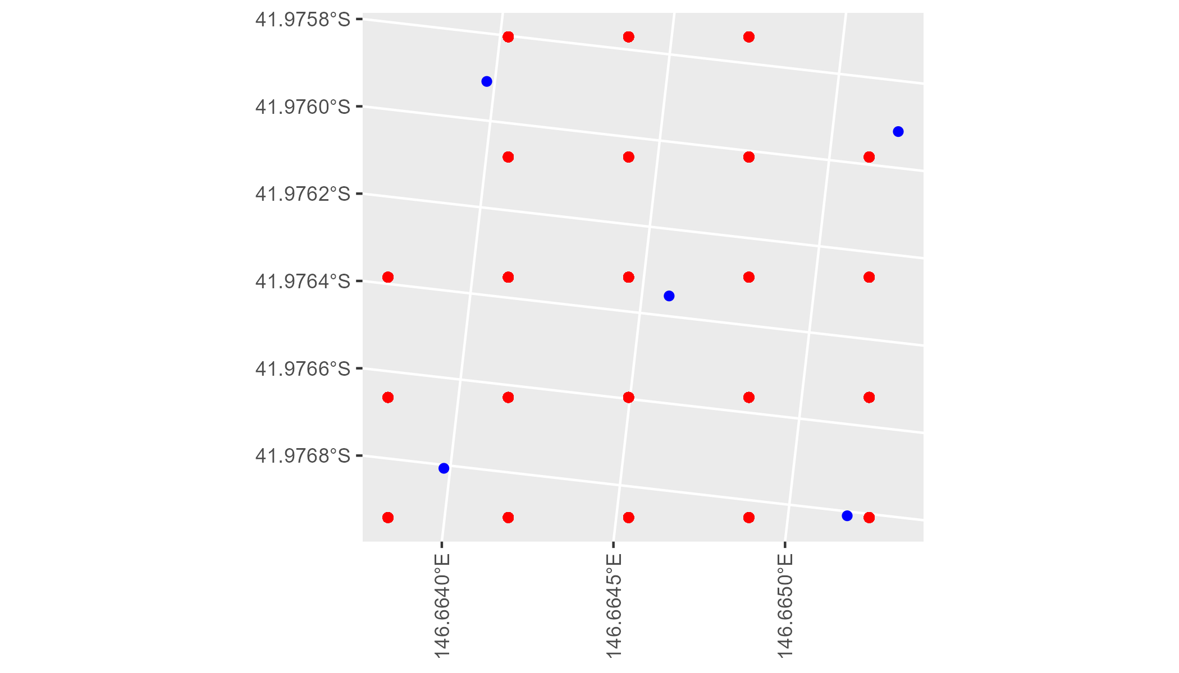

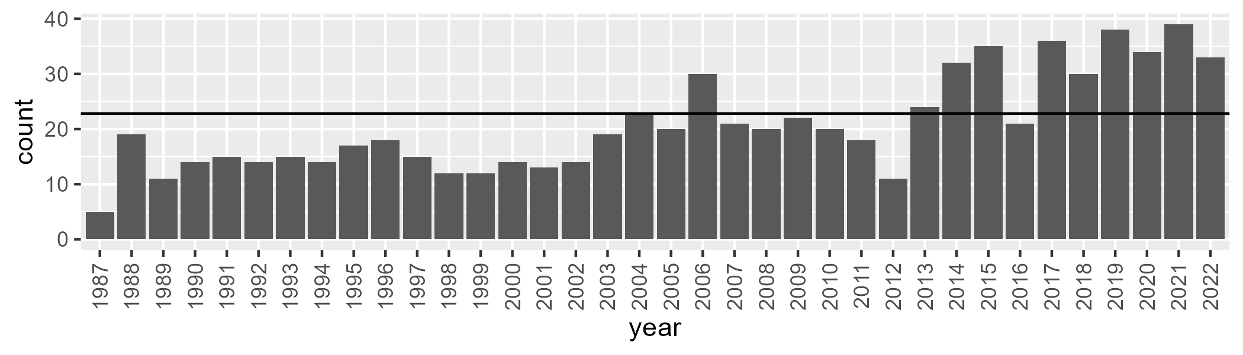

Number of samples: 748

# TCATCH0006

| Min. | 1st Qu. | Median | Mean | 3rd Qu. | Max. |
| --- | --- | --- | --- | --- | --- |
| 19.66624 | 39.40922 | 45.51468 | 46.02979 | 52.05818 | 93.68423 |

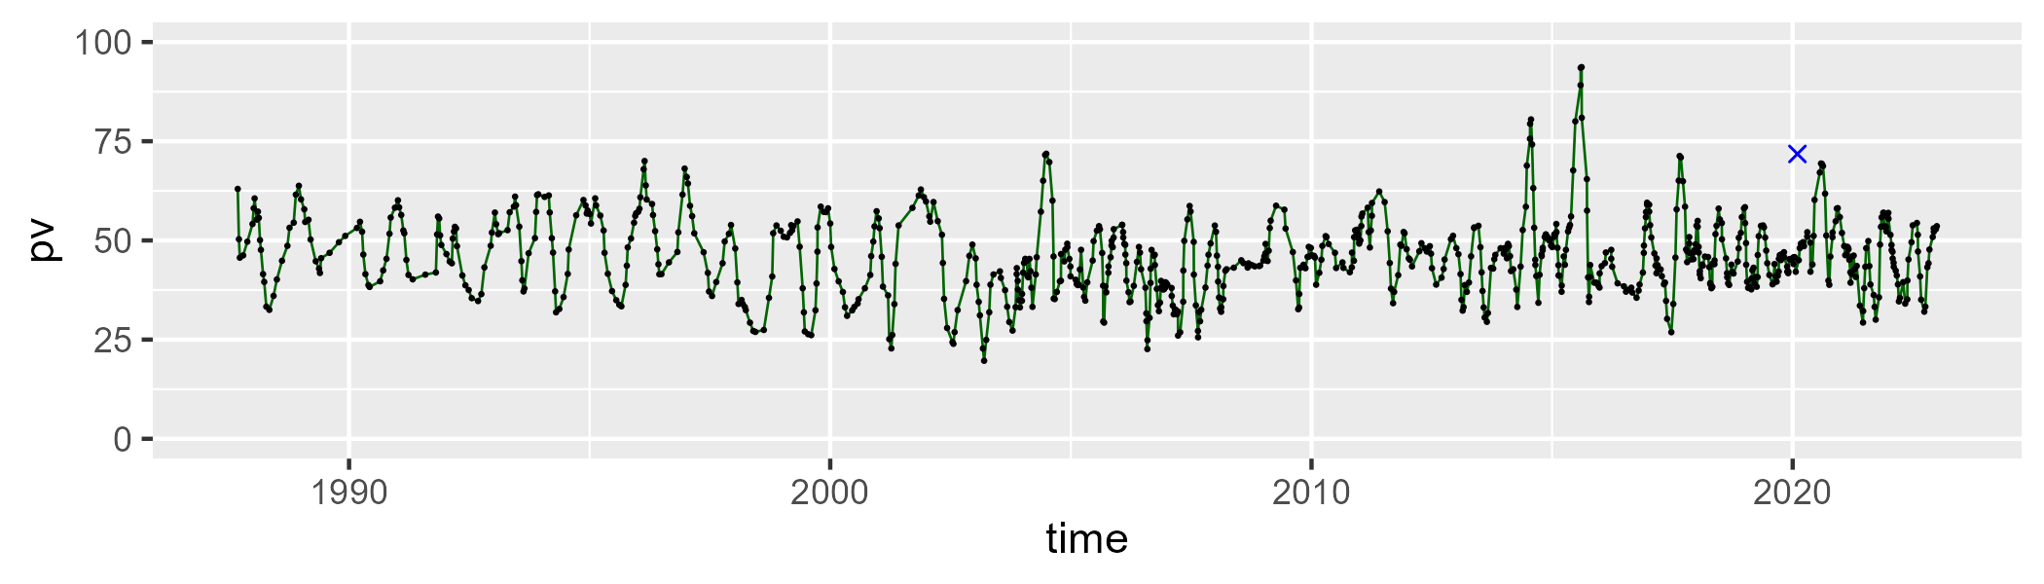

| Min. | 1st Qu. | Median | Mean | 3rd Qu. | Max. |
| --- | --- | --- | --- | --- | --- |
| 7.550503 | 40.28185 | 45.51788 | 45.52246 | 51.06364 | 69.1191 |

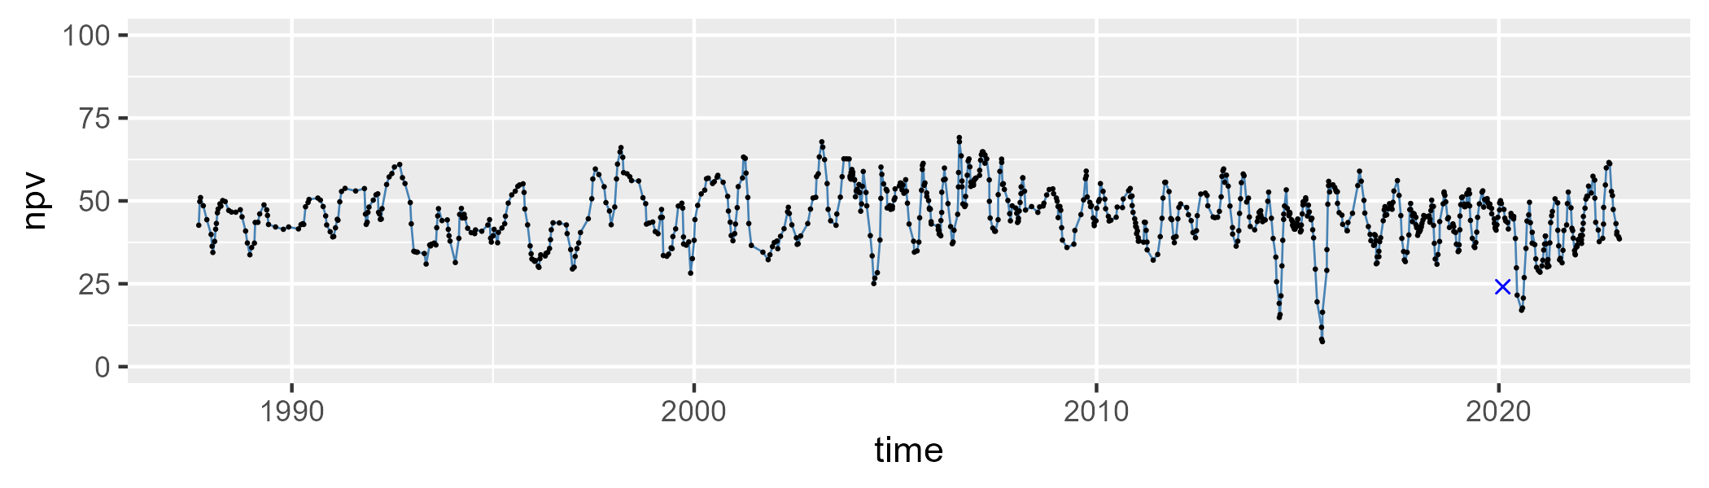

| Min. | 1st Qu. | Median | Mean | 3rd Qu. | Max. |
| --- | --- | --- | --- | --- | --- |
| 0 | 3.860213 | 6.46859 | 7.594421 | 9.867285 | 37.80649 |

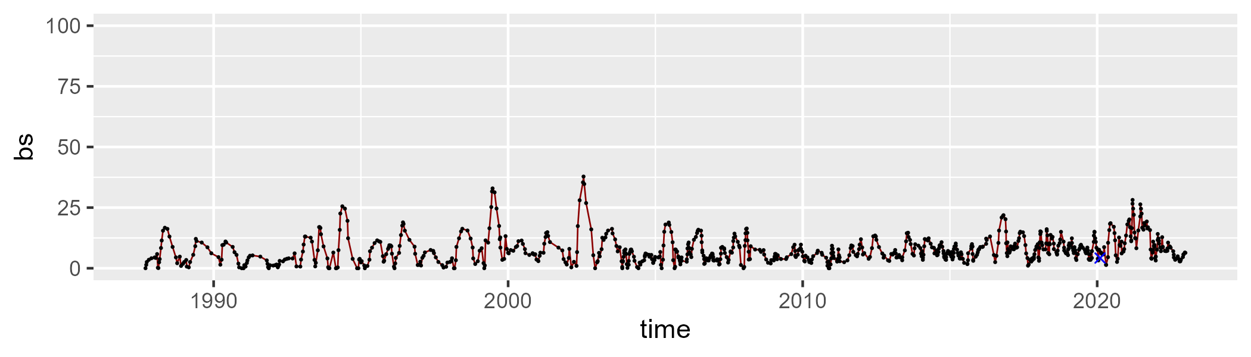

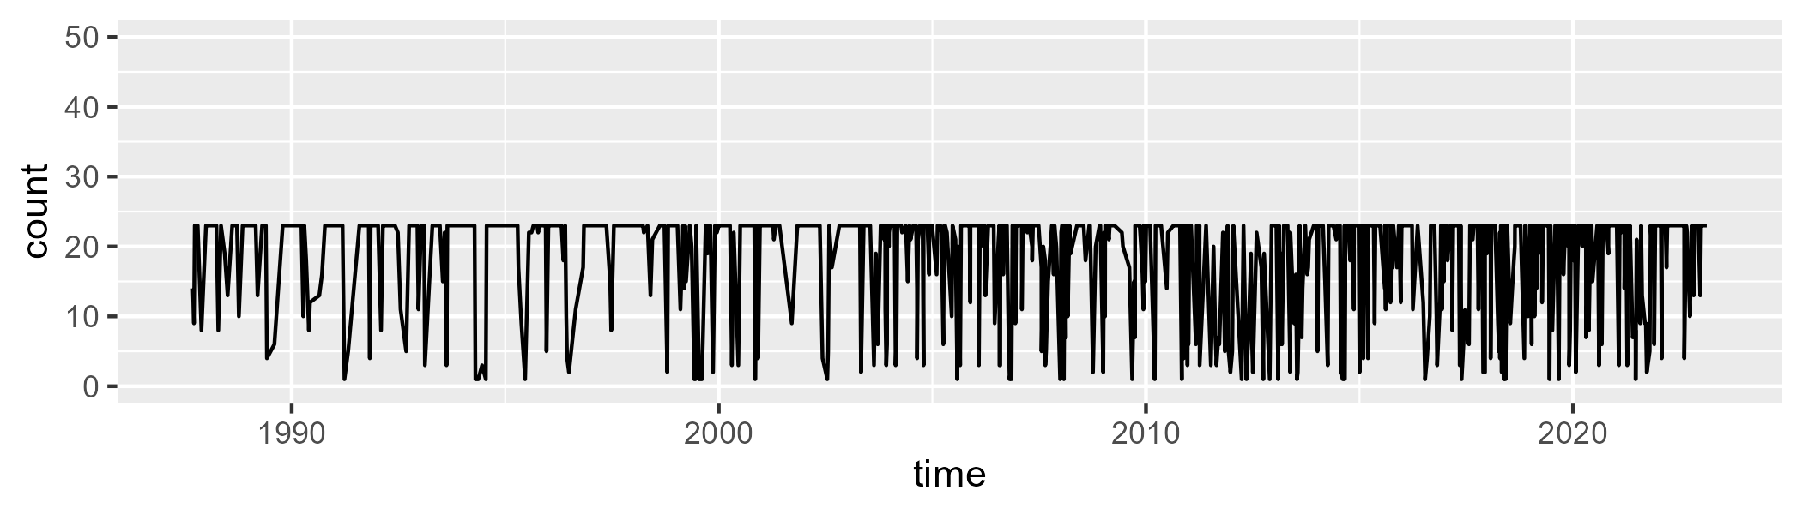

Min. : 1.00 1st Qu.:15.00 Median :23.00 Mean :18.48 3rd Qu.:23.00 Max. :23.00

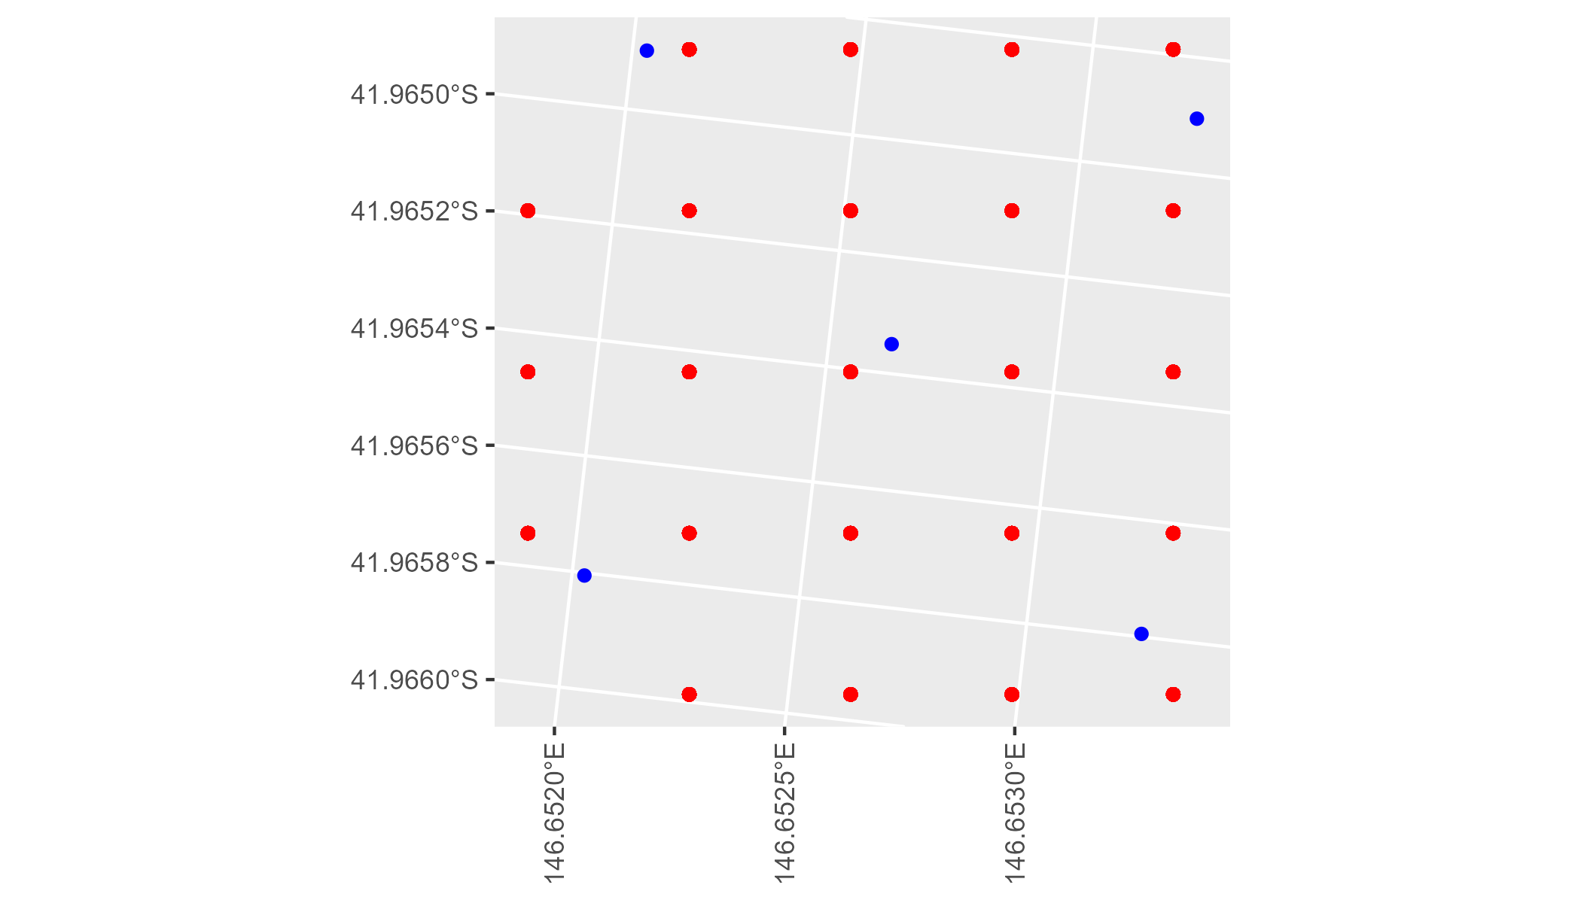

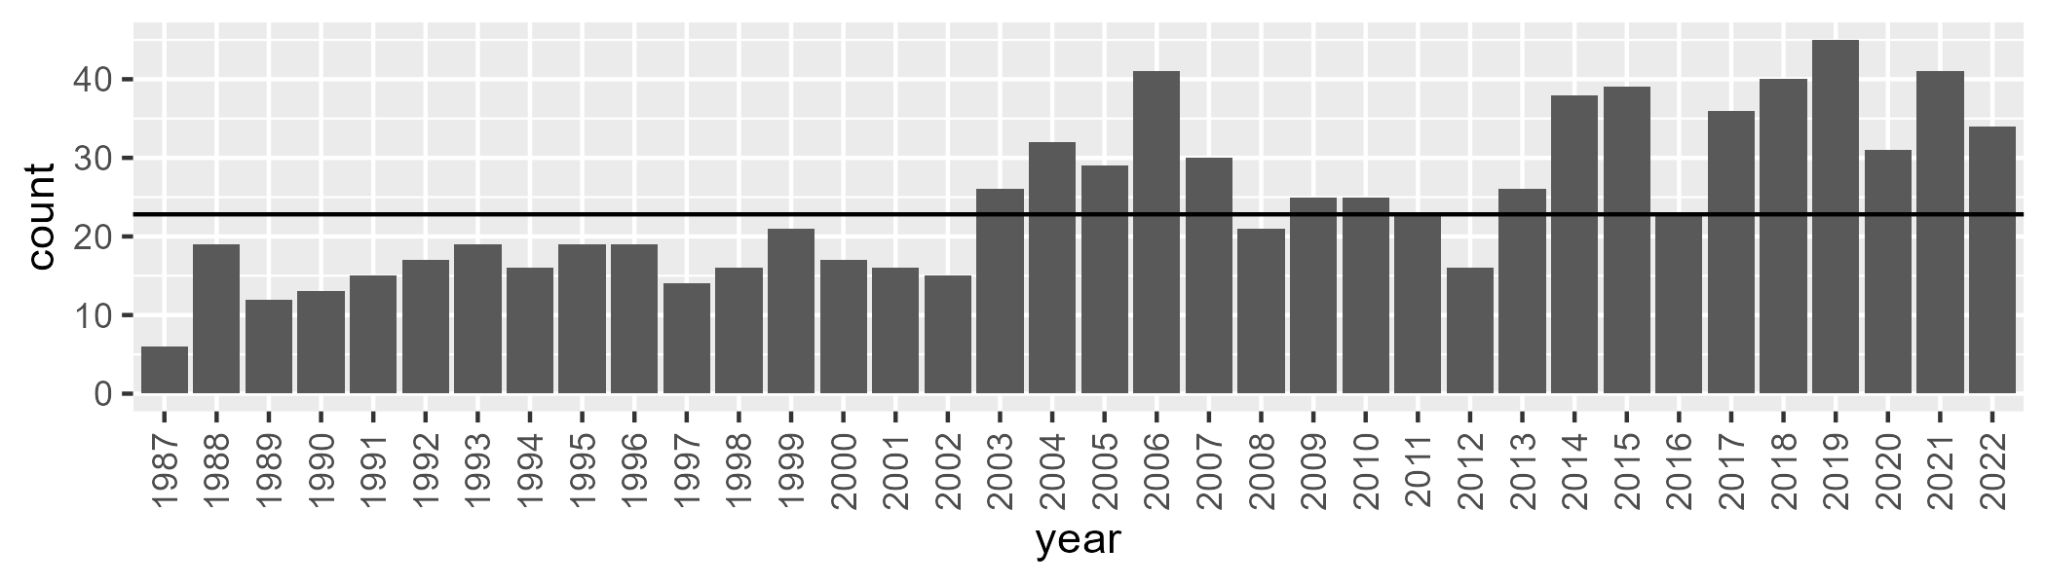

Number of samples: 875

# TCATCH0007

| Min. | 1st Qu. | Median | Mean | 3rd Qu. | Max. |
| --- | --- | --- | --- | --- | --- |
| 27.07696 | 41.07672 | 45.03088 | 45.52565 | 48.40724 | 89.90983 |

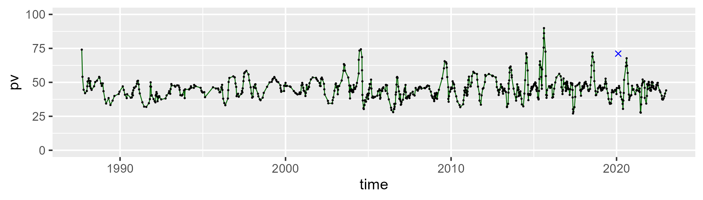

| Min. | 1st Qu. | Median | Mean | 3rd Qu. | Max. |
| --- | --- | --- | --- | --- | --- |
| 10.93369 | 39.82436 | 45.25647 | 43.64818 | 48.47703 | 59.45336 |

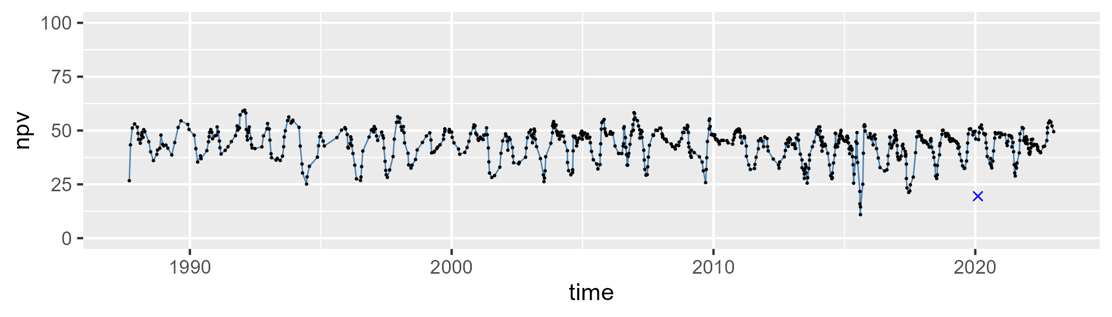

| Min. | 1st Qu. | Median | Mean | 3rd Qu. | Max. |
| --- | --- | --- | --- | --- | --- |
| 0 | 5.054314 | 8.352755 | 10.23698 | 13.54394 | 46.97865 |

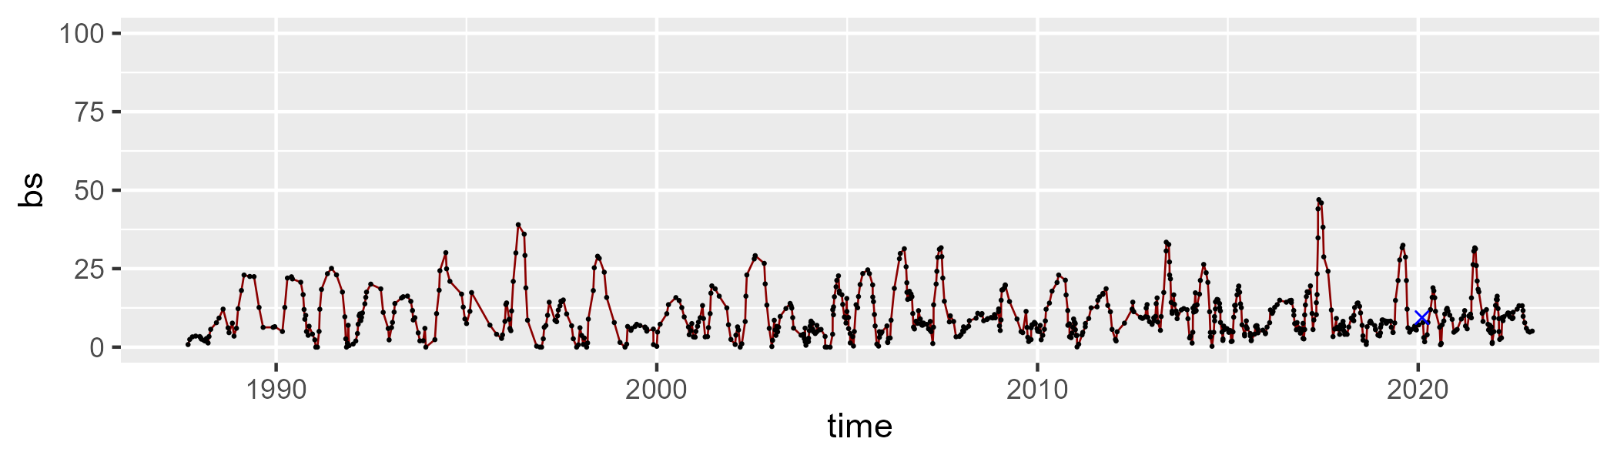

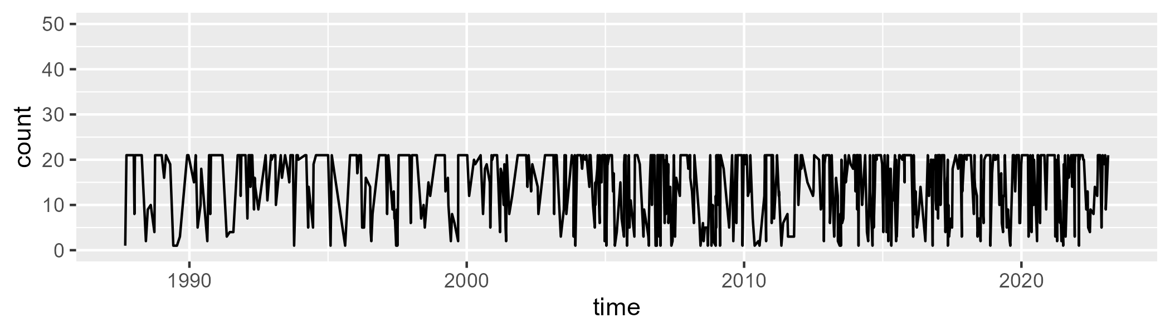

Min. : 1.00 1st Qu.: 9.00 Median :20.00 Mean :15.22 3rd Qu.:21.00 Max. :21.00

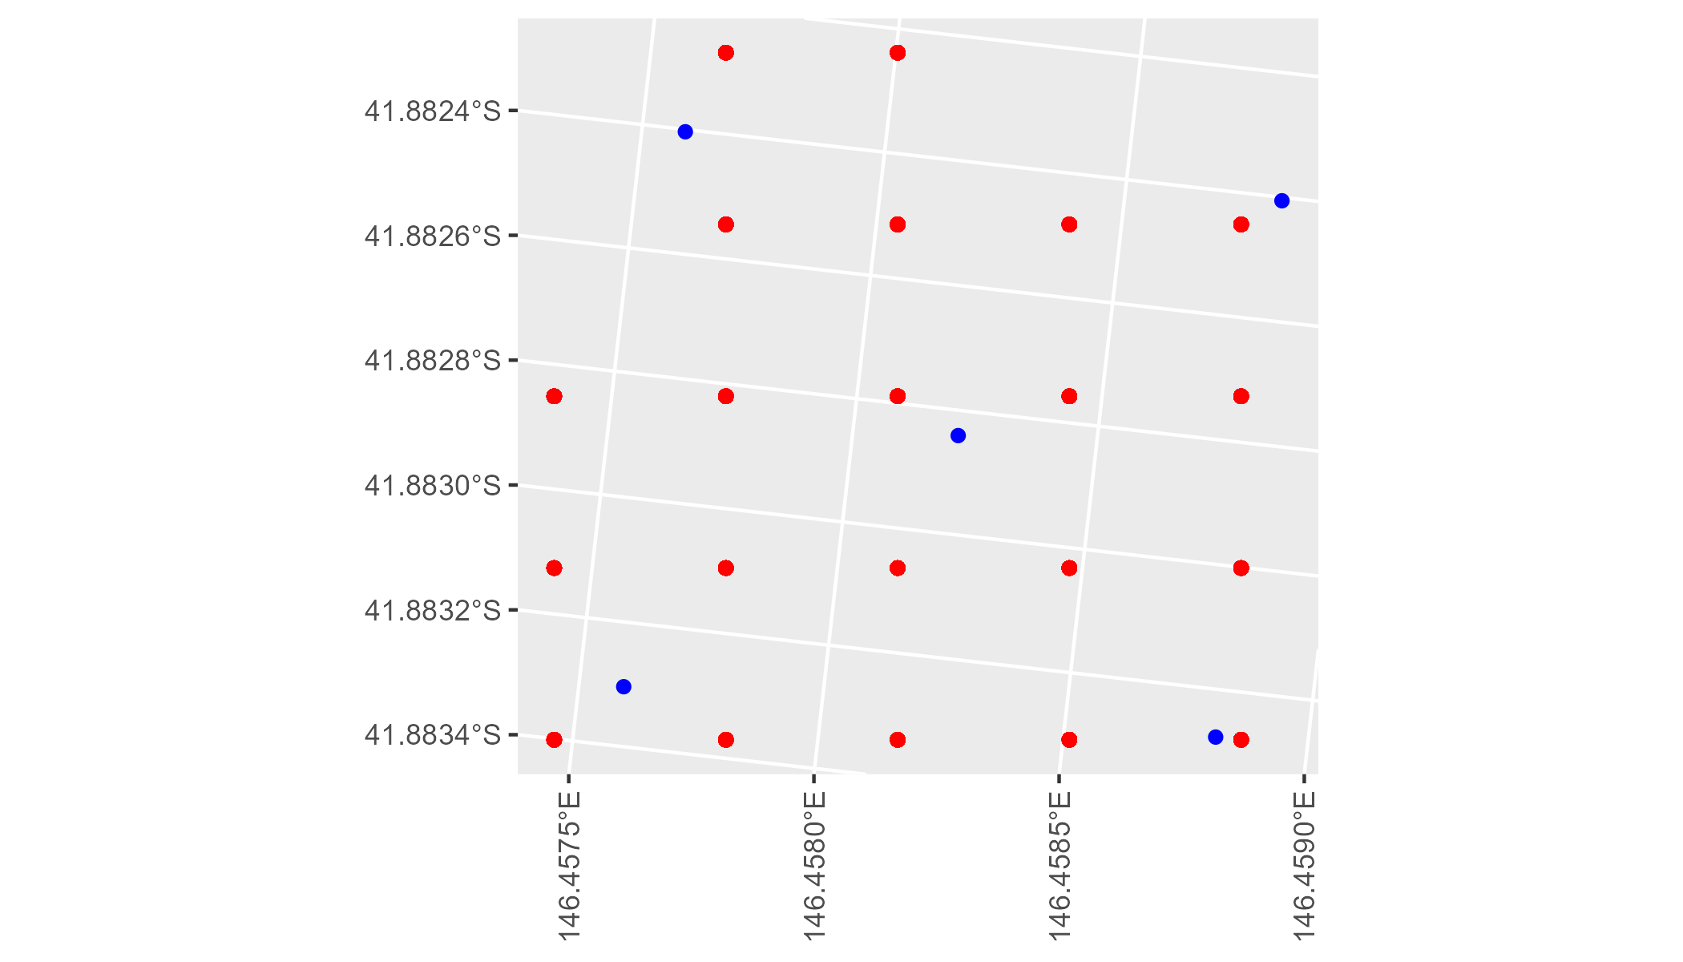

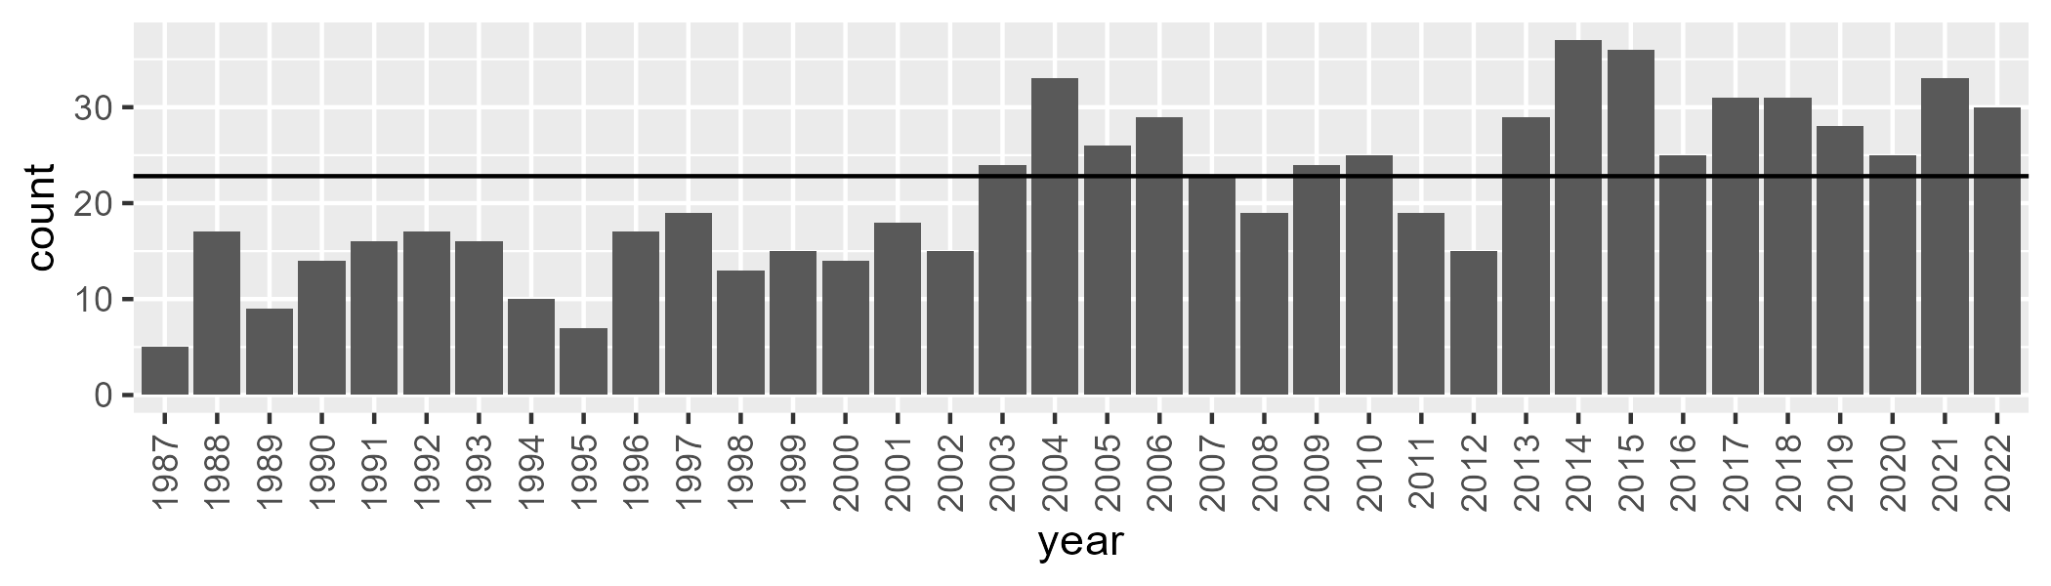

Number of samples: 764

# TCATCH0008

| Min. | 1st Qu. | Median | Mean | 3rd Qu. | Max. |
| --- | --- | --- | --- | --- | --- |
| 25.23329 | 43.19328 | 47.80158 | 48.11823 | 52.61981 | 92.7129 |

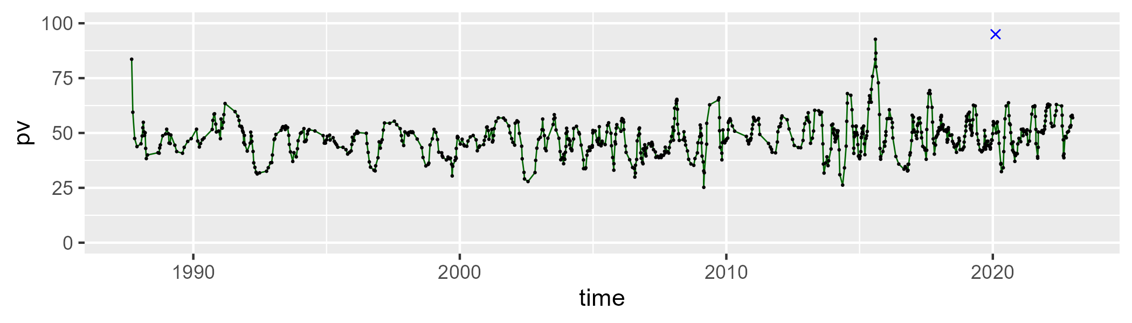

| Min. | 1st Qu. | Median | Mean | 3rd Qu. | Max. |
| --- | --- | --- | --- | --- | --- |
| 8.478441 | 36.91614 | 41.09083 | 40.39556 | 44.84086 | 58.44076 |

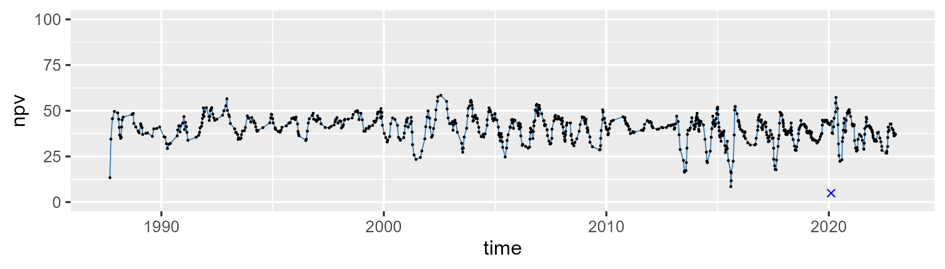

| Min. | 1st Qu. | Median | Mean | 3rd Qu. | Max. |
| --- | --- | --- | --- | --- | --- |
| 0 | 5.678282 | 9.213154 | 10.74177 | 14.41282 | 35.4247 |

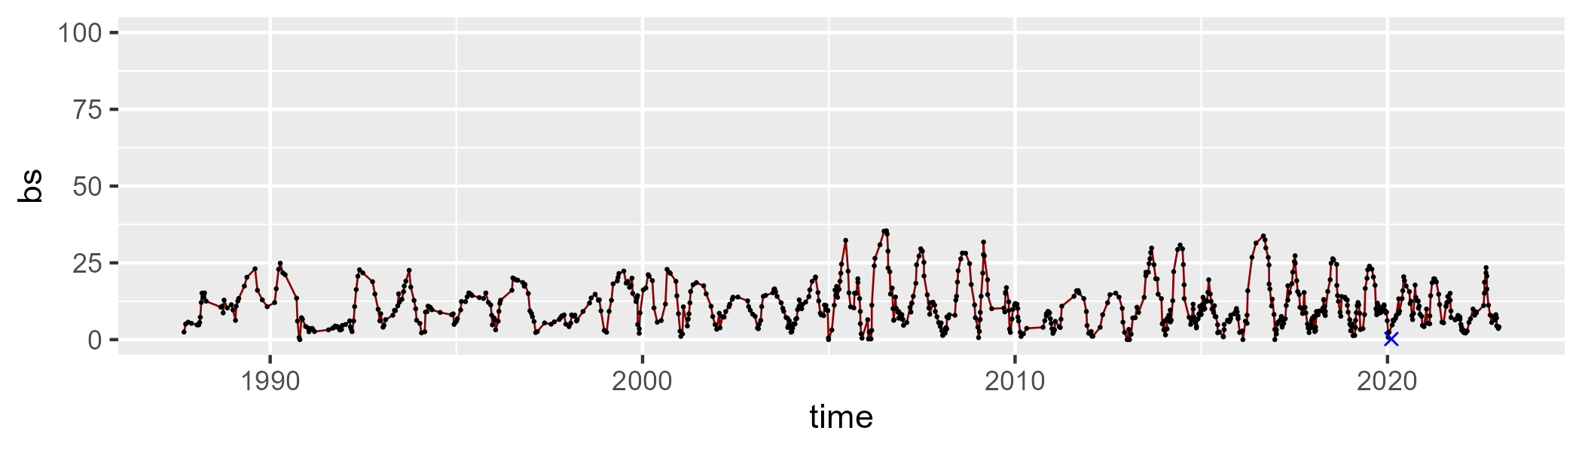

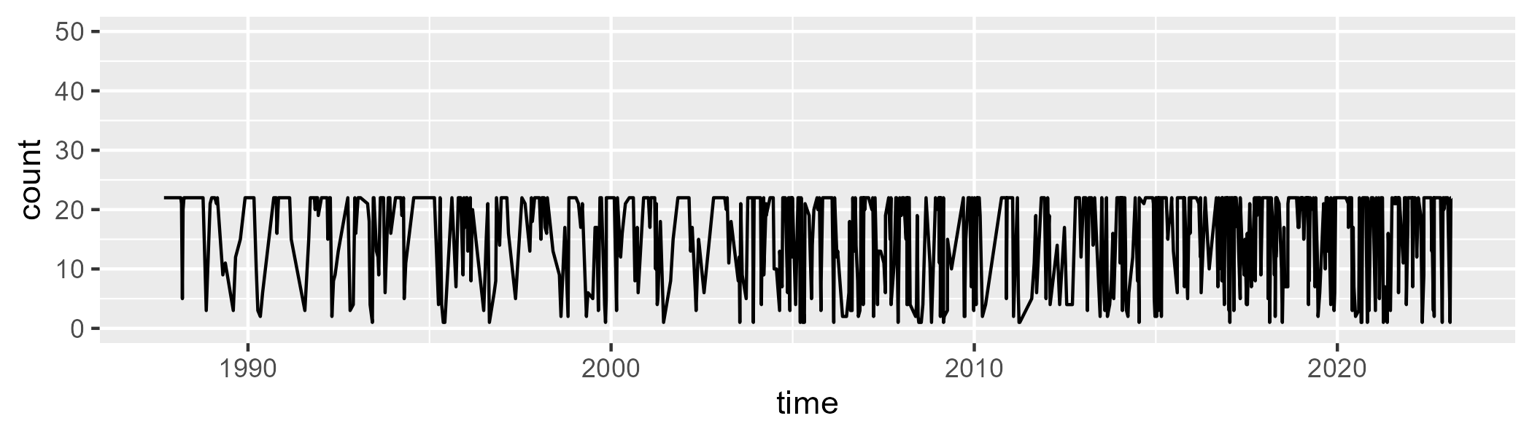

Min. : 1.00 1st Qu.: 9.00 Median :22.00 Mean :16.17 3rd Qu.:22.00 Max. :22.00

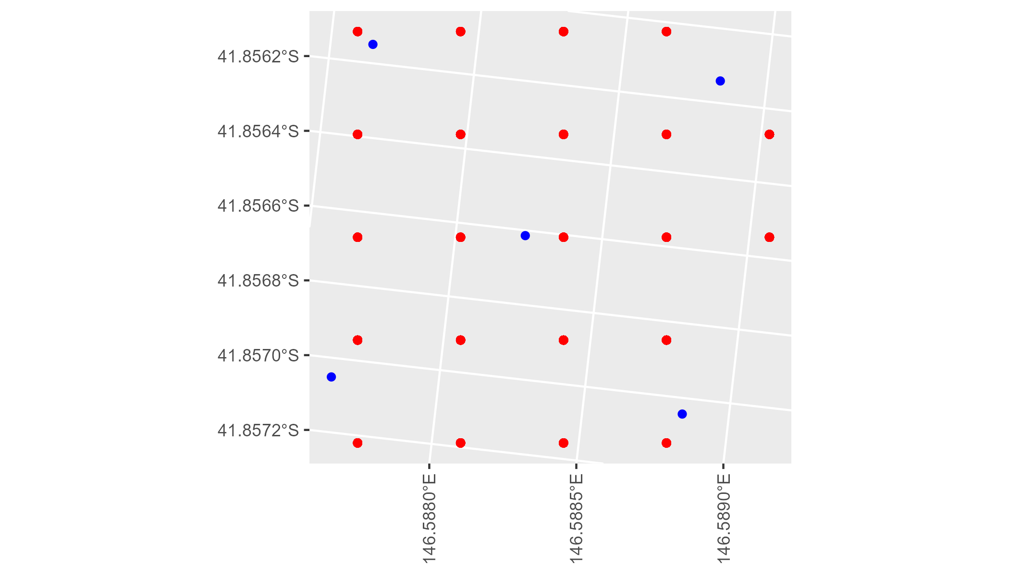

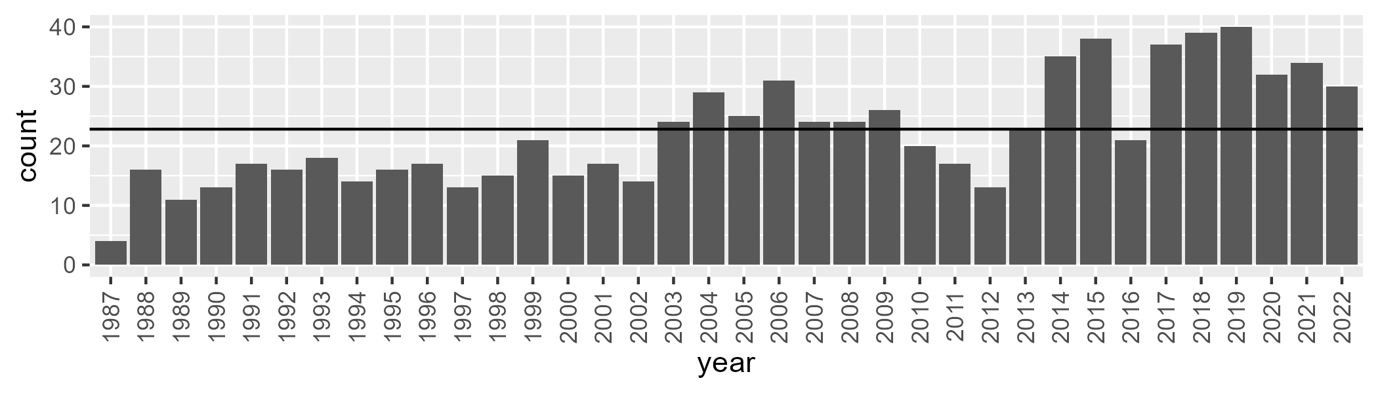

Number of samples: 799

# TCATCH0009

| Min. | 1st Qu. | Median | Mean | 3rd Qu. | Max. |
| --- | --- | --- | --- | --- | --- |
| 0 | 37.86491 | 42.66724 | 42.15844 | 47.87779 | 71.39235 |

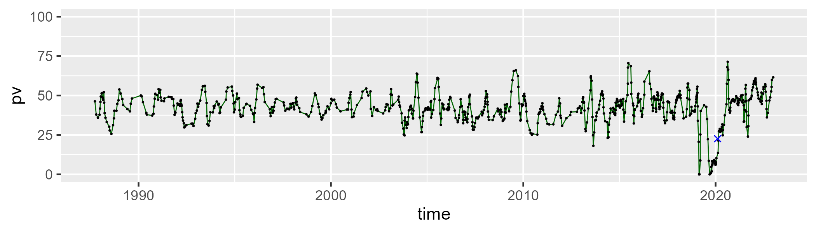

| Min. | 1st Qu. | Median | Mean | 3rd Qu. | Max. |
| --- | --- | --- | --- | --- | --- |
| 0 | 36.06546 | 42.77483 | 40.99041 | 47.03725 | 60.43249 |

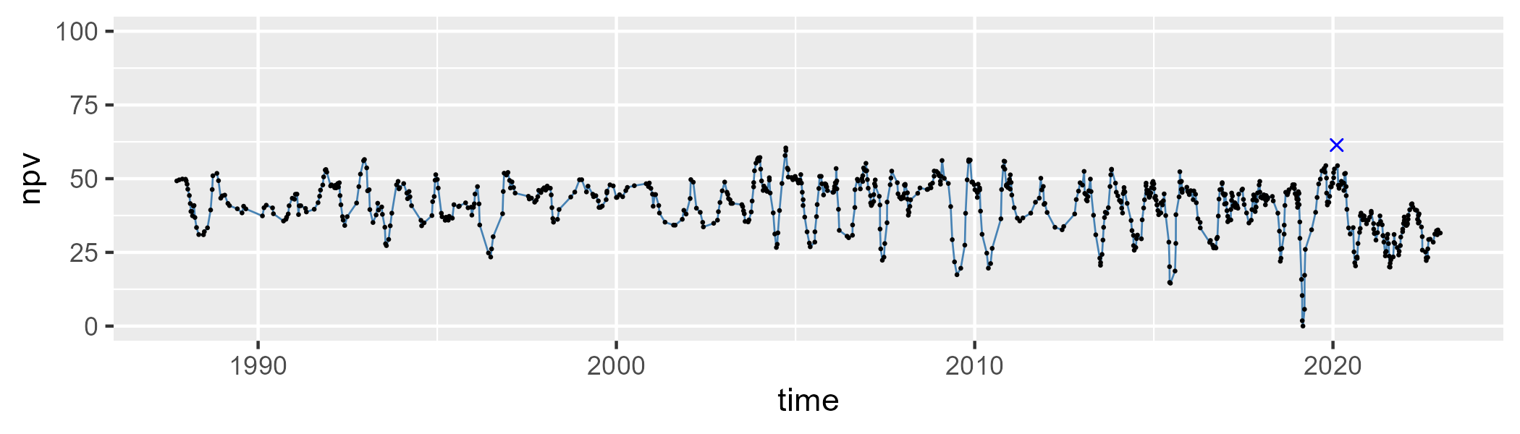

| Min. | 1st Qu. | Median | Mean | 3rd Qu. | Max. |
| --- | --- | --- | --- | --- | --- |
| 0 | 7.924332 | 12.77303 | 15.98175 | 20.91828 | 103.1635 |

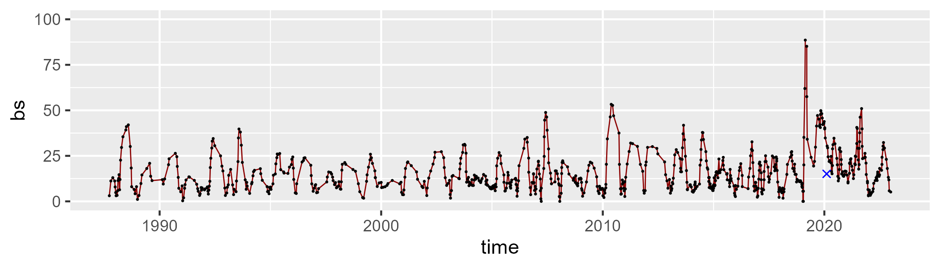

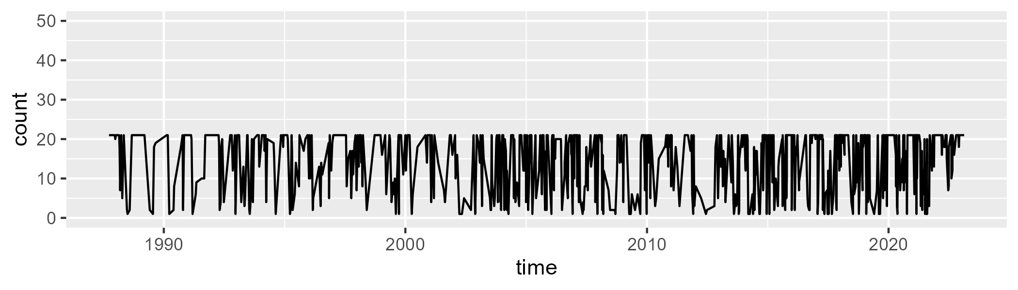

Min. : 1.00 1st Qu.: 7.00 Median :19.00 Mean :14.61 3rd Qu.:21.00 Max. :21.00

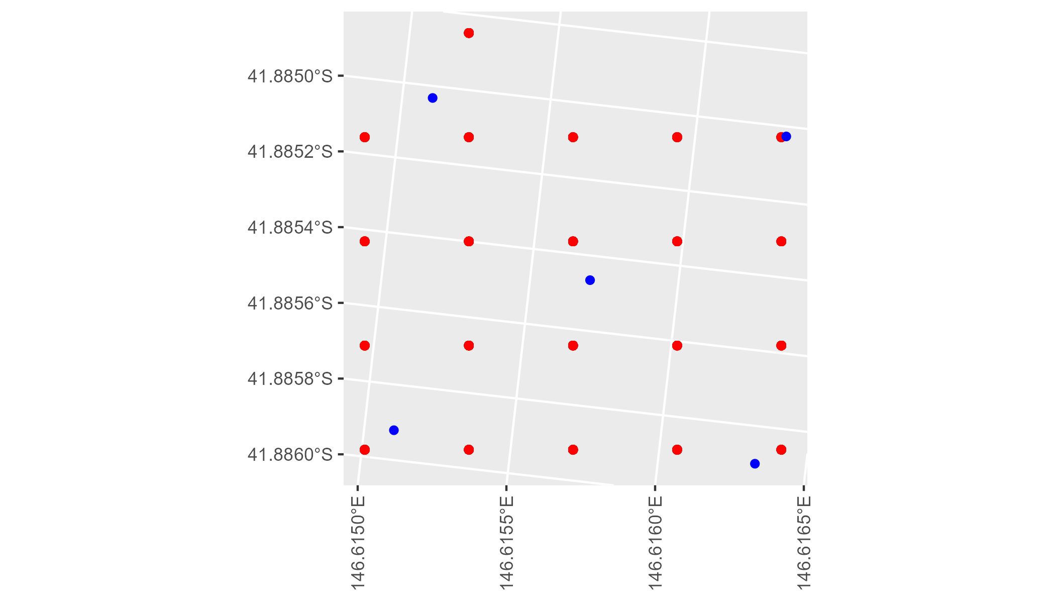

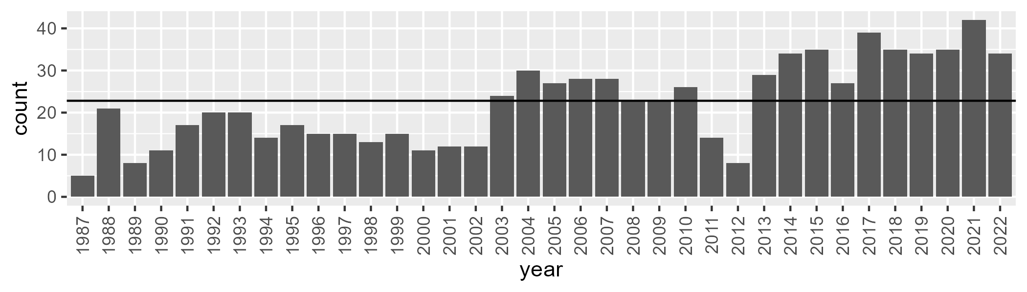

Number of samples: 801

# TCATCH0010

| Min. | 1st Qu. | Median | Mean | 3rd Qu. | Max. |
| --- | --- | --- | --- | --- | --- |
| 15.9331 | 48.71544 | 54.17948 | 54.324 | 59.84901 | 82.11156 |

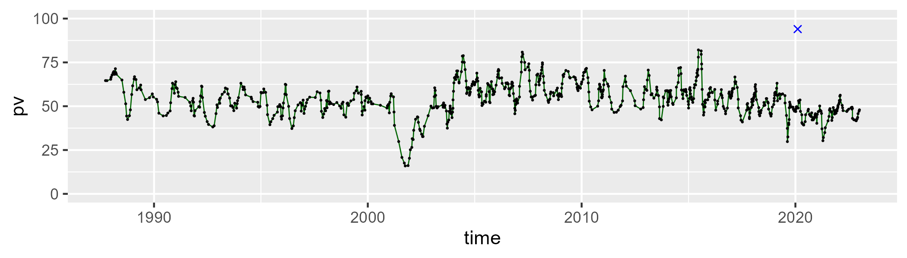

| Min. | 1st Qu. | Median | Mean | 3rd Qu. | Max. |
| --- | --- | --- | --- | --- | --- |
| 11.80226 | 29.74604 | 34.58188 | 34.37445 | 39.21068 | 58.5863 |

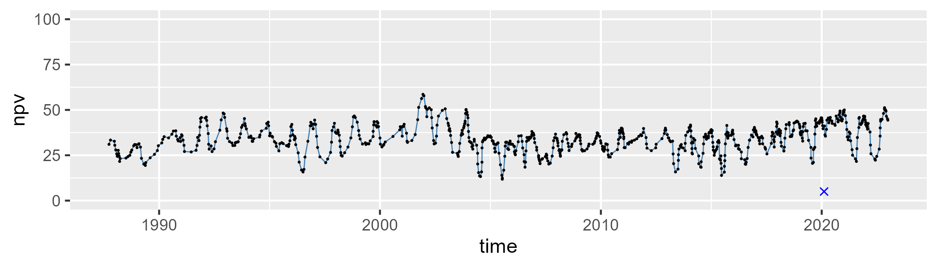

| Min. | 1st Qu. | Median | Mean | 3rd Qu. | Max. |
| --- | --- | --- | --- | --- | --- |
| 0 | 4.315785 | 8.321102 | 10.42824 | 15.00193 | 45.1333 |

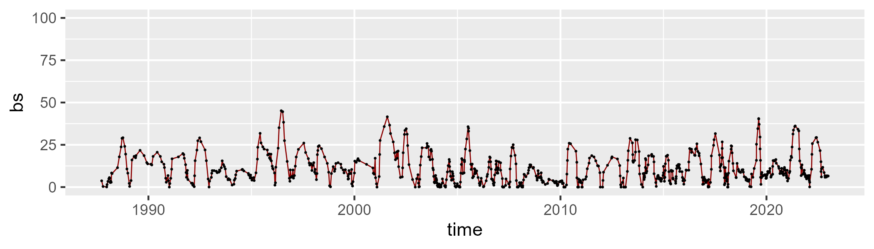

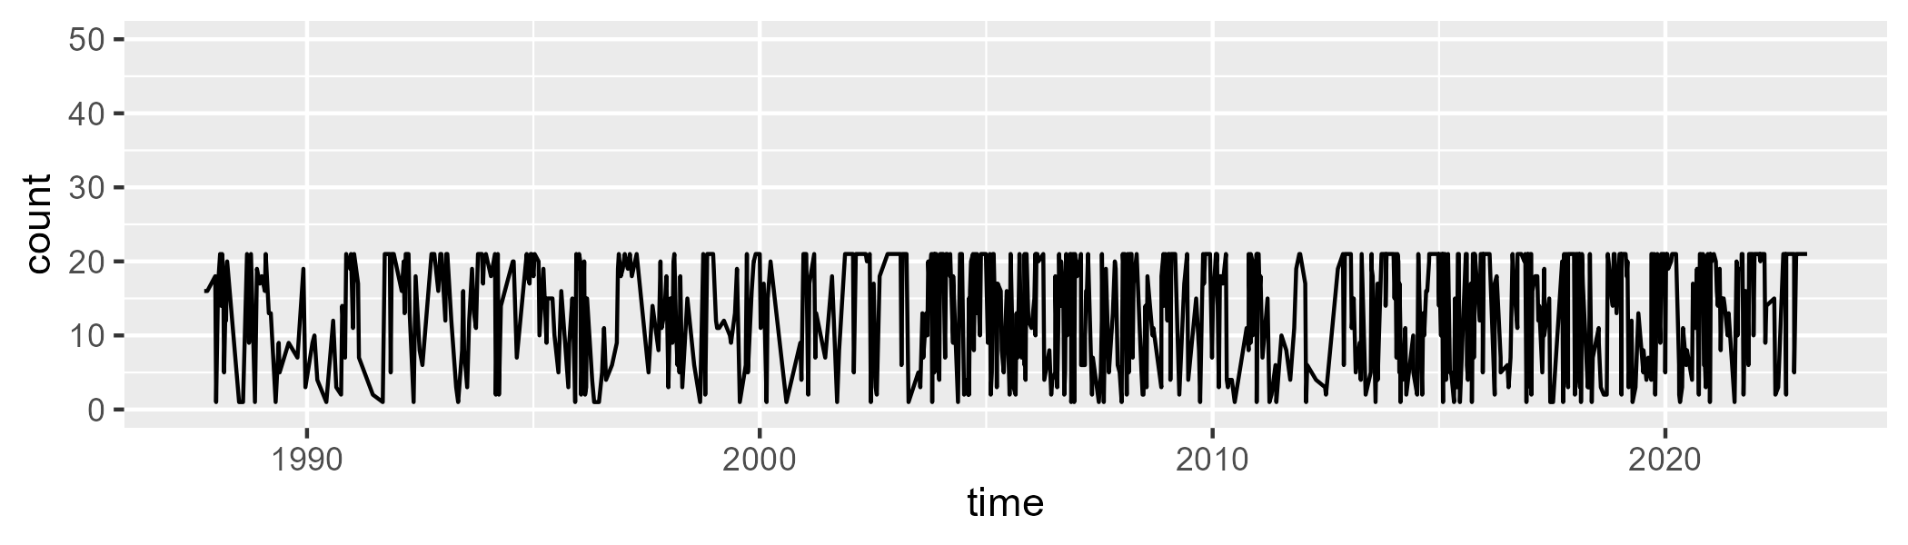

Min. : 1.00 1st Qu.: 6.00 Median :16.50 Mean :13.79 3rd Qu.:21.00 Max. :21.00

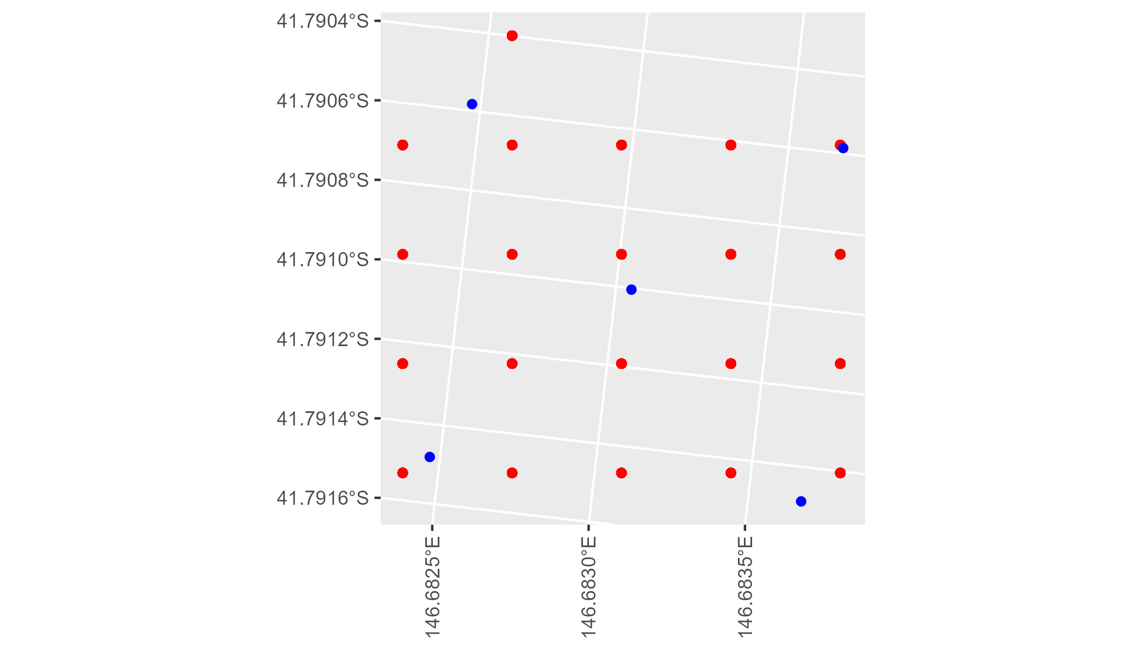

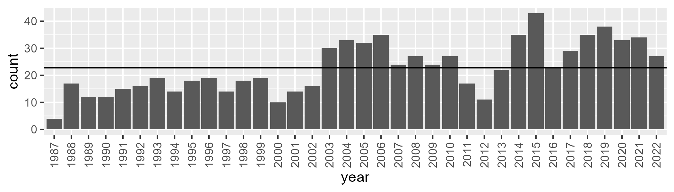

Number of samples: 816

# TCATCH0011

| Min. | 1st Qu. | Median | Mean | 3rd Qu. | Max. |
| --- | --- | --- | --- | --- | --- |
| 1.065375 | 39.24765 | 45.93884 | 42.56728 | 51.45605 | 71.58548 |

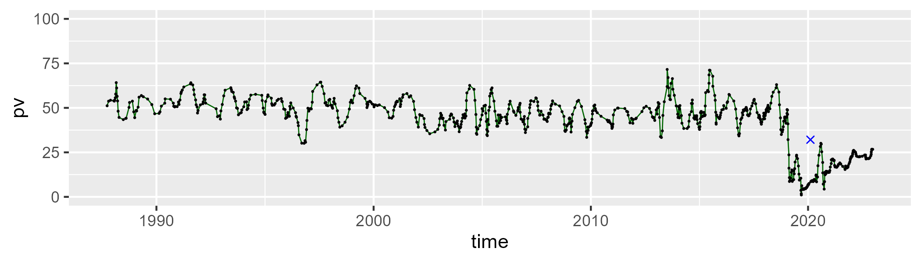

| Min. | 1st Qu. | Median | Mean | 3rd Qu. | Max. |
| --- | --- | --- | --- | --- | --- |
| 6.559096 | 32.02859 | 38.79341 | 38.05768 | 44.37238 | 64.4571 |

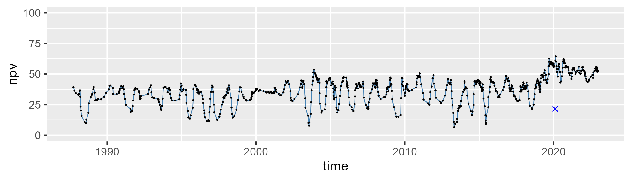

| Min. | 1st Qu. | Median | Mean | 3rd Qu. | Max. |
| --- | --- | --- | --- | --- | --- |
| 0 | 10.45394 | 15.23251 | 18.09487 | 23.25879 | 57.22967 |

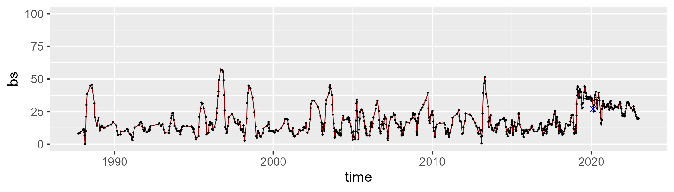

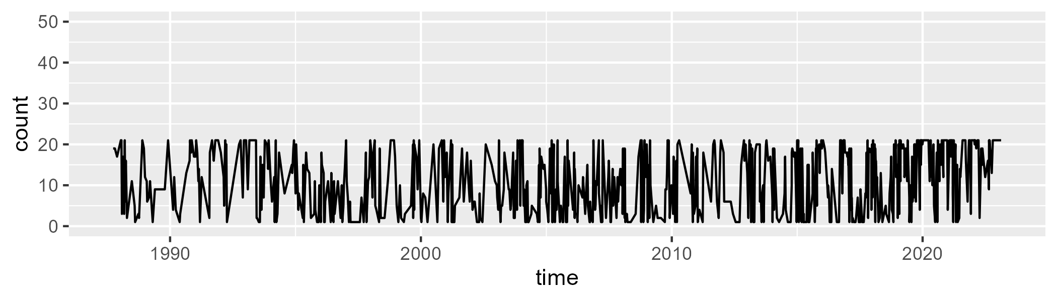

Min. : 1.00 1st Qu.: 4.00 Median :12.00 Mean :11.54 3rd Qu.:19.00 Max. :21.00

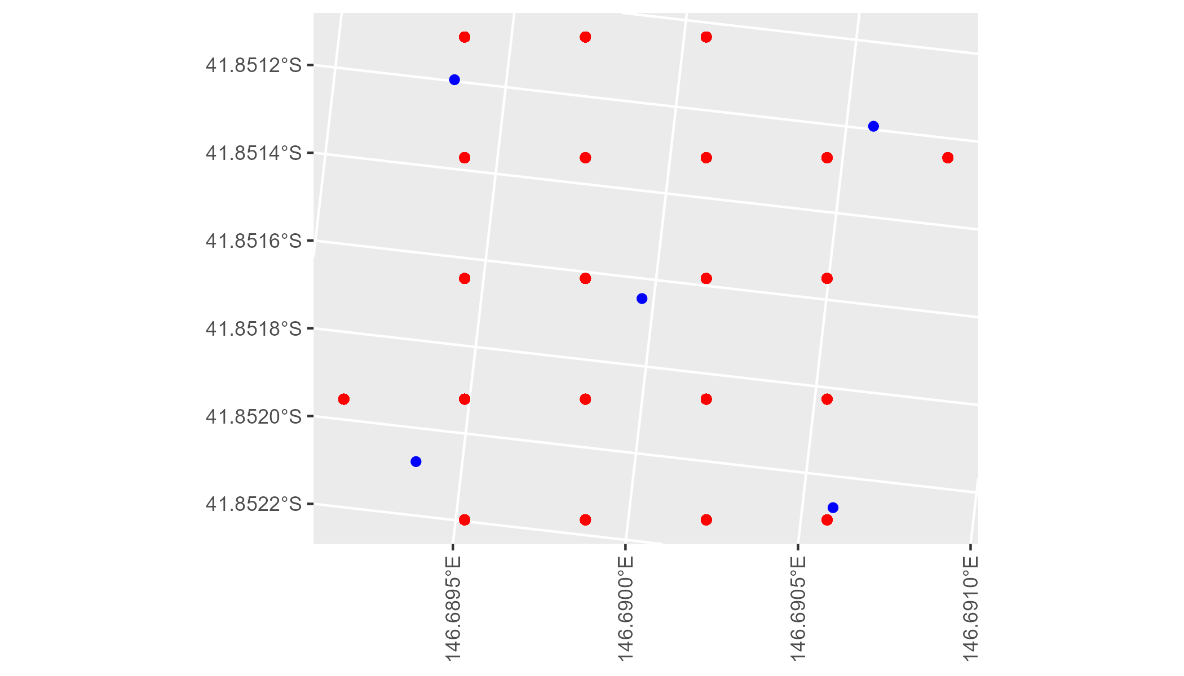

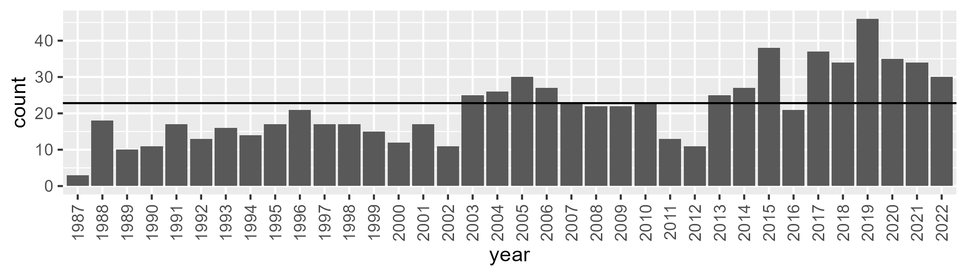

Number of samples: 778

# TCATCH0012

| Min. | 1st Qu. | Median | Mean | 3rd Qu. | Max. |
| --- | --- | --- | --- | --- | --- |
| 17.99937 | 48.05235 | 58.19844 | 58.17463 | 68.60859 | 87.29157 |

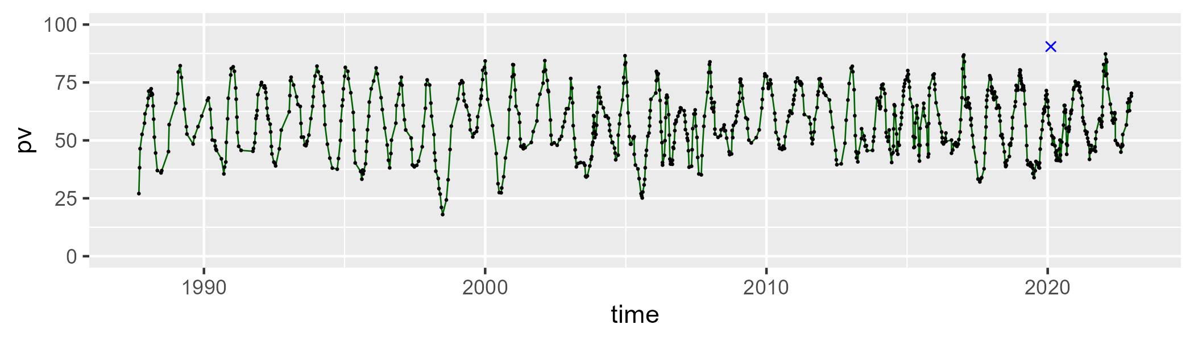

| Min. | 1st Qu. | Median | Mean | 3rd Qu. | Max. |
| --- | --- | --- | --- | --- | --- |
| 5.502103 | 21.15344 | 28.69954 | 29.24402 | 36.86918 | 57.16931 |

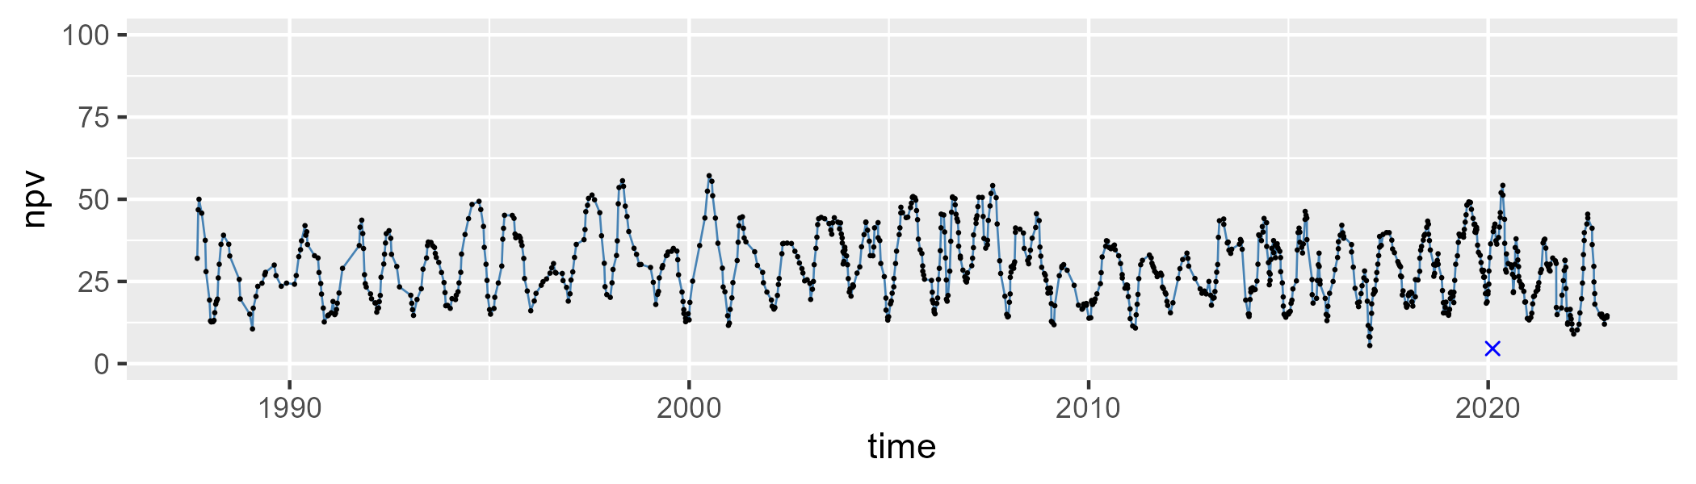

| Min. | 1st Qu. | Median | Mean | 3rd Qu. | Max. |
| --- | --- | --- | --- | --- | --- |
| 0 | 6.177626 | 10.00594 | 11.34877 | 15.46407 | 40.54271 |

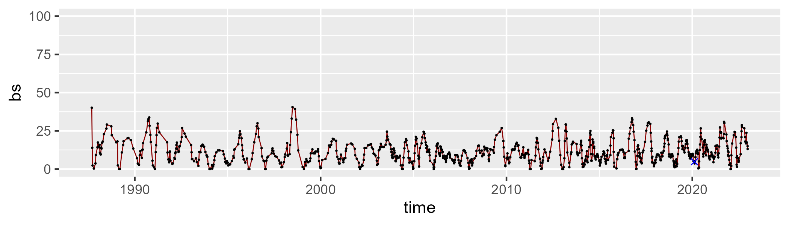

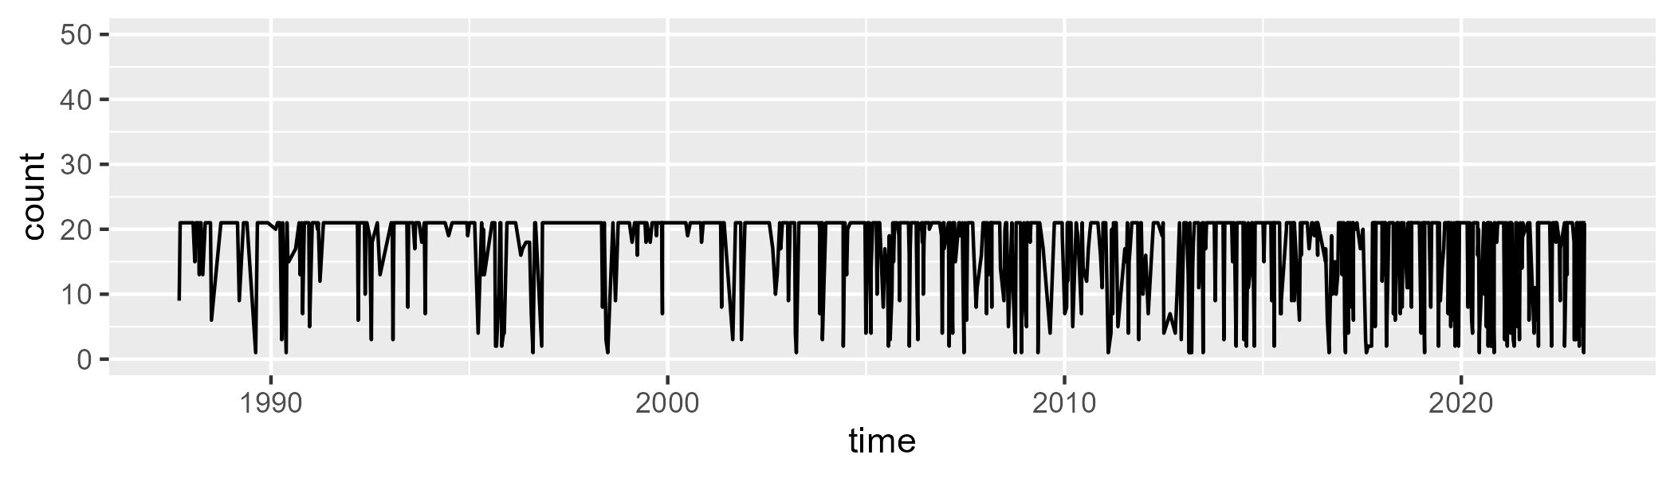

Min. : 1.00 1st Qu.:16.00 Median :21.00 Mean :17.25 3rd Qu.:21.00 Max. :21.00

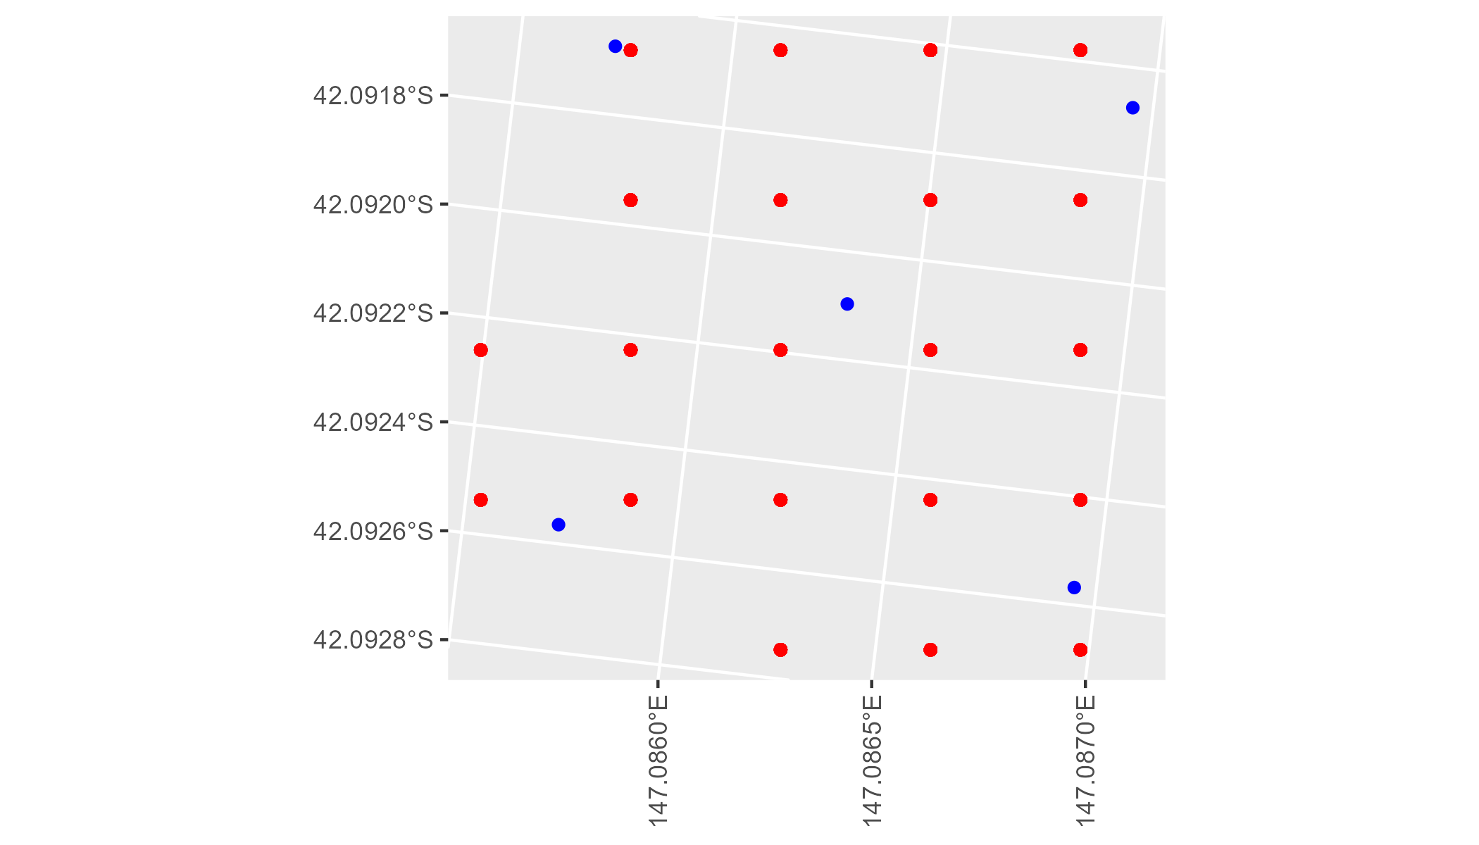

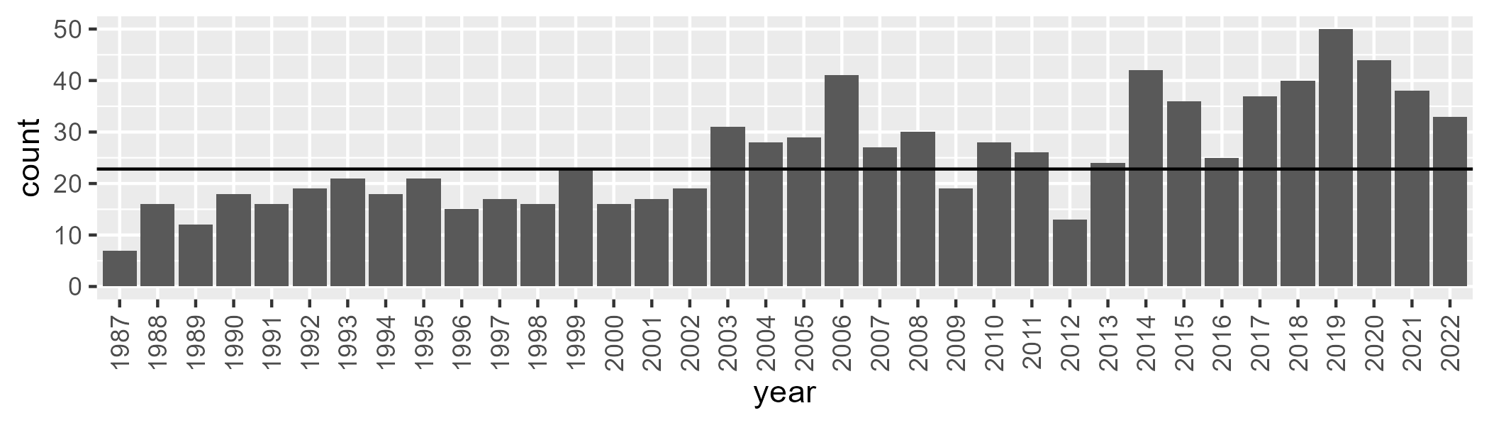

Number of samples: 912

# TCATNM0001

| Min. | 1st Qu. | Median | Mean | 3rd Qu. | Max. |
| --- | --- | --- | --- | --- | --- |
| 31.81685 | 47.88093 | 51.85226 | 51.52711 | 55.3373 | 68.44632 |

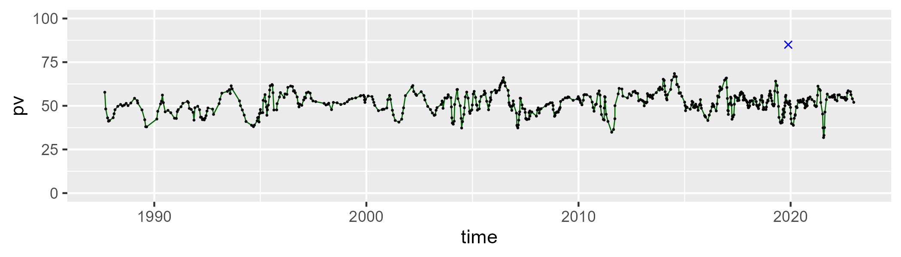

| Min. | 1st Qu. | Median | Mean | 3rd Qu. | Max. |
| --- | --- | --- | --- | --- | --- |
| 15.98645 | 32.23369 | 36.63795 | 36.54723 | 40.61091 | 54.76907 |

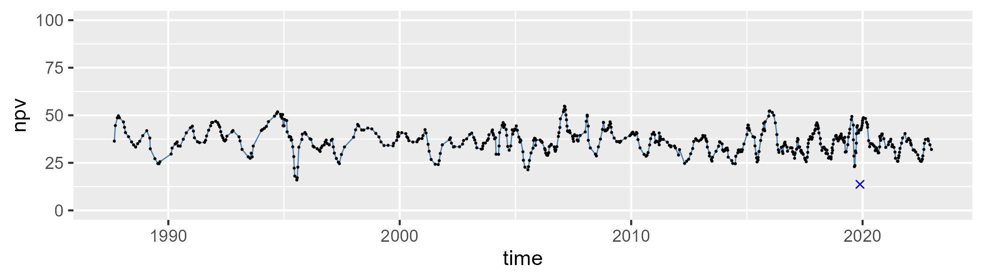

| Min. | 1st Qu. | Median | Mean | 3rd Qu. | Max. |
| --- | --- | --- | --- | --- | --- |
| 0 | 5.771728 | 9.415689 | 10.64969 | 14.53179 | 39.43714 |

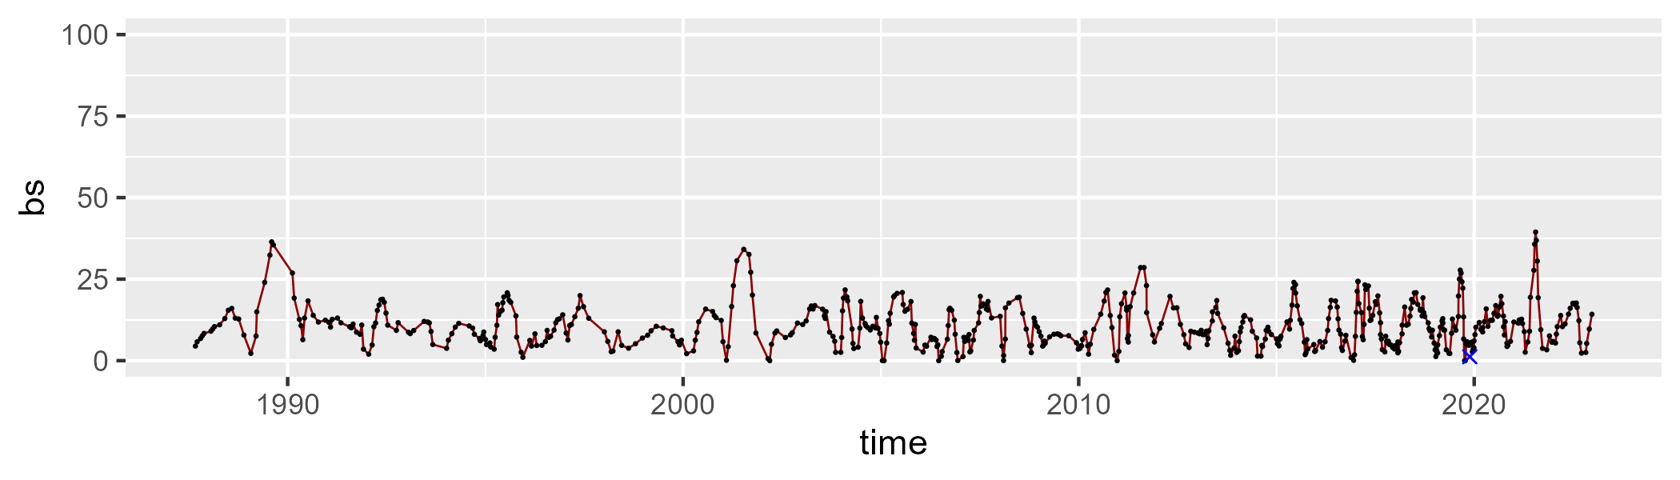

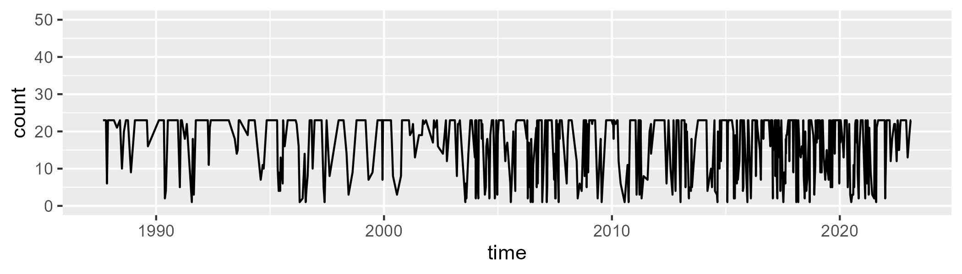

Min. : 1.00 1st Qu.:10.00 Median :23.00 Mean :17.03 3rd Qu.:23.00 Max. :23.00

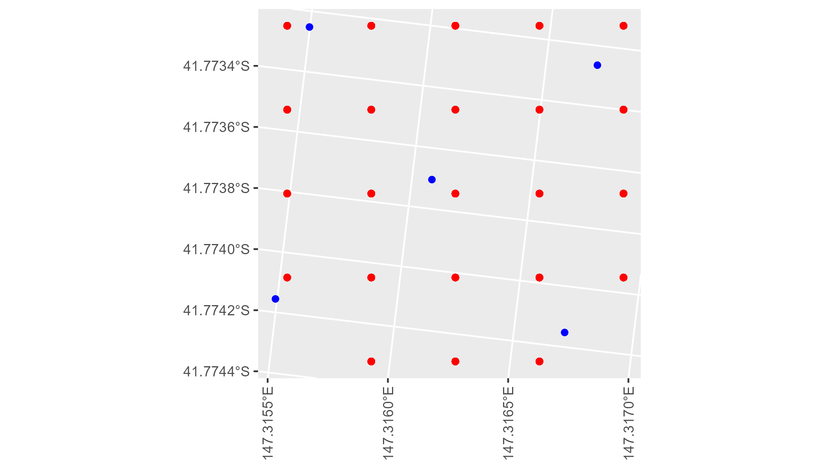

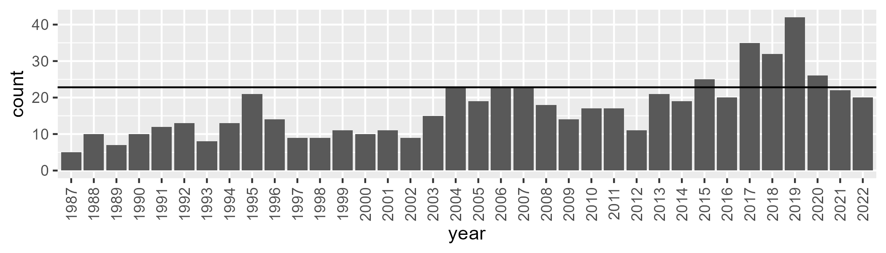

Number of samples: 614

# TCATNM0002

| Min. | 1st Qu. | Median | Mean | 3rd Qu. | Max. |
| --- | --- | --- | --- | --- | --- |
| 22.74719 | 39.76255 | 45.46142 | 45.45357 | 51.42222 | 66.55386 |

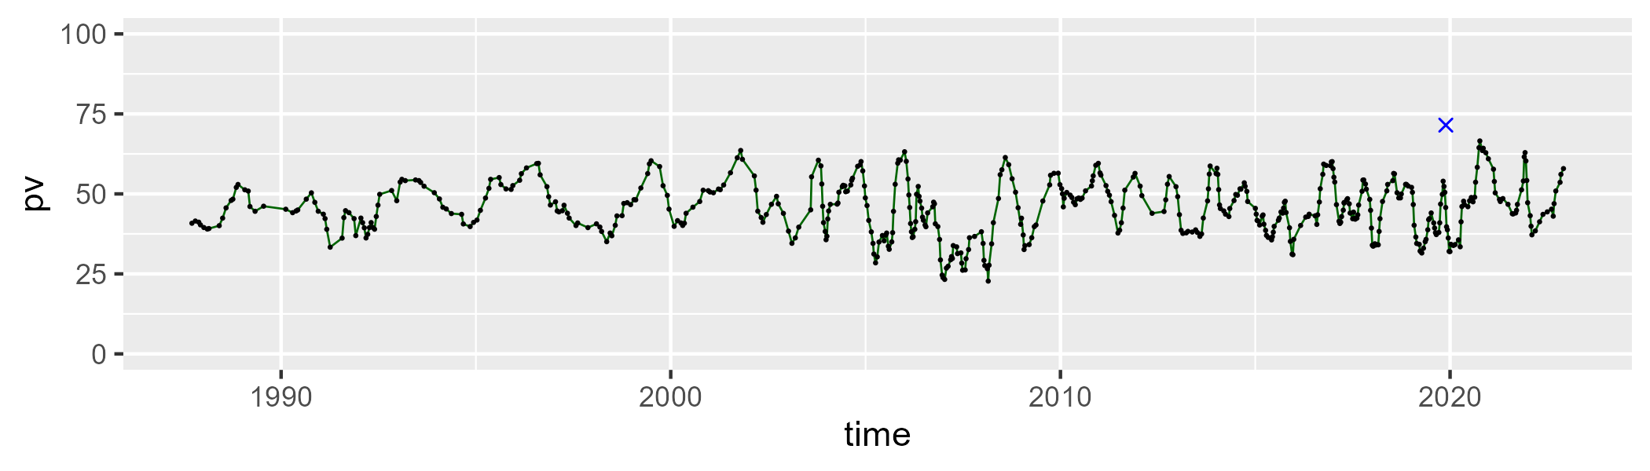

| Min. | 1st Qu. | Median | Mean | 3rd Qu. | Max. |
| --- | --- | --- | --- | --- | --- |
| 20.46814 | 37.11819 | 43.19858 | 43.298 | 48.55028 | 73.1257 |

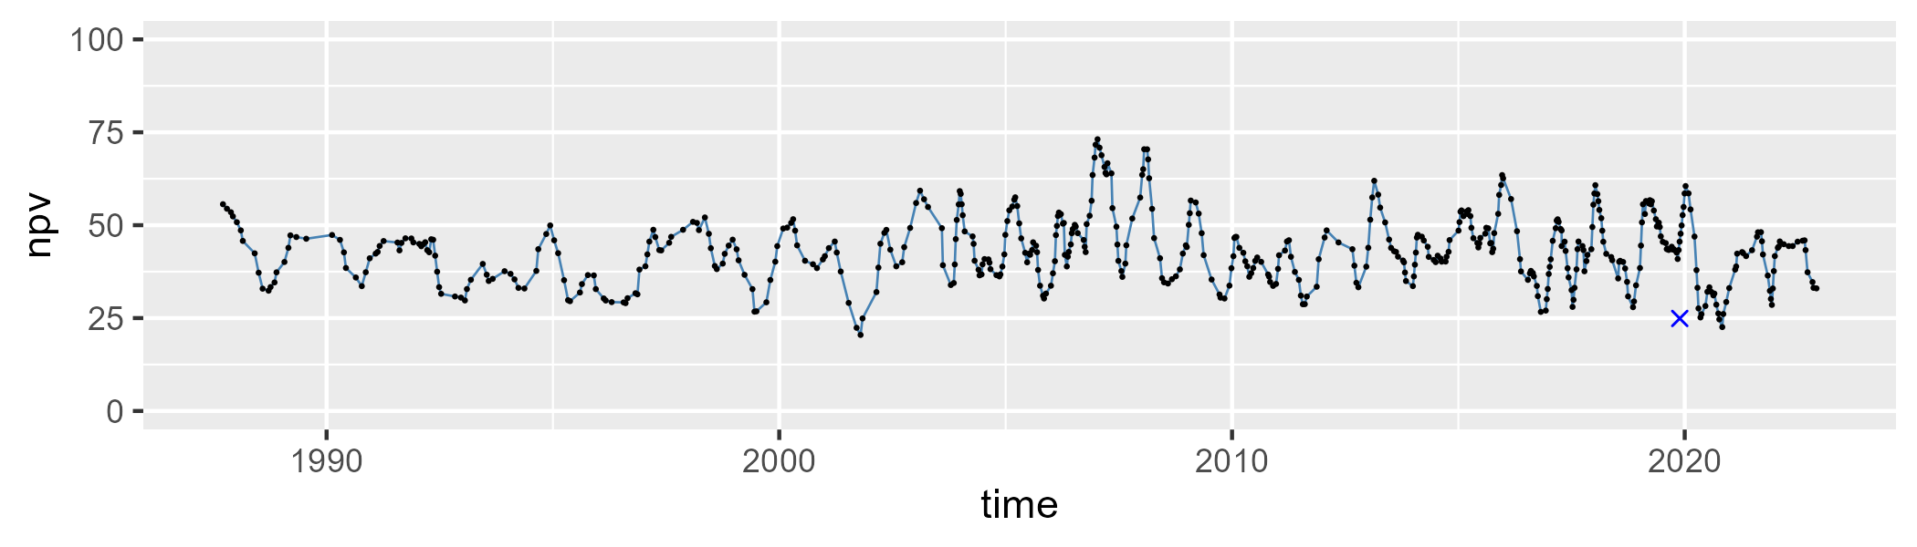

| Min. | 1st Qu. | Median | Mean | 3rd Qu. | Max. |
| --- | --- | --- | --- | --- | --- |
| 0 | 6.02754 | 8.999382 | 10.04819 | 12.93255 | 35.03646 |

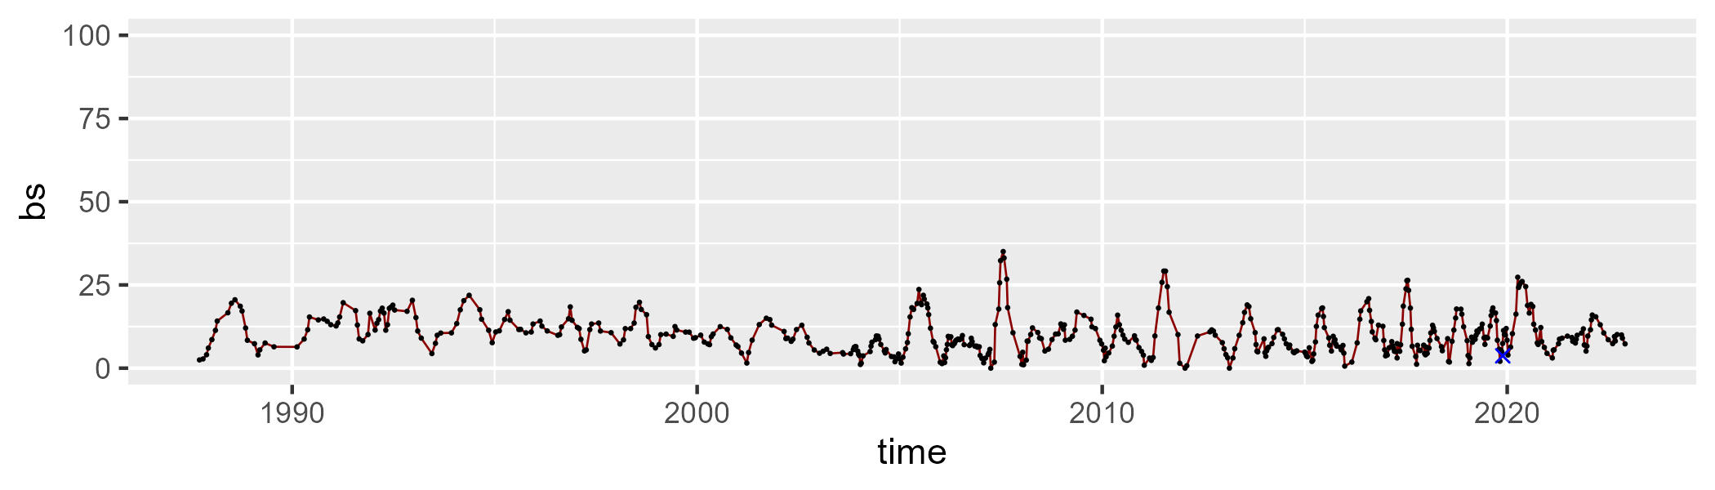

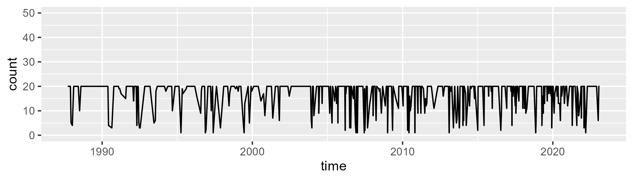

Min. : 1.00 1st Qu.:16.00 Median :20.00 Mean :16.84 3rd Qu.:20.00 Max. :20.00

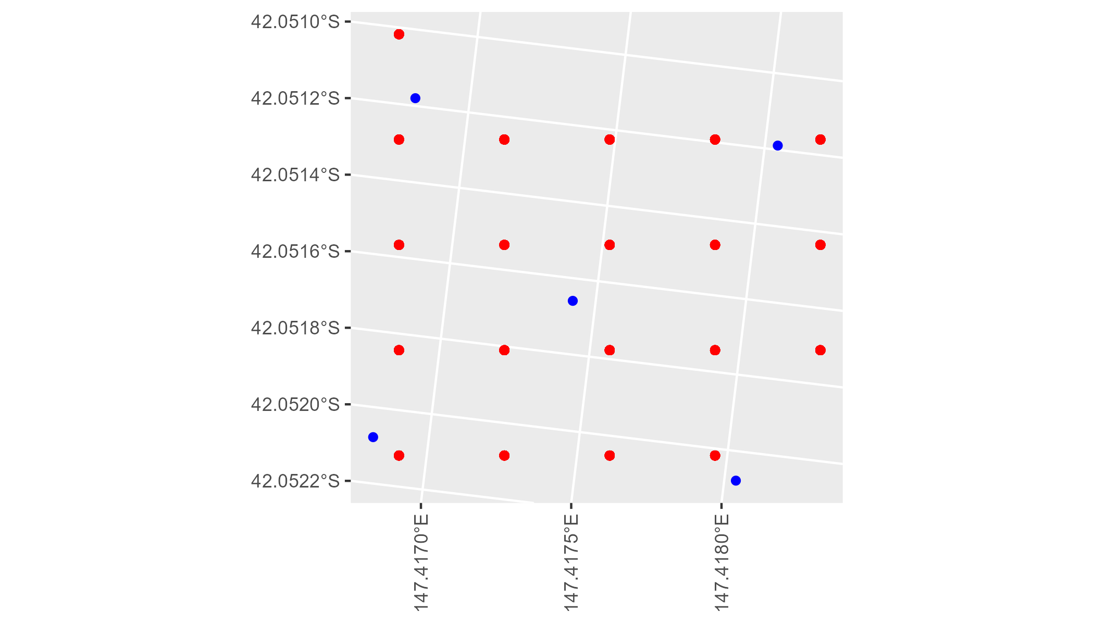

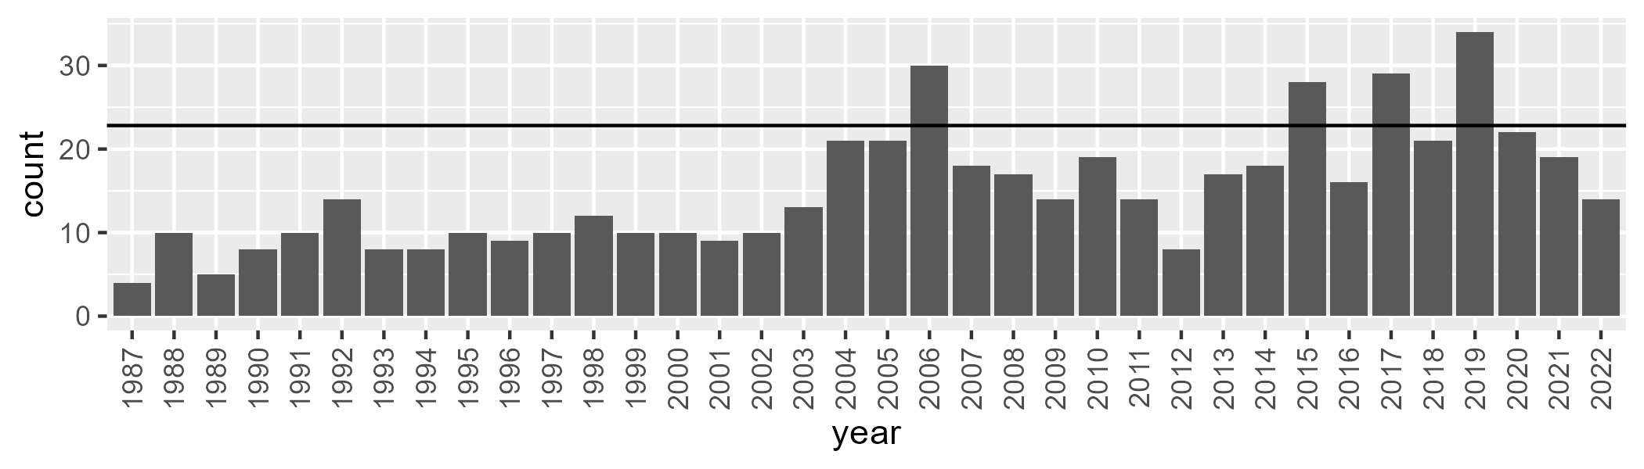

Number of samples: 540

# TCATNM0003

| Min. | 1st Qu. | Median | Mean | 3rd Qu. | Max. |
| --- | --- | --- | --- | --- | --- |
| 24.80494 | 38.02662 | 42.68078 | 42.56731 | 47.74378 | 59.96511 |

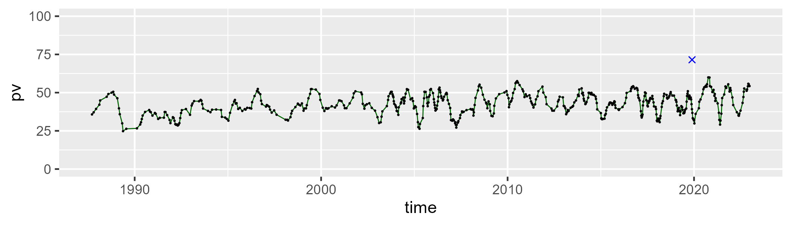

| Min. | 1st Qu. | Median | Mean | 3rd Qu. | Max. |
| --- | --- | --- | --- | --- | --- |
| 30.63955 | 42.32833 | 47.98855 | 47.98639 | 53.10932 | 66.37889 |

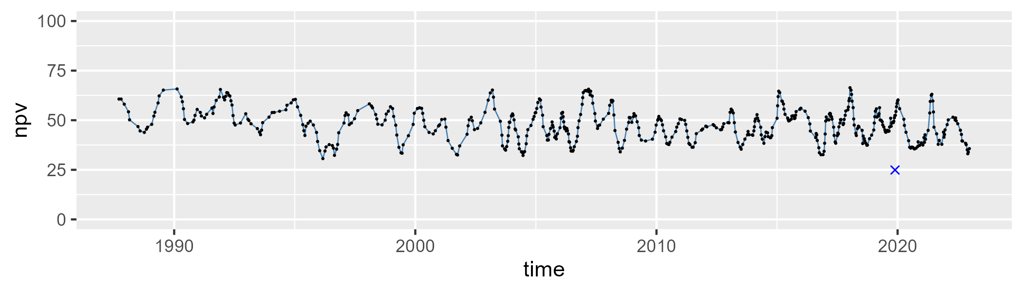

| Min. | 1st Qu. | Median | Mean | 3rd Qu. | Max. |
| --- | --- | --- | --- | --- | --- |
| 0 | 4.505825 | 7.737861 | 8.368371 | 11.34975 | 28.35393 |

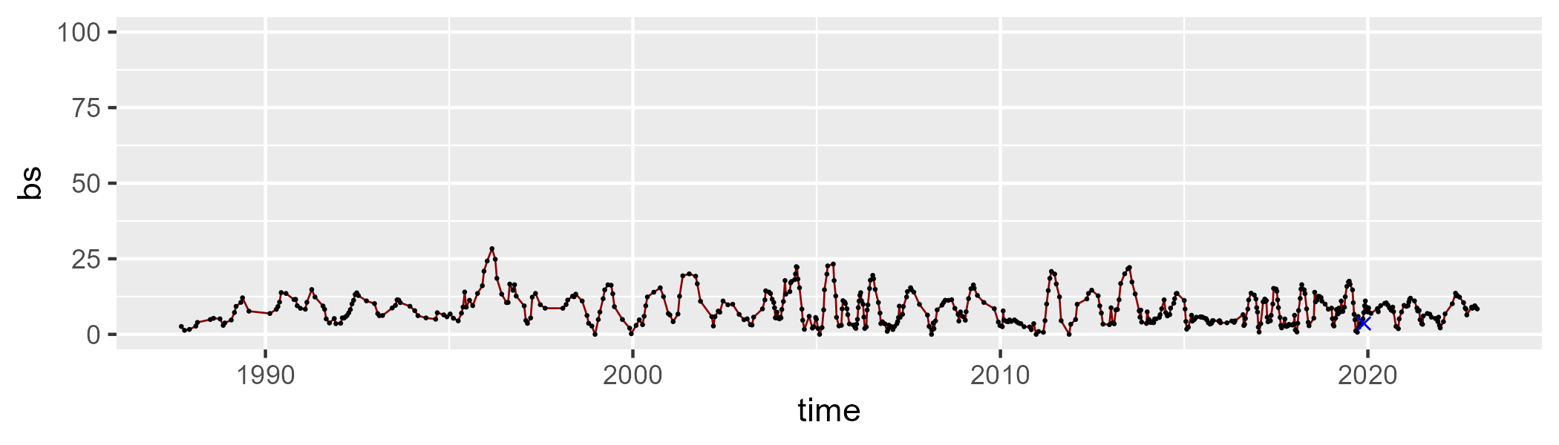

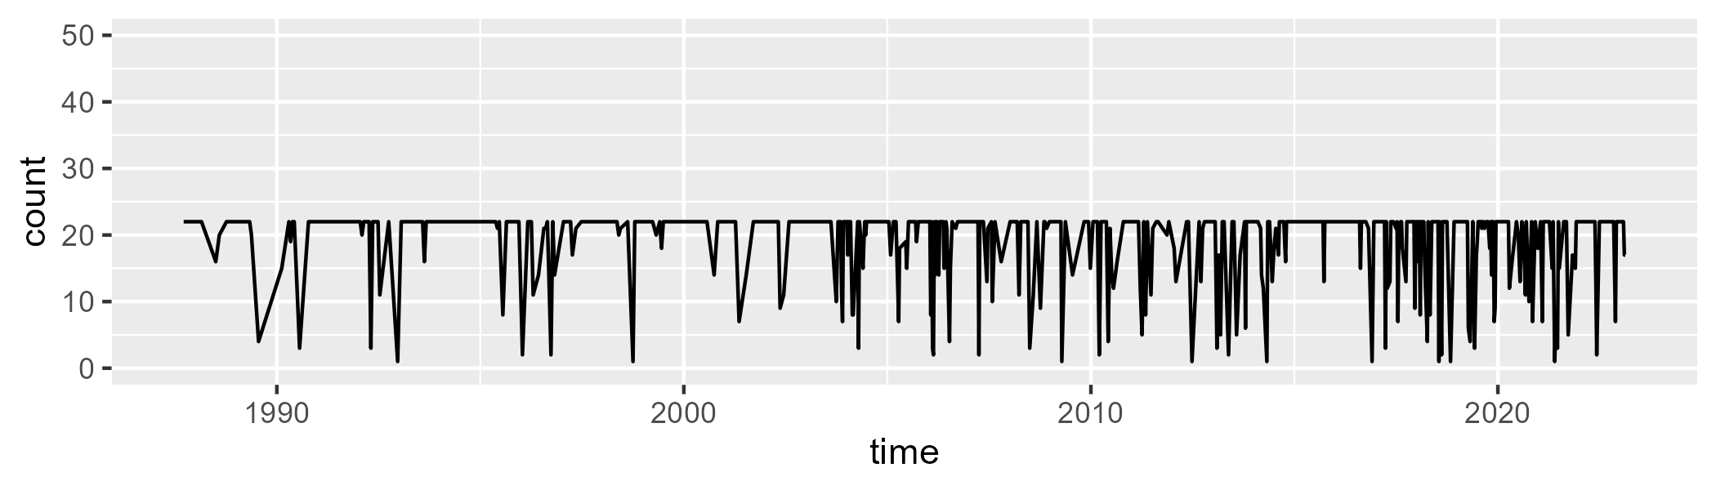

Min. : 1.00 1st Qu.:20.00 Median :22.00 Mean :19.08 3rd Qu.:22.00 Max. :22.00

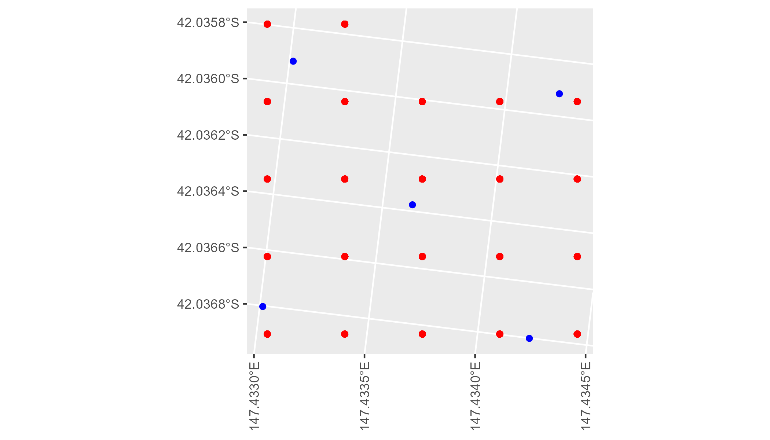

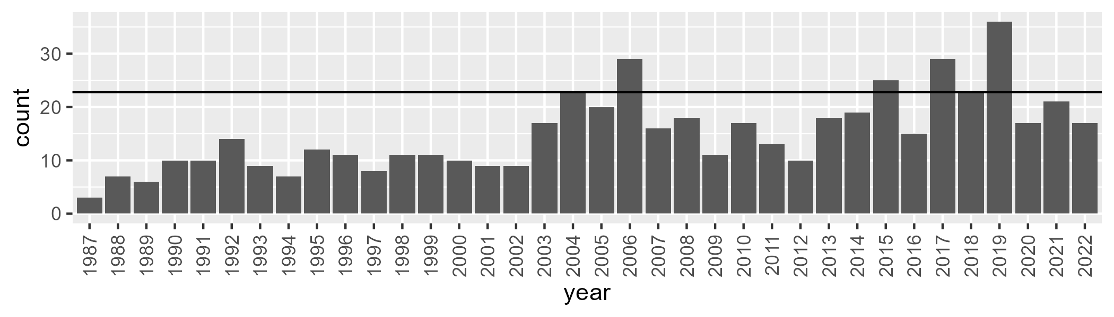

Number of samples: 541

# TCATNM0004

| Min. | 1st Qu. | Median | Mean | 3rd Qu. | Max. |
| --- | --- | --- | --- | --- | --- |
| 32.62601 | 44.93518 | 48.66869 | 48.95422 | 53.03754 | 63.92751 |

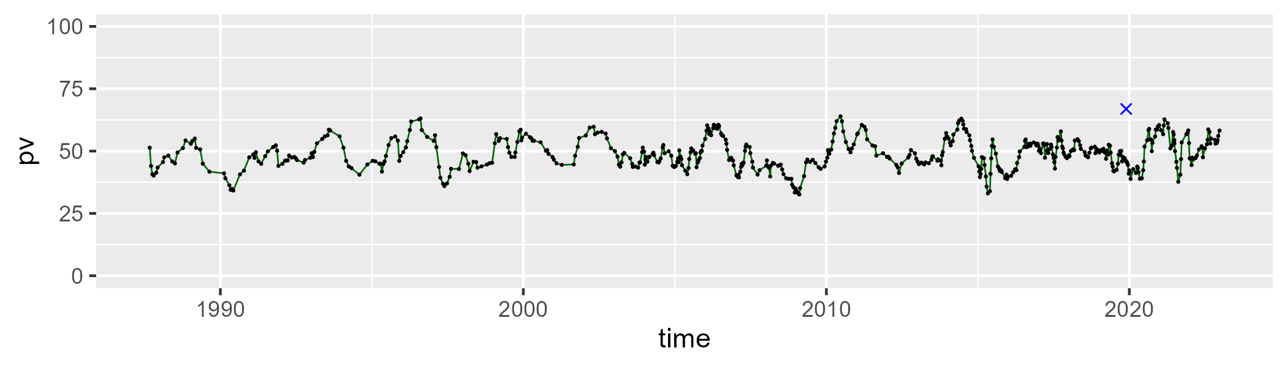

| Min. | 1st Qu. | Median | Mean | 3rd Qu. | Max. |
| --- | --- | --- | --- | --- | --- |
| 24.10445 | 37.29296 | 41.23515 | 41.78788 | 46.28076 | 62.49475 |

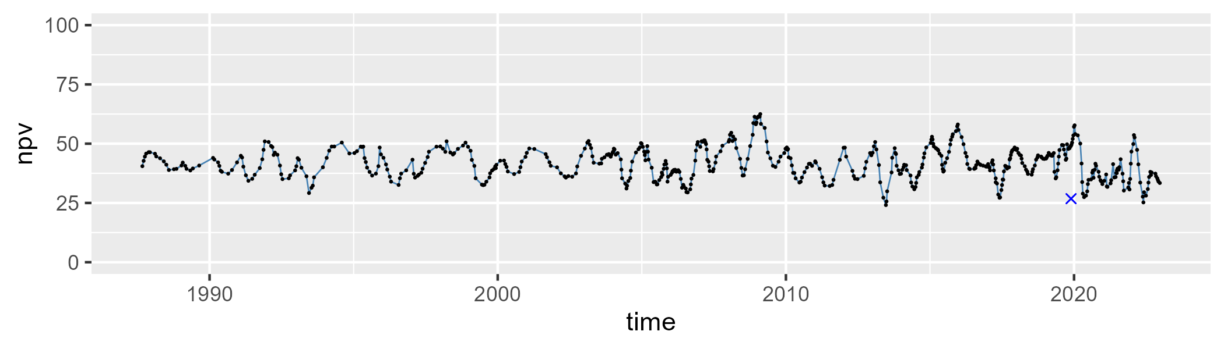

| Min. | 1st Qu. | Median | Mean | 3rd Qu. | Max. |
| --- | --- | --- | --- | --- | --- |
| 0 | 3.906722 | 6.346133 | 8.083385 | 11.00604 | 31.86841 |

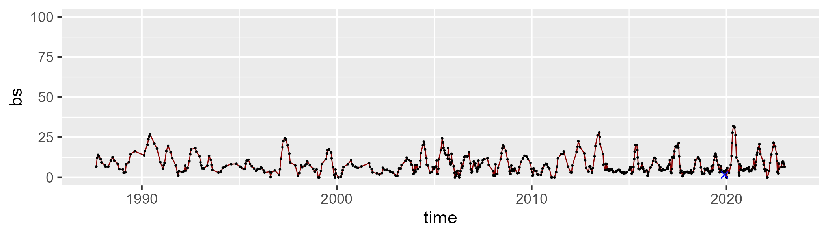

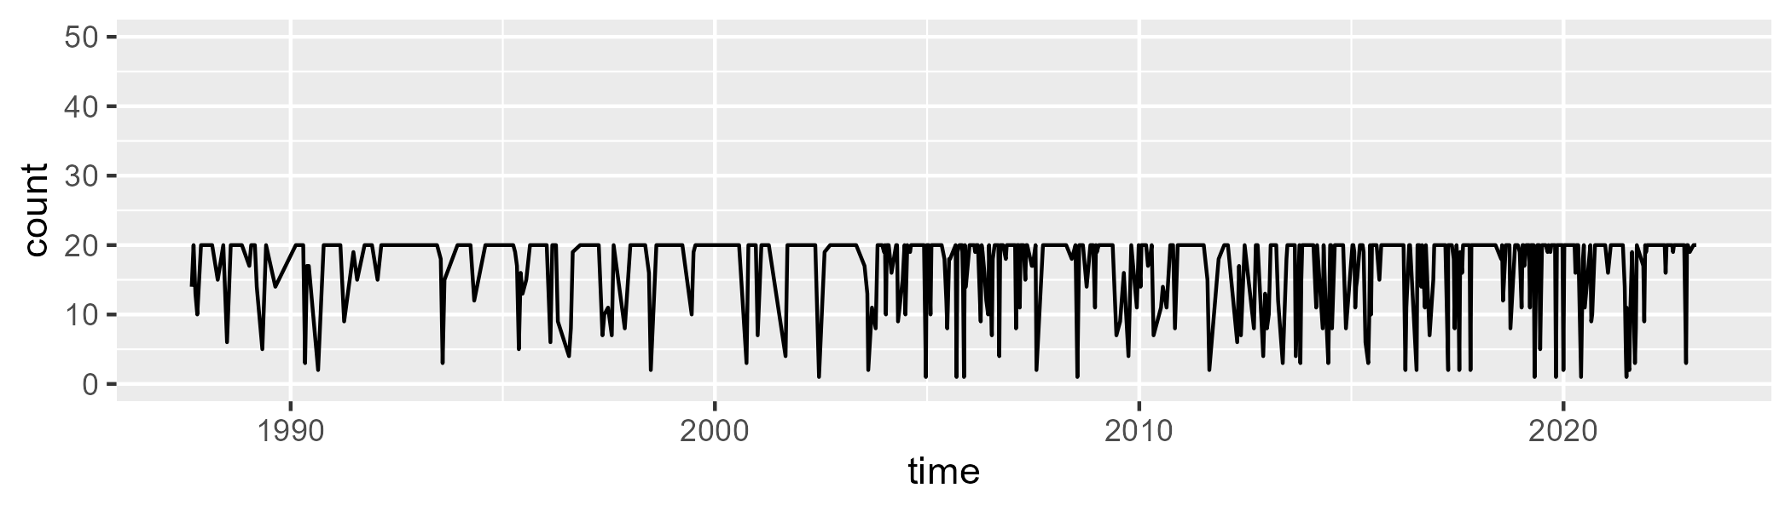

Min. : 1.00 1st Qu.:16.00 Median :20.00 Mean :17.03 3rd Qu.:20.00 Max. :20.00

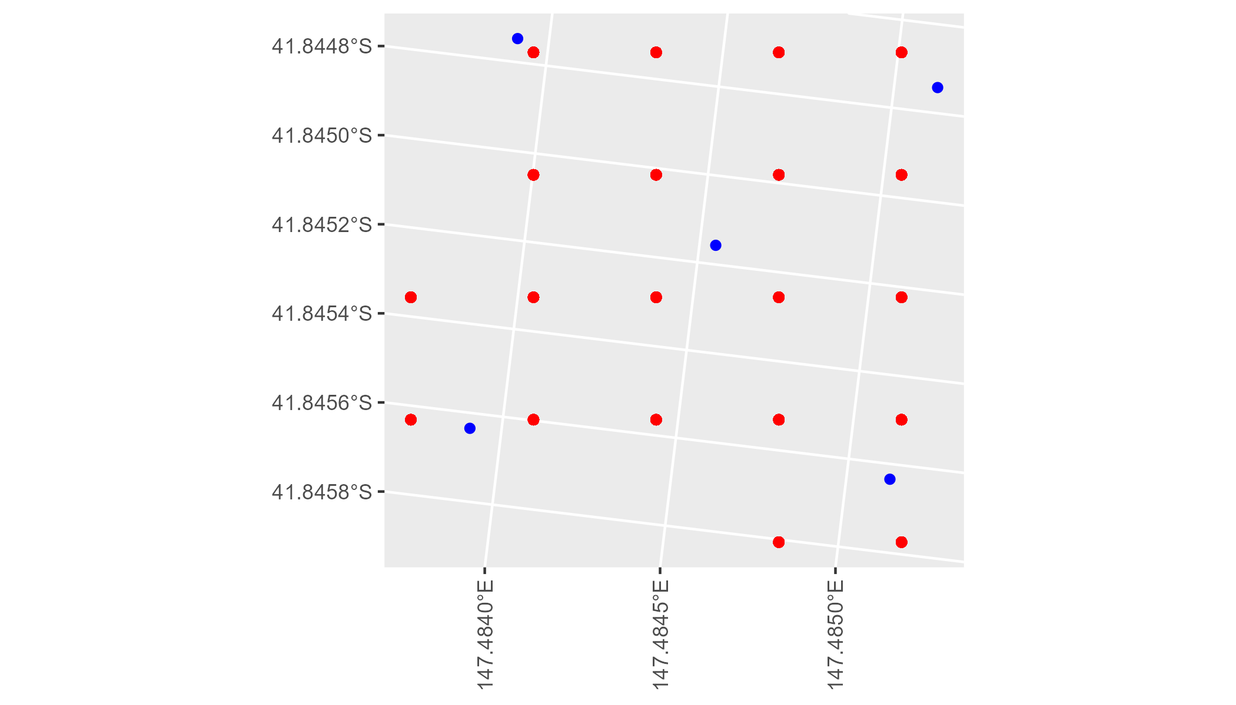

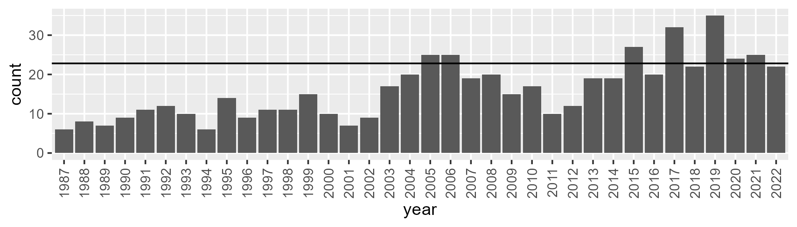

Number of samples: 580

# TCATNM0005

| Min. | 1st Qu. | Median | Mean | 3rd Qu. | Max. |
| --- | --- | --- | --- | --- | --- |
| 8.810785 | 33.26703 | 44.40342 | 42.87028 | 52.49066 | 69.67159 |

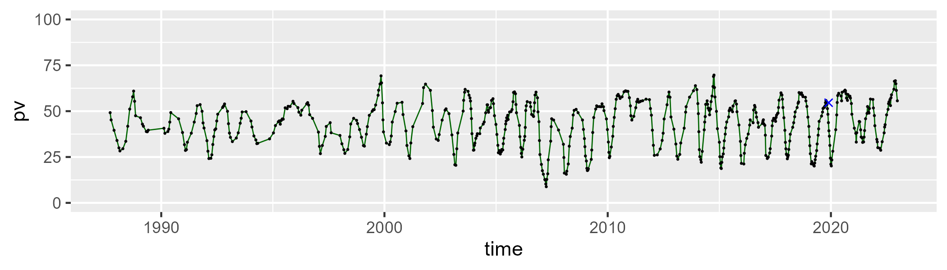

| Min. | 1st Qu. | Median | Mean | 3rd Qu. | Max. |
| --- | --- | --- | --- | --- | --- |
| 14.76552 | 34.82677 | 43.24541 | 44.06259 | 54.32785 | 72.34476 |

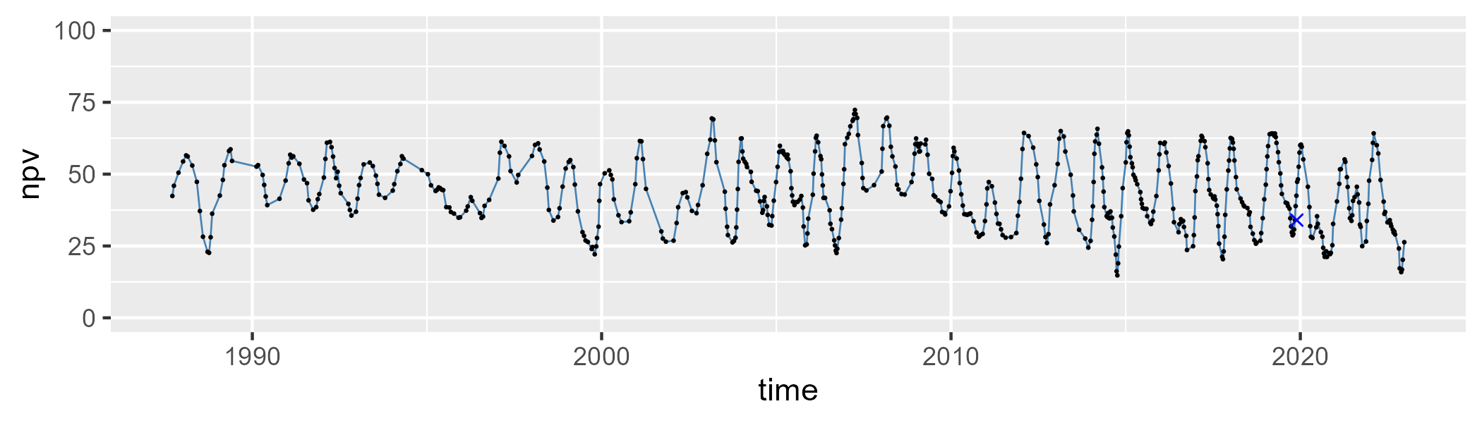

| Min. | 1st Qu. | Median | Mean | 3rd Qu. | Max. |
| --- | --- | --- | --- | --- | --- |
| 0 | 8.813666 | 11.37066 | 11.69936 | 14.00911 | 31.75559 |

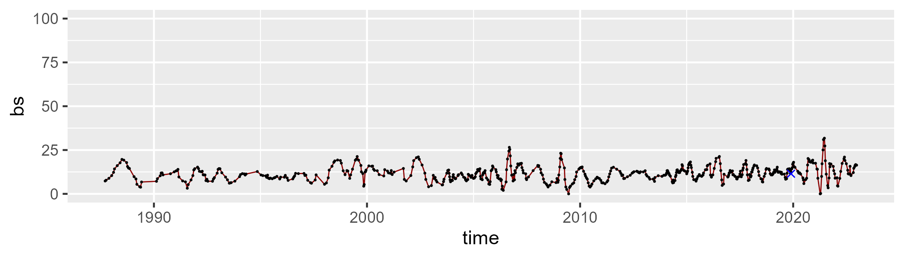

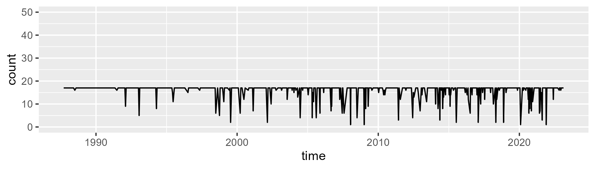

Min. : 1.00 1st Qu.:17.00 Median :17.00 Mean :15.81 3rd Qu.:17.00 Max. :17.00

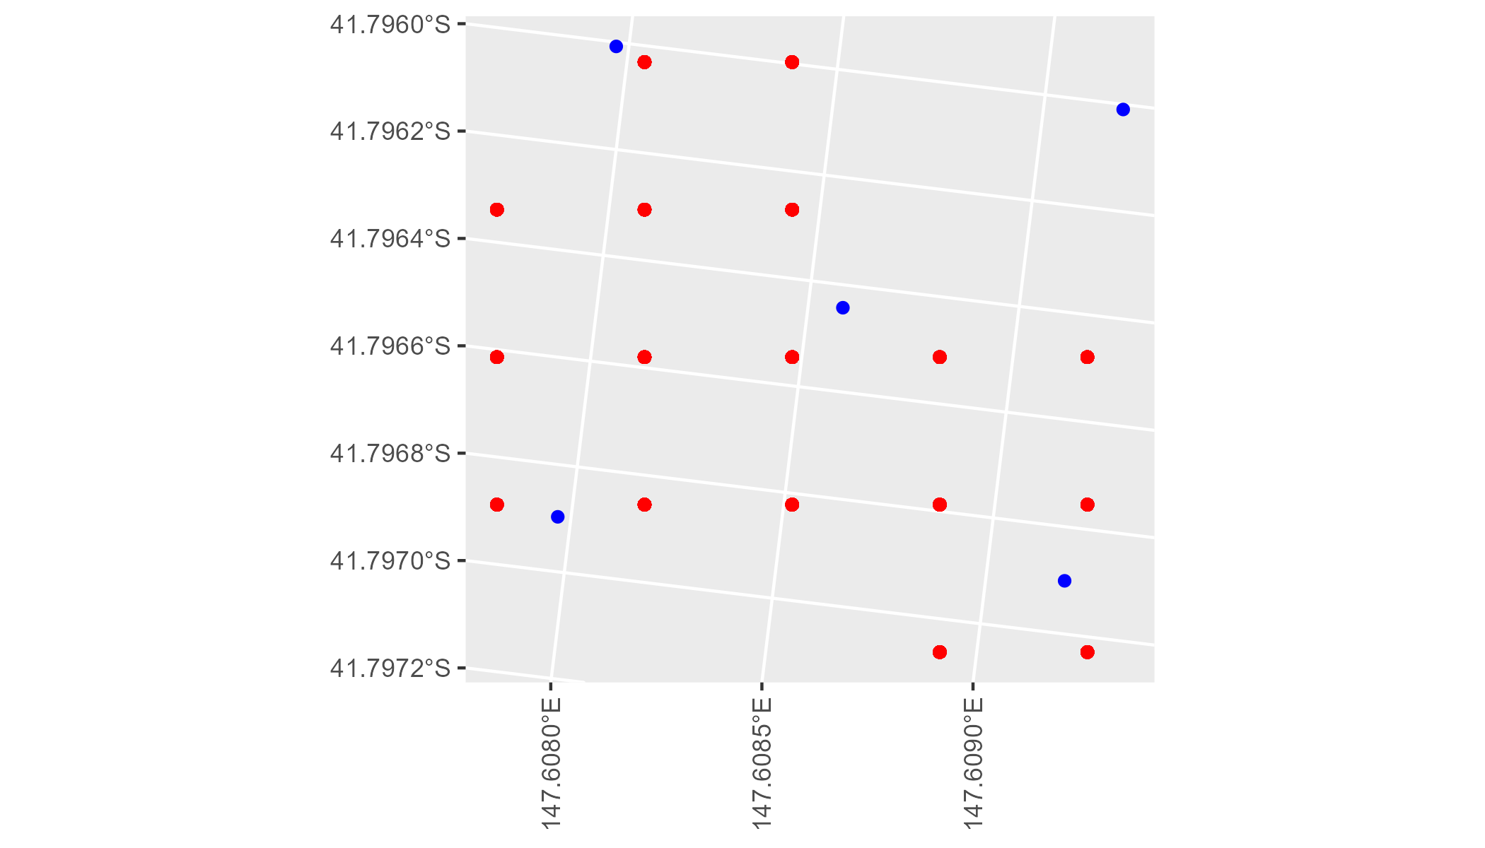

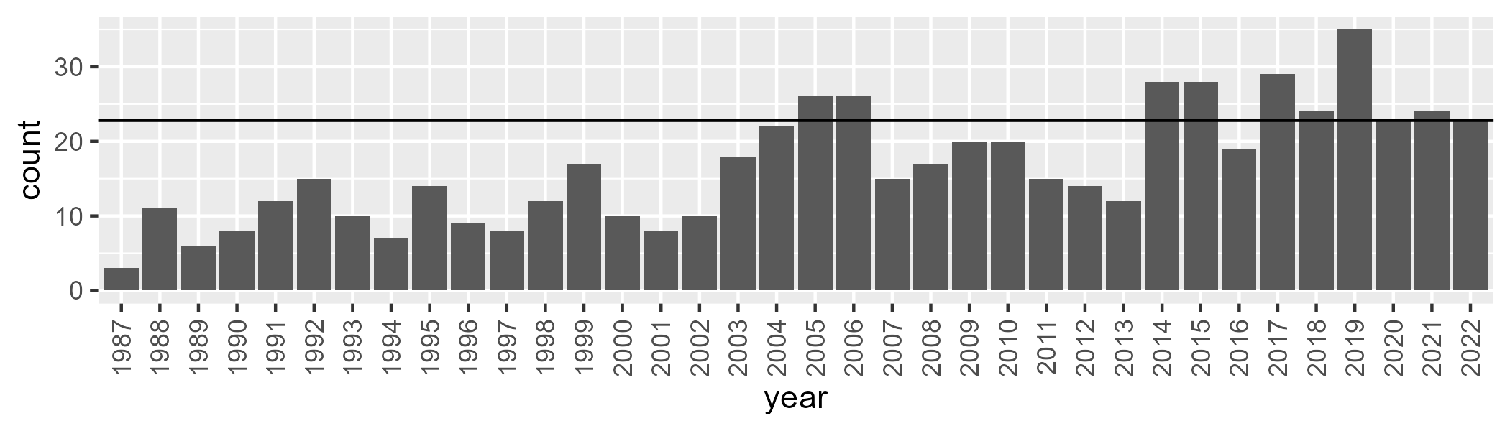

Number of samples: 598

# TCATNM0006

| Min. | 1st Qu. | Median | Mean | 3rd Qu. | Max. |
| --- | --- | --- | --- | --- | --- |
| 26.28962 | 40.9303 | 47.23647 | 47.07665 | 52.81768 | 69.34269 |

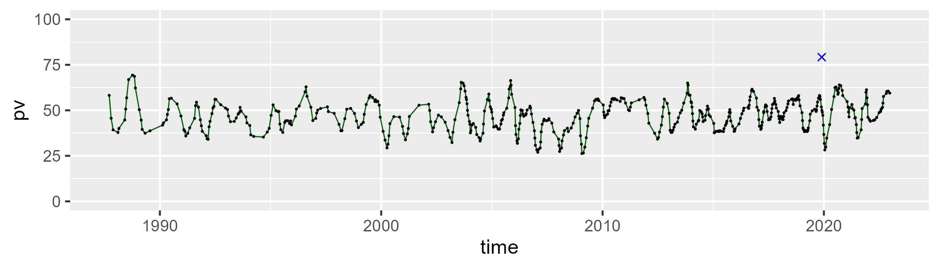

| Min. | 1st Qu. | Median | Mean | 3rd Qu. | Max. |
| --- | --- | --- | --- | --- | --- |
| 22.18885 | 37.26176 | 43.30268 | 42.74798 | 48.97892 | 65.3011 |

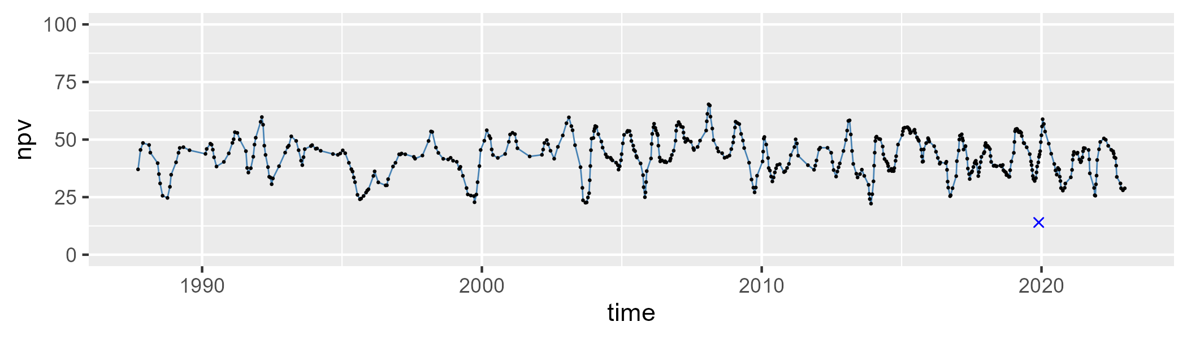

| Min. | 1st Qu. | Median | Mean | 3rd Qu. | Max. |
| --- | --- | --- | --- | --- | --- |
| 0 | 5.44362 | 8.087687 | 8.924552 | 11.24122 | 34.95879 |

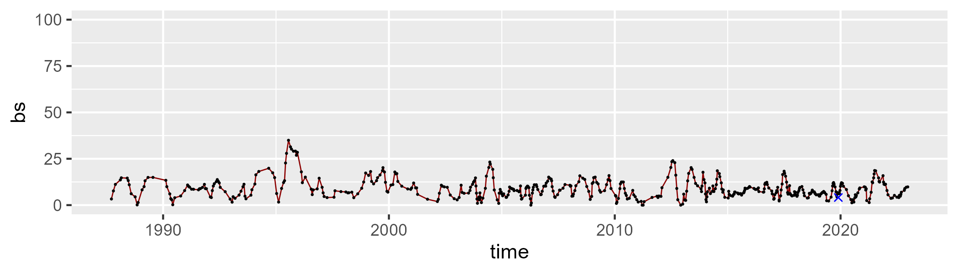

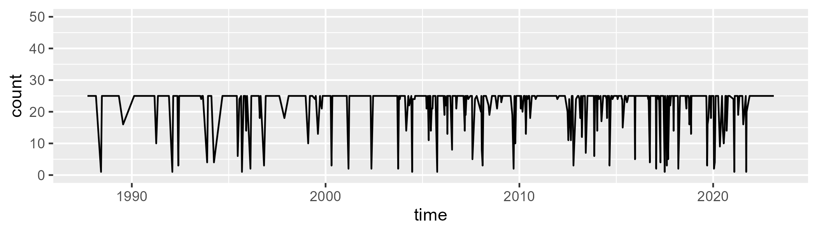

Min. : 1.00 1st Qu.:25.00 Median :25.00 Mean :22.46 3rd Qu.:25.00 Max. :25.00

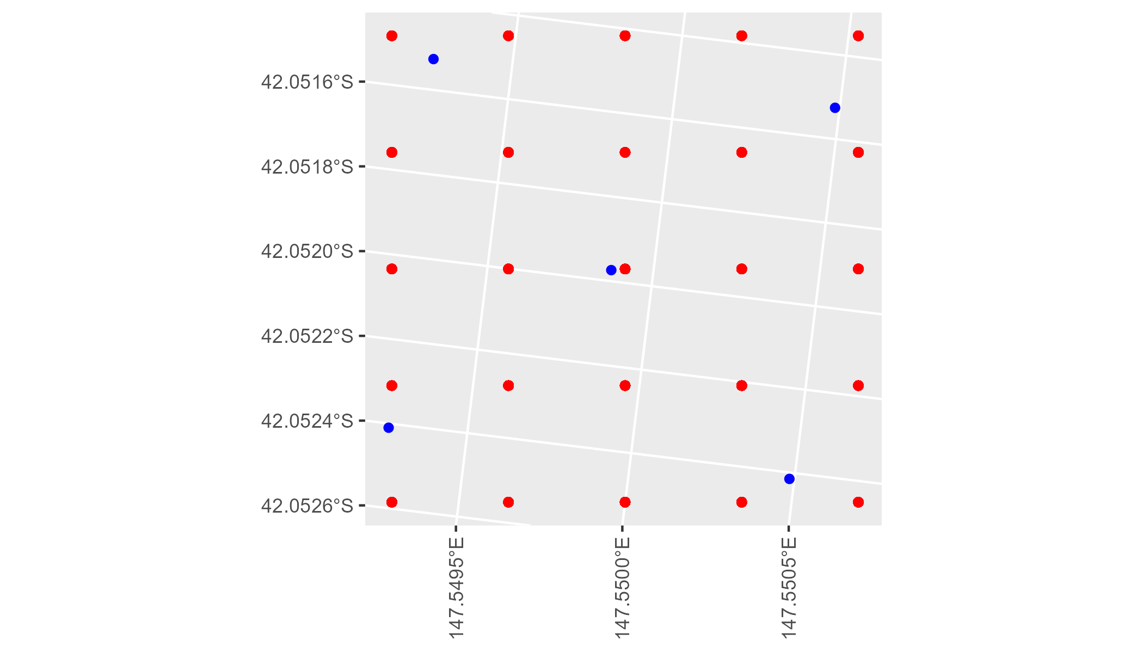

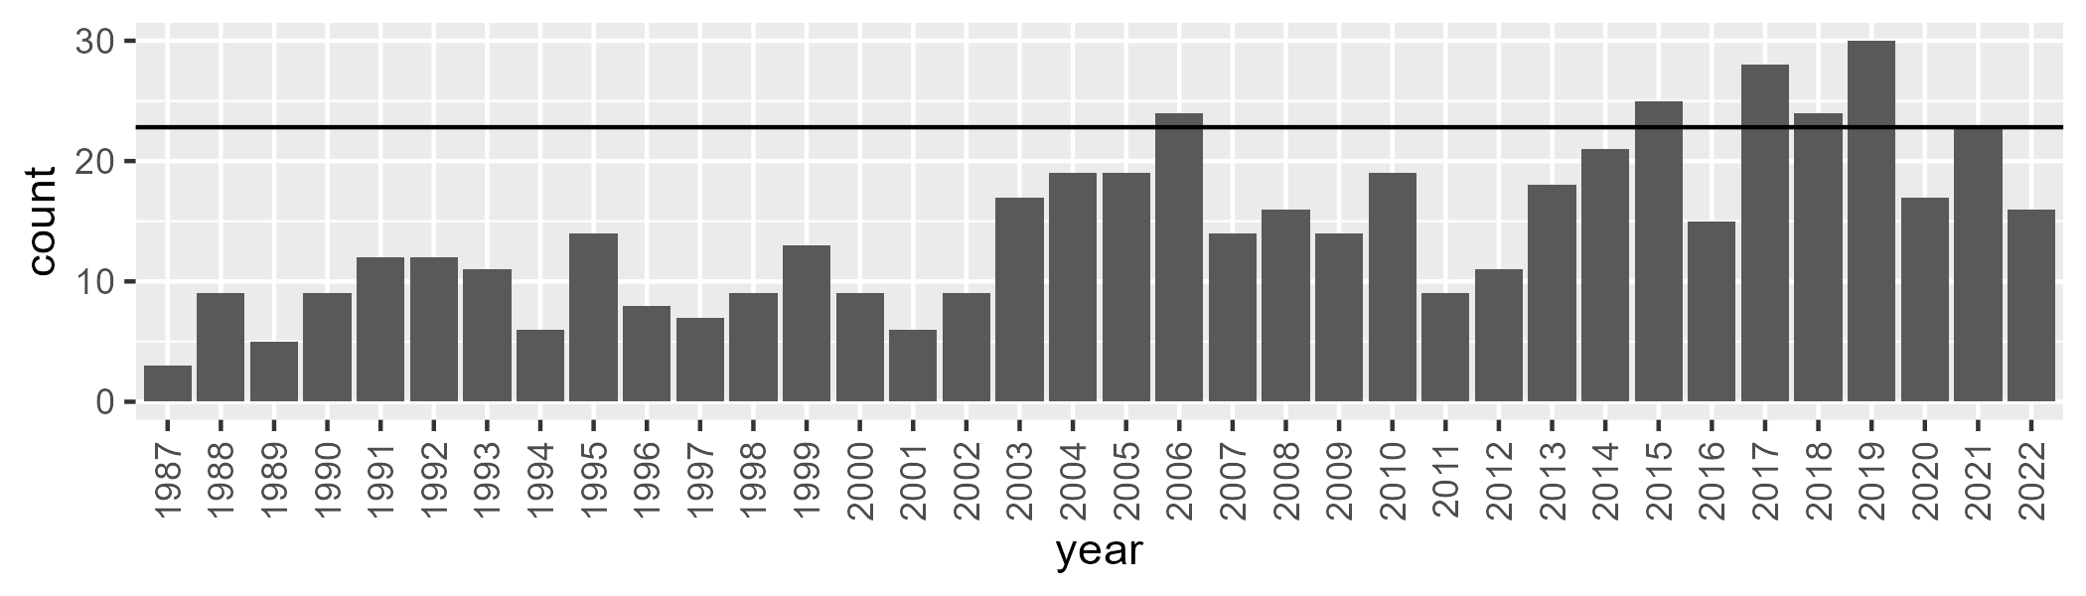

Number of samples: 521